UNITED STATES

SECURITIES AND EXCHANGE COMMISSION
Washington, D.C. 20549

SCHEDULE 14A

Proxy Statement Pursuant to Section 14(a) of the

Securities Exchange Act of 1934

Filed by the Registrant ☒ Filed by a party other than the Registrant ☐

Check the appropriate box:

- Preliminary Proxy Statement

- Confidential, for Use of the Commission Only (as permitted by Rule 14a-6(e)(2))

- Definitive Proxy Statement

- Definitive Additional Materials

- Soliciting Material Under Rule 240.14a-12

BROWN & BROWN, INC.

(Name of Registrant as Specified In Its Charter)

(Name of Person(s) Filing Proxy Statement, if other than the Registrant)

Payment of Filing Fee (Check the appropriate box):

- No fee required.

- Fee paid previously with preliminary materials.

- Fee computed on table in exhibit required by Item 25(b) per Exchange Act Rules 14a-6(i)(1) and 0-11.






Your Vote Counts!

BROWN & BROWN, INC.

2024 Annual Meeting

Vote by May 07, 2024

11:59 PM ET

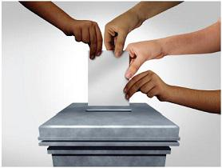



FLASHID-JOB#

You invested in BROWN & BROWN, INC. and it’s time to vote!

You have the right to vote on proposals being presented at the Annual Meeting. This is an important notice regarding the availability of proxy material for the shareholder meeting to be held on May 08, 2024.

Get informed before you vote

View the Annual Report, Proxy Statement online OR you can receive a free paper or email copy of the material(s) by requesting prior to April 25, 2024. If you would like to request a copy of the material(s) for this and/or future shareholder meetings, you may (1) visit www.ProxyVote.com,
- call 1-800-579-1639 or (3) send an email to sendmaterial@proxyvote.com. If sending an email, please include your control number (indicated below) in the subject line. Unless requested, you will not otherwise receive a paper or email copy.
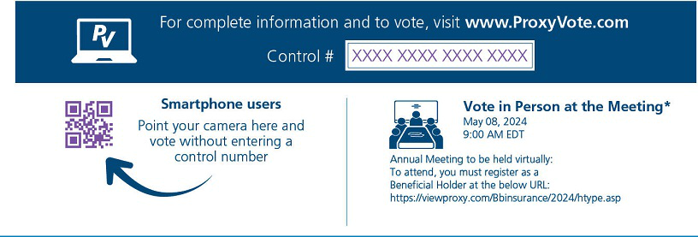

- If you choose to vote these shares in person at the meeting, you must request a “legal proxy.” To do so, please follow the instructions at www.ProxyVote.com or request a paper copy of the materials, which will contain the appropriate instructions. Please check the meeting materials for any special requirements for meeting attendance.

Vote at www.ProxyVote.com Control # XXXX XXXX XXXX XXXX

THIS IS NOT A VOTABLE BALLOT

This is an overview of the proposals being presented at the upcoming shareholder meeting. Please follow the instructions on the reverse side to vote these important matters.

Voting Items

Board


Recommends

1. |  | Election of Directors
 |  | Nominees:
 |  | 01 | J. Hyatt Brown | 06 | James S. Hunt | 11 | Jaymin B. Patel
 | 02 |  | J. Powell Brown | 07 | Toni Jennings | 12 | H. Palmer Proctor, Jr. | For
 | 03 |  | Lawrence L. Gellerstedt | 08 | Paul J. Krump | 13 | Wendell S. Reilly
 | 04 |  | James C. Hays | 09 | Timothy R.M. Main | 14 | Kathleen A. Savio
 | 05 |  | Theodore J. Hoepner | 10 | Bronislaw E. Masojada | 15 | Chilton D. Varner
2. |  | To ratify the appointment of Deloitte & Touche LLP as Brown & Brown, Inc.’s independent registered public accountants for |  |  |  |  |  | For
 |  | the fiscal year ending December 31, 2024. |  |  |  |  |  | For
3. |  | To approve, on an advisory basis, the compensation of named executive officers. |  |  |  |  |  | For
NOTE: Such other business as may properly come before the meeting or any adjournment thereof.


Under New York Stock Exchange rules, brokers may vote “routine” matters at their discretion if your voting instructions are not communicated to us at least 10 days before the meeting. We will nevertheless follow your instructions, even if the broker’s discretionary vote has already been given, provided your instructions are received prior to the meeting date.

FLASHID-JOB#

1.00000 322,224 148,294

