UNITED STATES
SECURITIES AND EXCHANGE COMMISSION
Washington, D.C. 20549

FORM 8-K

CURRENT REPORT
Pursuant to Section 13 or 15(d) of the Securities Exchange Act of 1934
Date of Report (Date of earliest event reported): April 09, 2024

BROWN & BROWN, INC.
(Exact name of registrant as specified in its charter)

Florida |  |  | 001-13619 | 59-0864469
(State or other jurisdiction  of incorporation) |  |  | (Commission File Number) | (IRS Employer  Identification No.)
300 North Beach Street
Daytona Beach, Florida |  |  |  | 32114
(Address of principal executive offices) |  |  |  | (Zip Code)

Registrant’s telephone number, including area code: (386) 252-9601

(Former name or former address, if changed since last report)

Check the appropriate box below if the Form 8-K filing is intended to simultaneously satisfy the filing obligation of the registrant under any of the following provisions:
☐Written communications pursuant to Rule 425 under the Securities Act (17 CFR 230.425)
☐Soliciting material pursuant to Rule 14a-12 under the Exchange Act (17 CFR 240.14a-12)
☐Pre-commencement communications pursuant to Rule 14d-2(b) under the Exchange Act (17 CFR 240.14d-2(b))
☐Pre-commencement communications pursuant to Rule 13e-4(c) under the Exchange Act (17 CFR 240.13e-4(c))
Securities registered pursuant to Section 12(b) of the Act:
Title of each class |  | Trading  Symbol(s) |  | Name of each exchange on which registered
Common Stock, $0.10 Par Value |  | BRO |  | New York Stock Exchange
Indicate by check mark whether the registrant is an emerging growth company as defined in Rule 405 of the Securities Act of 1933 (§ 230.405 of this chapter) or Rule 12b-2 of the Securities Exchange Act of 1934 (§ 240.12b-2 of this chapter).
Emerging growth company ☐
If an emerging growth company, indicate by check mark if the registrant has elected not to use the extended transition period for complying with any new or revised financial accounting standards provided pursuant to Section 13(a) of the Exchange Act. ☐

Item 7.01 Regulation FD Disclosure.
On April 9, 2024, the Company issued its annual Global Impact Report. A copy of the report is furnished as Exhibit 99.1 to this Current Report on Form 8-K and incorporated by reference herein.
The information furnished in this Item 7.01 (including Exhibit 99.1) shall not be deemed “filed” for purposes of Section 18 of the Securities Exchange Act of 1934, as amended (the "Exchange Act"), or otherwise subject to the liabilities of that section, nor shall such information be deemed incorporated by reference in any filing under the Securities Act of 1933, as amended, or the Exchange Act, regardless of any general incorporation language in such filing, except as shall be expressly set forth by specific reference in such filing.
Item 9.01 Financial Statements and Exhibits.
(d) Exhibits
The following exhibit is furnished herewith:
Exhibit No. |  | Description
99.1 |  | Brown & Brown, Inc. 2024 Global Impact Report
104 |  | Cover Page Interactive Data File (formatted in inline XBRL).

SIGNATURES
Pursuant to the requirements of the Securities Exchange Act of 1934, the registrant has duly caused this report to be signed on its behalf by the undersigned hereunto duly authorized.
 |  |  | BROWN & BROWN, INC.
 |  |  | (Registrant)
Date: | April 9, 2024 | By: | /s/ Anthony M. Robinson
Anthony M. Robinson
Secretary

Exhibit 99.1


Focused on Forever 2024 GLOBAL IMPAC TREPORT Company Logo

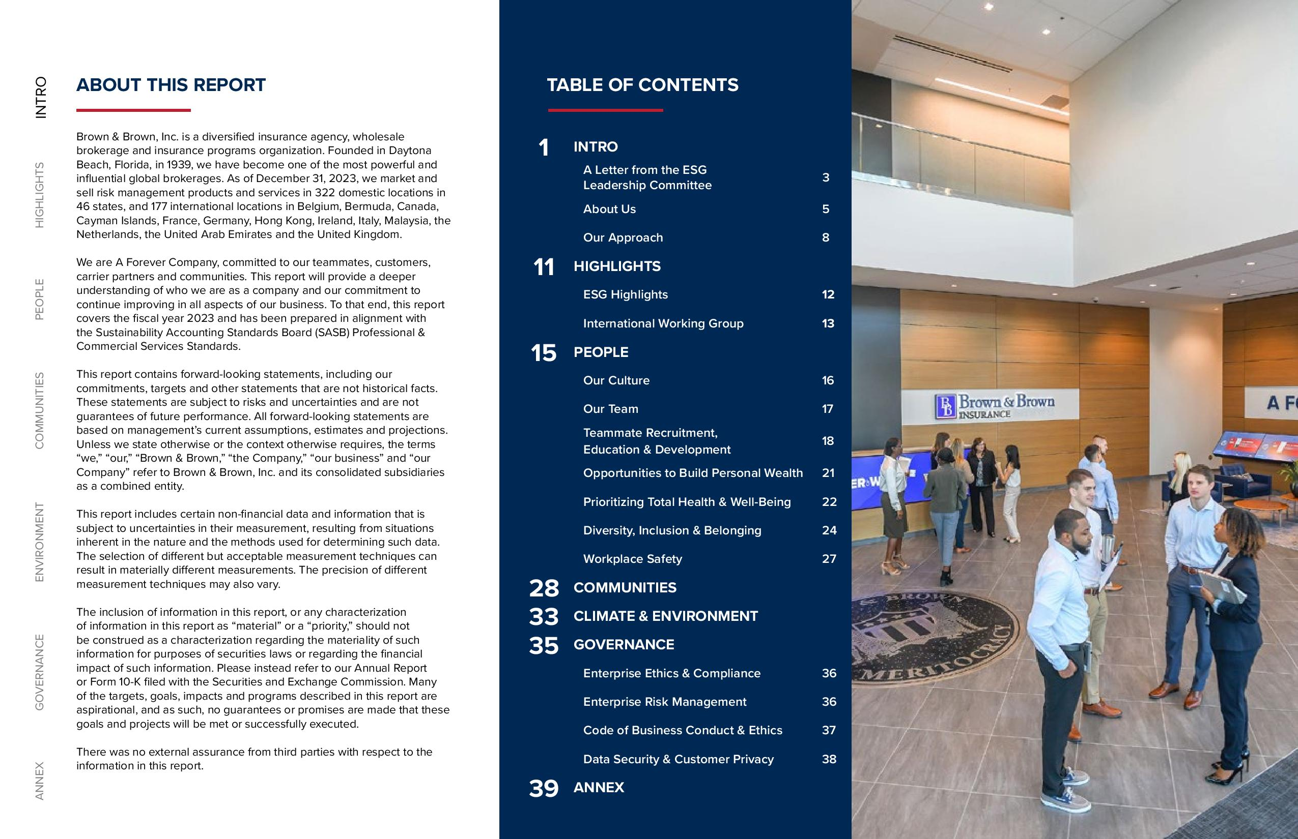
ANNEX GOVERNANCE ENVIRONMENT COMMUNITIES PEOPLE HIGHLIGHTS INTRO ABOUT THIS REPORT Brown & Brown, Inc. is a diversified insurance agency, wholesale brokerage and insurance programs organization. Founded in Daytona Beach, Florida, in 1939, we have become one of the most powerful and influential global brokerages. As of December 31, 2023, we market and sell risk management products and services in 322 domestic locations in 46 states, and 177 international locations in Belgium, Bermuda, Canada, Cayman Islands, France, Germany, Hong Kong, Ireland, Italy, Malaysia, the Netherlands, the United Arab Emirates and the United Kingdom. We are A Forever Company, committed to our teammates, customers, carrier partners and communities. This report will provide a deeper understanding of who we are as a company and our commitment to continue improving in all aspects of our business. To that end, this report covers the fiscal year 2023 and has been prepared in alignment with the Sustainability Accounting Standards Board (SASB) Professional & Commercial Services Standards. This report contains forward-looking statements, including our commitments, targets and other statements that are not historical facts. These statements are subject to risks and uncertainties and are not guarantees of future performance. All forward-looking statements are based on management’s current assumptions, estimates and projections. Unless we state otherwise or the context otherwise requires, the terms “we,” “our,” “Brown & Brown,” “the Company,” “our business” and “our Company” refer to Brown & Brown, Inc. and its consolidated subsidiaries as a combined entity. This report includes certain non-financial data and information that is subject to uncertainties in their measurement, resulting from situations inherent in the nature and the methods used for determining such data. The selection of different but acceptable measurement techniques can result in materially different measurements. The precision of different measurement techniques may also vary. The inclusion of information in this report, or any characterization of information in this report as “material” or a “priority,” should not be construed as a characterization regarding the materiality of such information for purposes of securities laws or regarding the financial impact of such information. Please instead refer to our Annual Report or Form 10-K filed with the Securities and Exchange Commission. Many of the targets, goals, impacts and programs described in this report are aspirational, and as such, no guarantees or promises are made that these goals and projects will be met or successfully executed. There was no external assurance from third parties with respect to the information in this report. TABLE OF CONTENTS 1 INTRO A Letter from the ESG Leadership Committee 3 About Us 5 Our Approach 8 11 HIGHLIGHTS ESG Highlights 12 International Working Group 13 15 PEOPLE Our Culture 16 Our Team 17 Teammate Recruitment, Education & Development 18 Opportunities to Build Personal Wealth 21 Prioritizing Total Health & Well-Being 22 Diversity, Inclusion & Belonging 24 Workplace Safety 27 28 COMMUNITIES 33 CLIMATE & ENVIRONMENT 35 GOVERNANCE Enterprise Ethics & Compliance 36 Enterprise Risk Management 36 Code of Business Conduct & Ethics 37 Data Security & Customer Privacy 38 39 ANNEX

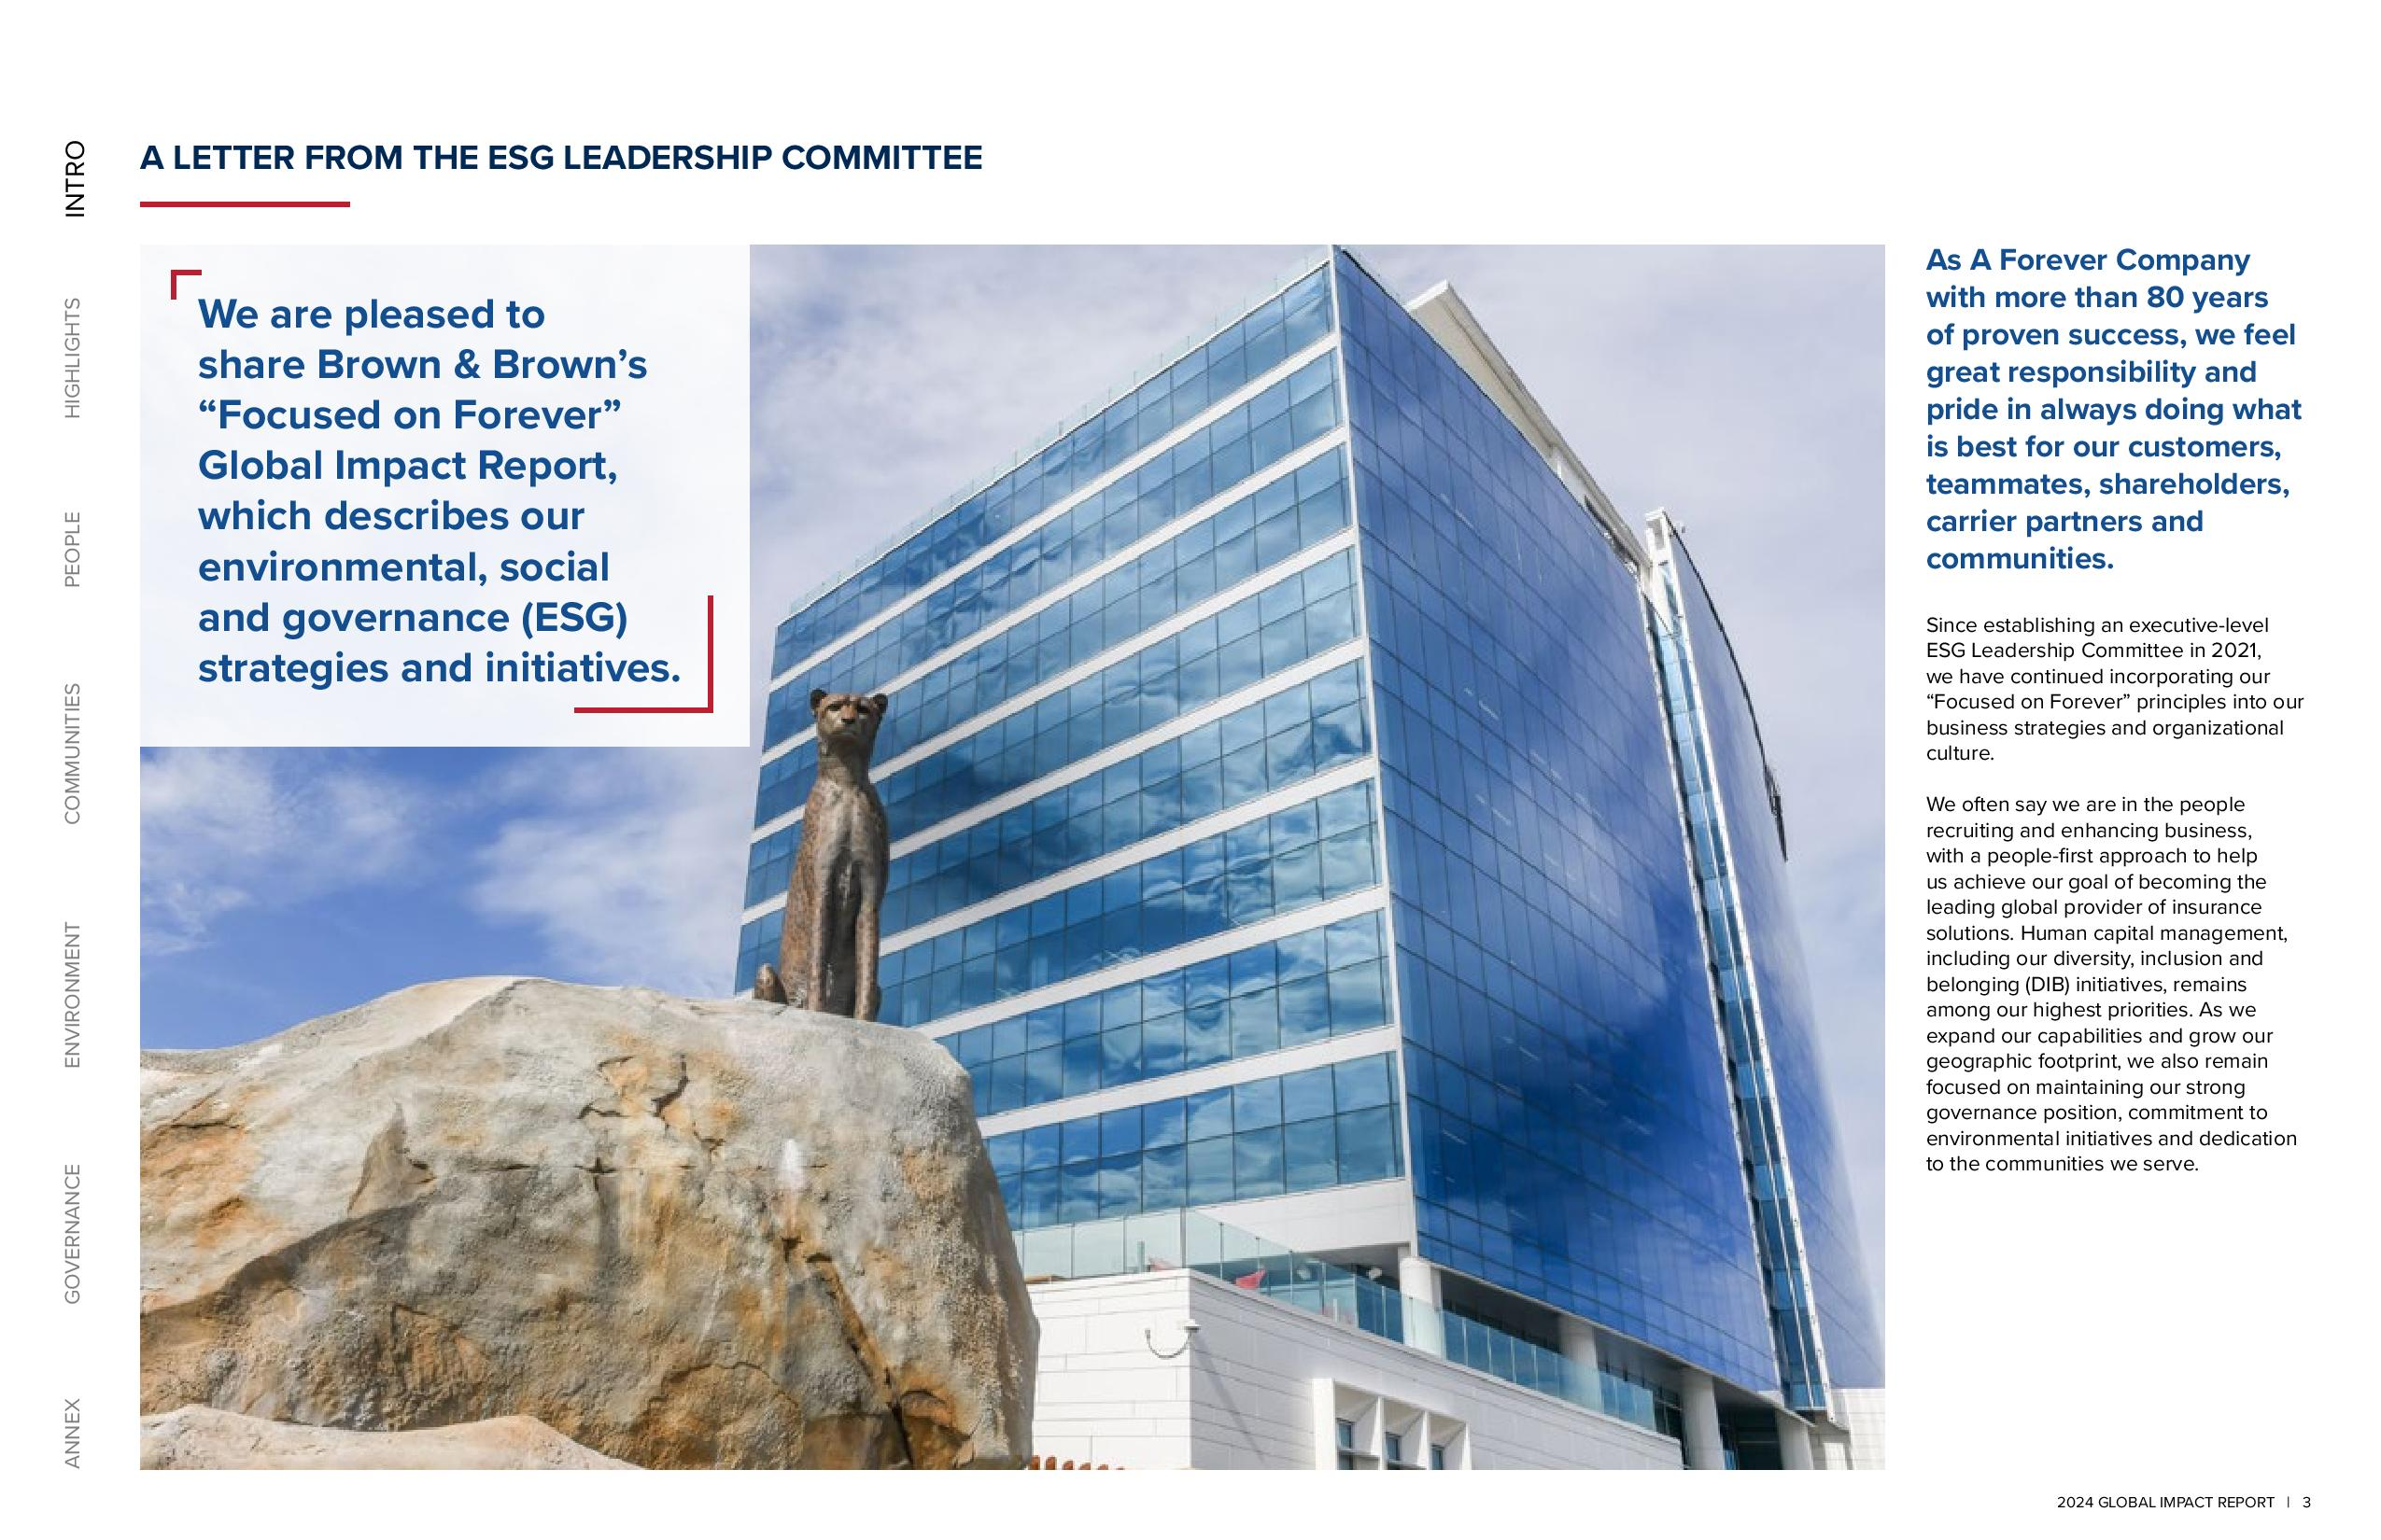
ANNEX GOVERNANCE ENVIRONMENT COMMUNITIES PEOPLE HIGHLIGHTS INTRO A LETTER FROM THE ESG LEADERSHIP COMMITTEE We are pleased to share Brown & Brown’s “Focused on Forever” Global Impact Report, which describes our environmental, social and governance (ESG) strategies and initiatives. As A Forever Company with more than 80 years of proven success, we feel great responsibility and pride in always doing what is best for our customers, teammates, shareholders, carrier partners and communities. Since establishing an executive-level ESG Leadership Committee in 2021, we have continued incorporating our “Focused on Forever” principles into our business strategies and organizational culture. We often say we are in the people recruiting and enhancing business, with a people-first approach to help us achieve our goal of becoming the leading global provider of insurance solutions. Human capital management, including our diversity, inclusion and belonging (DIB) initiatives, remains among our highest priorities. As we expand our capabilities and grow our geographic footprint, we also remain focused on maintaining our strong governance position, commitment to environmental initiatives and dedication to the communities we serve. 2024 GLOBAL IMPACT REPORT | 3

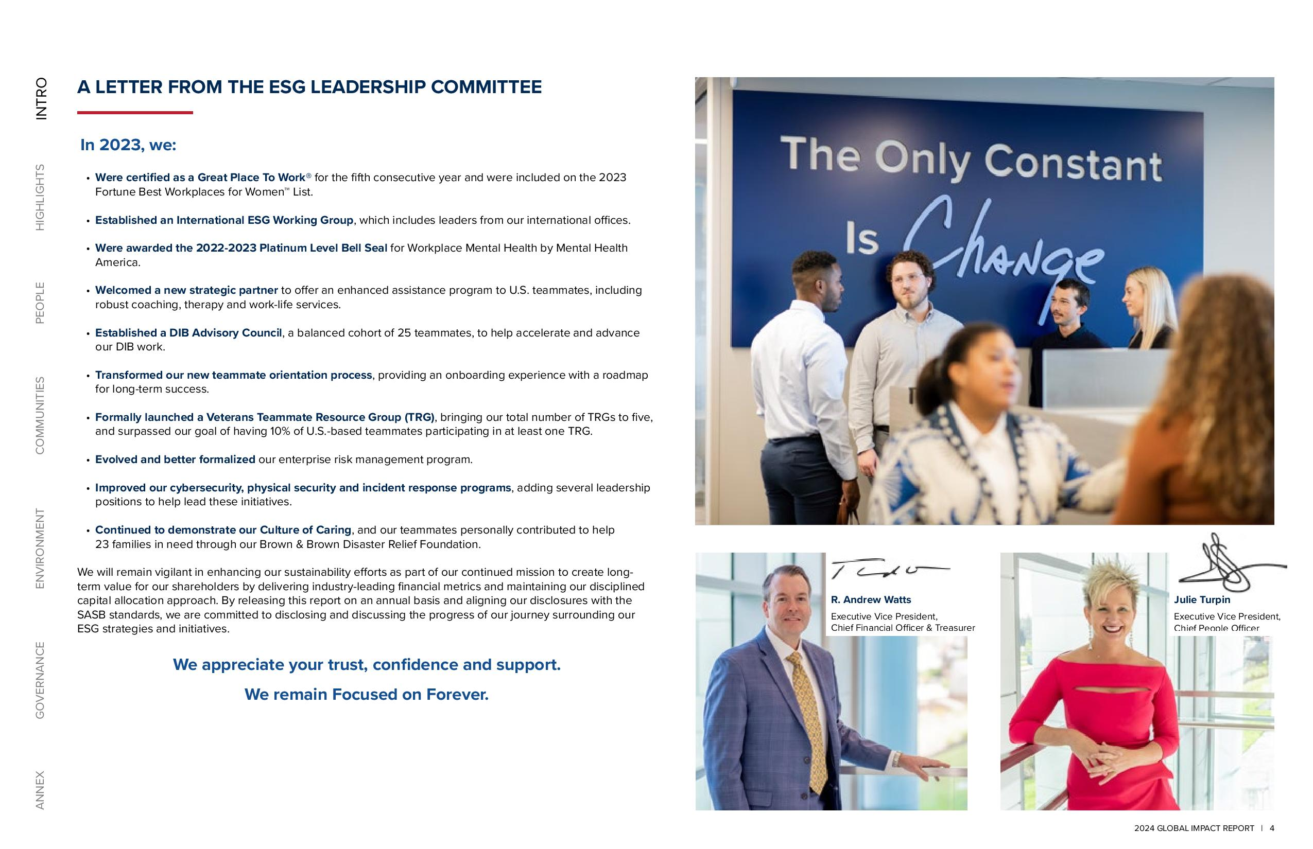
ANNEX GOVERNANCE ENVIRONMENT COMMUNITIES PEOPLE HIGHLIGHTS INTRO A LETTER FROM THE ESG LEADERSHIP COMMITTEE In 2023, we: Were certified as a Great Place To Work® for the fifth consecutive year and were included on the 2023 Fortune Best Workplaces for Women List. Established an International ESG Working Group, which includes leaders from our international offices. Were awarded the 2022-2023 Platinum Level Bell Seal for Workplace Mental Health by Mental Health America. Welcomed a new strategic partner to offer an enhanced assistance program to U.S. teammates, including robust coaching, therapy and work-life services. Established a DIB Advisory Council, a balanced cohort of 25 teammates, to help accelerate and advance our DIB work. Transformed our new teammate orientation process, providing an onboarding experience with a roadmap for long-term success. Formally launched a Veterans Teammate Resource Group (TRG), bringing our total number of TRGs to five, and surpassed our goal of having 10% of U.S.-based teammates participating in at least one TRG. Evolved and better formalized our enterprise risk management program. Improved our cybersecurity, physical security and incident response programs, adding several leadership positions to help lead these initiatives. Continued to demonstrate our Culture of Caring, and our teammates personally contributed to help 23 families in need through our Brown & Brown Disaster Relief Foundation. We will remain vigilant in enhancing our sustainability efforts as part of our continued mission to create longterm value for our shareholders by delivering industry-leading financial metrics and maintaining our disciplined capital allocation approach. By releasing this report on an annual basis and aligning our disclosures with the SASB standards, we are committed to disclosing and discussing the progress of our journey surrounding our ESG strategies and initiatives. We appreciate your trust, confidence and support. We remain Focused on Forever. R. Andrew Watts Executive Vice President, Chief Financial Officer & Treasurer Julie Turpin Executive Vice President, Chief People Officer 2024 GLOBAL IMPACT REPORT 4

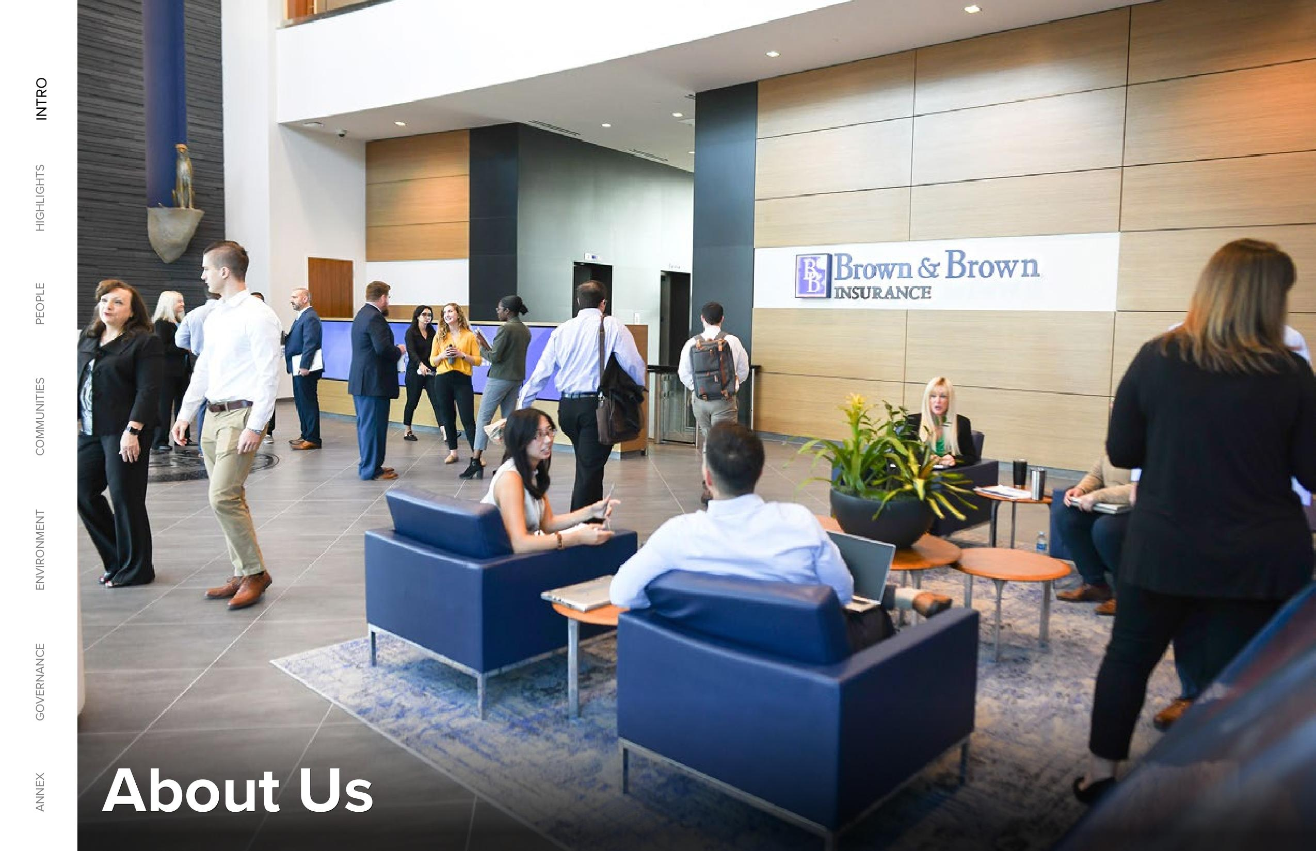
ANNEX GOVERNANCE ENVIRONMENT COMMUNITIES PEOPLE HIGHLIGHTS INTRO About Us

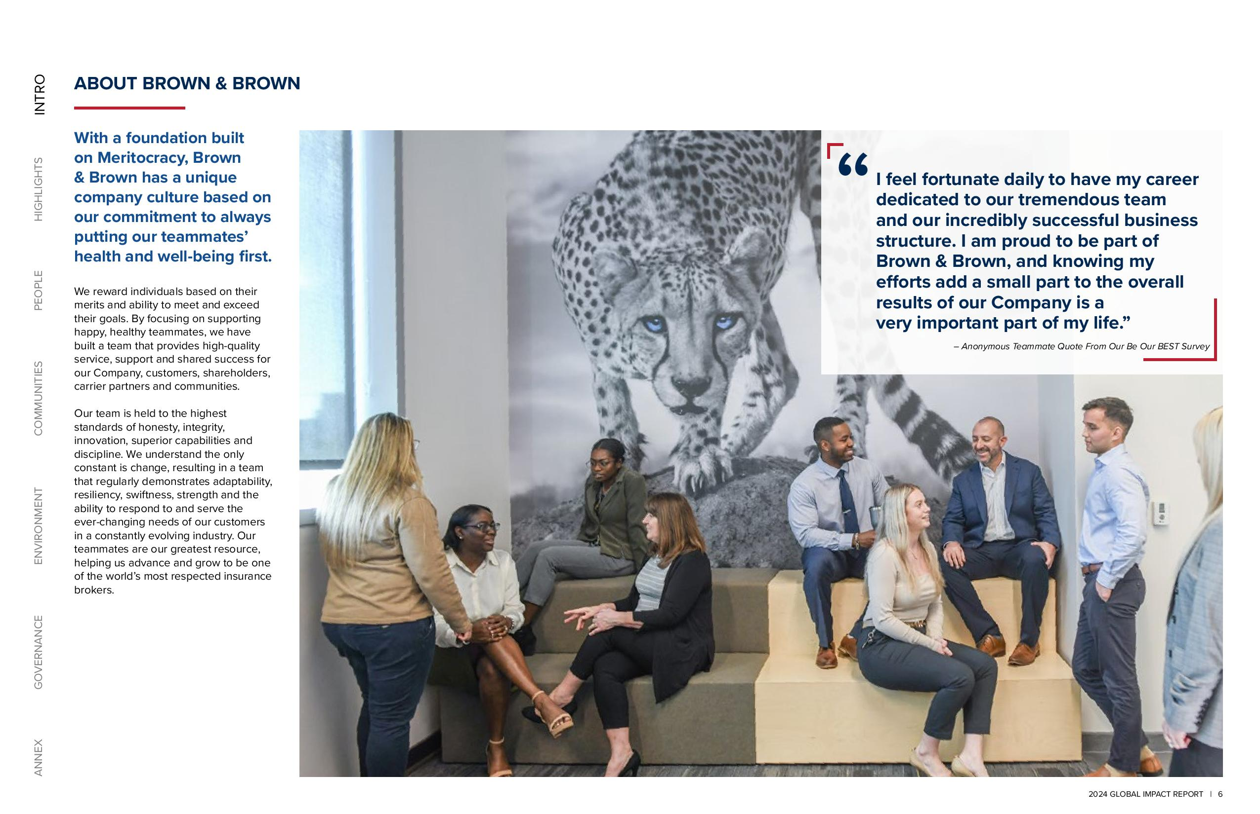
ANNEX GOVERNANCE ENVIRONMENT COMMUNITIES PEOPLE HIGHLIGHTS INTRO ABOUT BROWN & BROWN With a foundation built on Meritocracy, Brown & Brown has a unique company culture based on our commitment to always putting our teammates’ health and well-being first. We reward individuals based on their merits and ability to meet and exceed their goals. By focusing on supporting happy, healthy teammates, we have built a team that provides high-quality service, support and shared success for our Company, customers, shareholders, carrier partners and communities. Our team is held to the highest standards of honesty, integrity, innovation, superior capabilities and discipline. We understand the only constant is change, resulting in a team that regularly demonstrates adaptability, resiliency, swiftness, strength and the ability to respond to and serve the ever-changing needs of our customers in a constantly evolving industry. Our teammates are our greatest resource, helping us advance and grow to be one of the world’s most respected insurance brokers. I feel fortunate daily to have my career dedicated to our tremendous team and our incredibly successful business structure. I am proud to be part of Brown & Brown, and knowing my efforts add a small part to the overall results of our Company is a very important part of my life.” – Anonymous Teammate Quote From Our Be Our BEST Survey “ 2024 GLOBAL IMPACT REPORT | 6

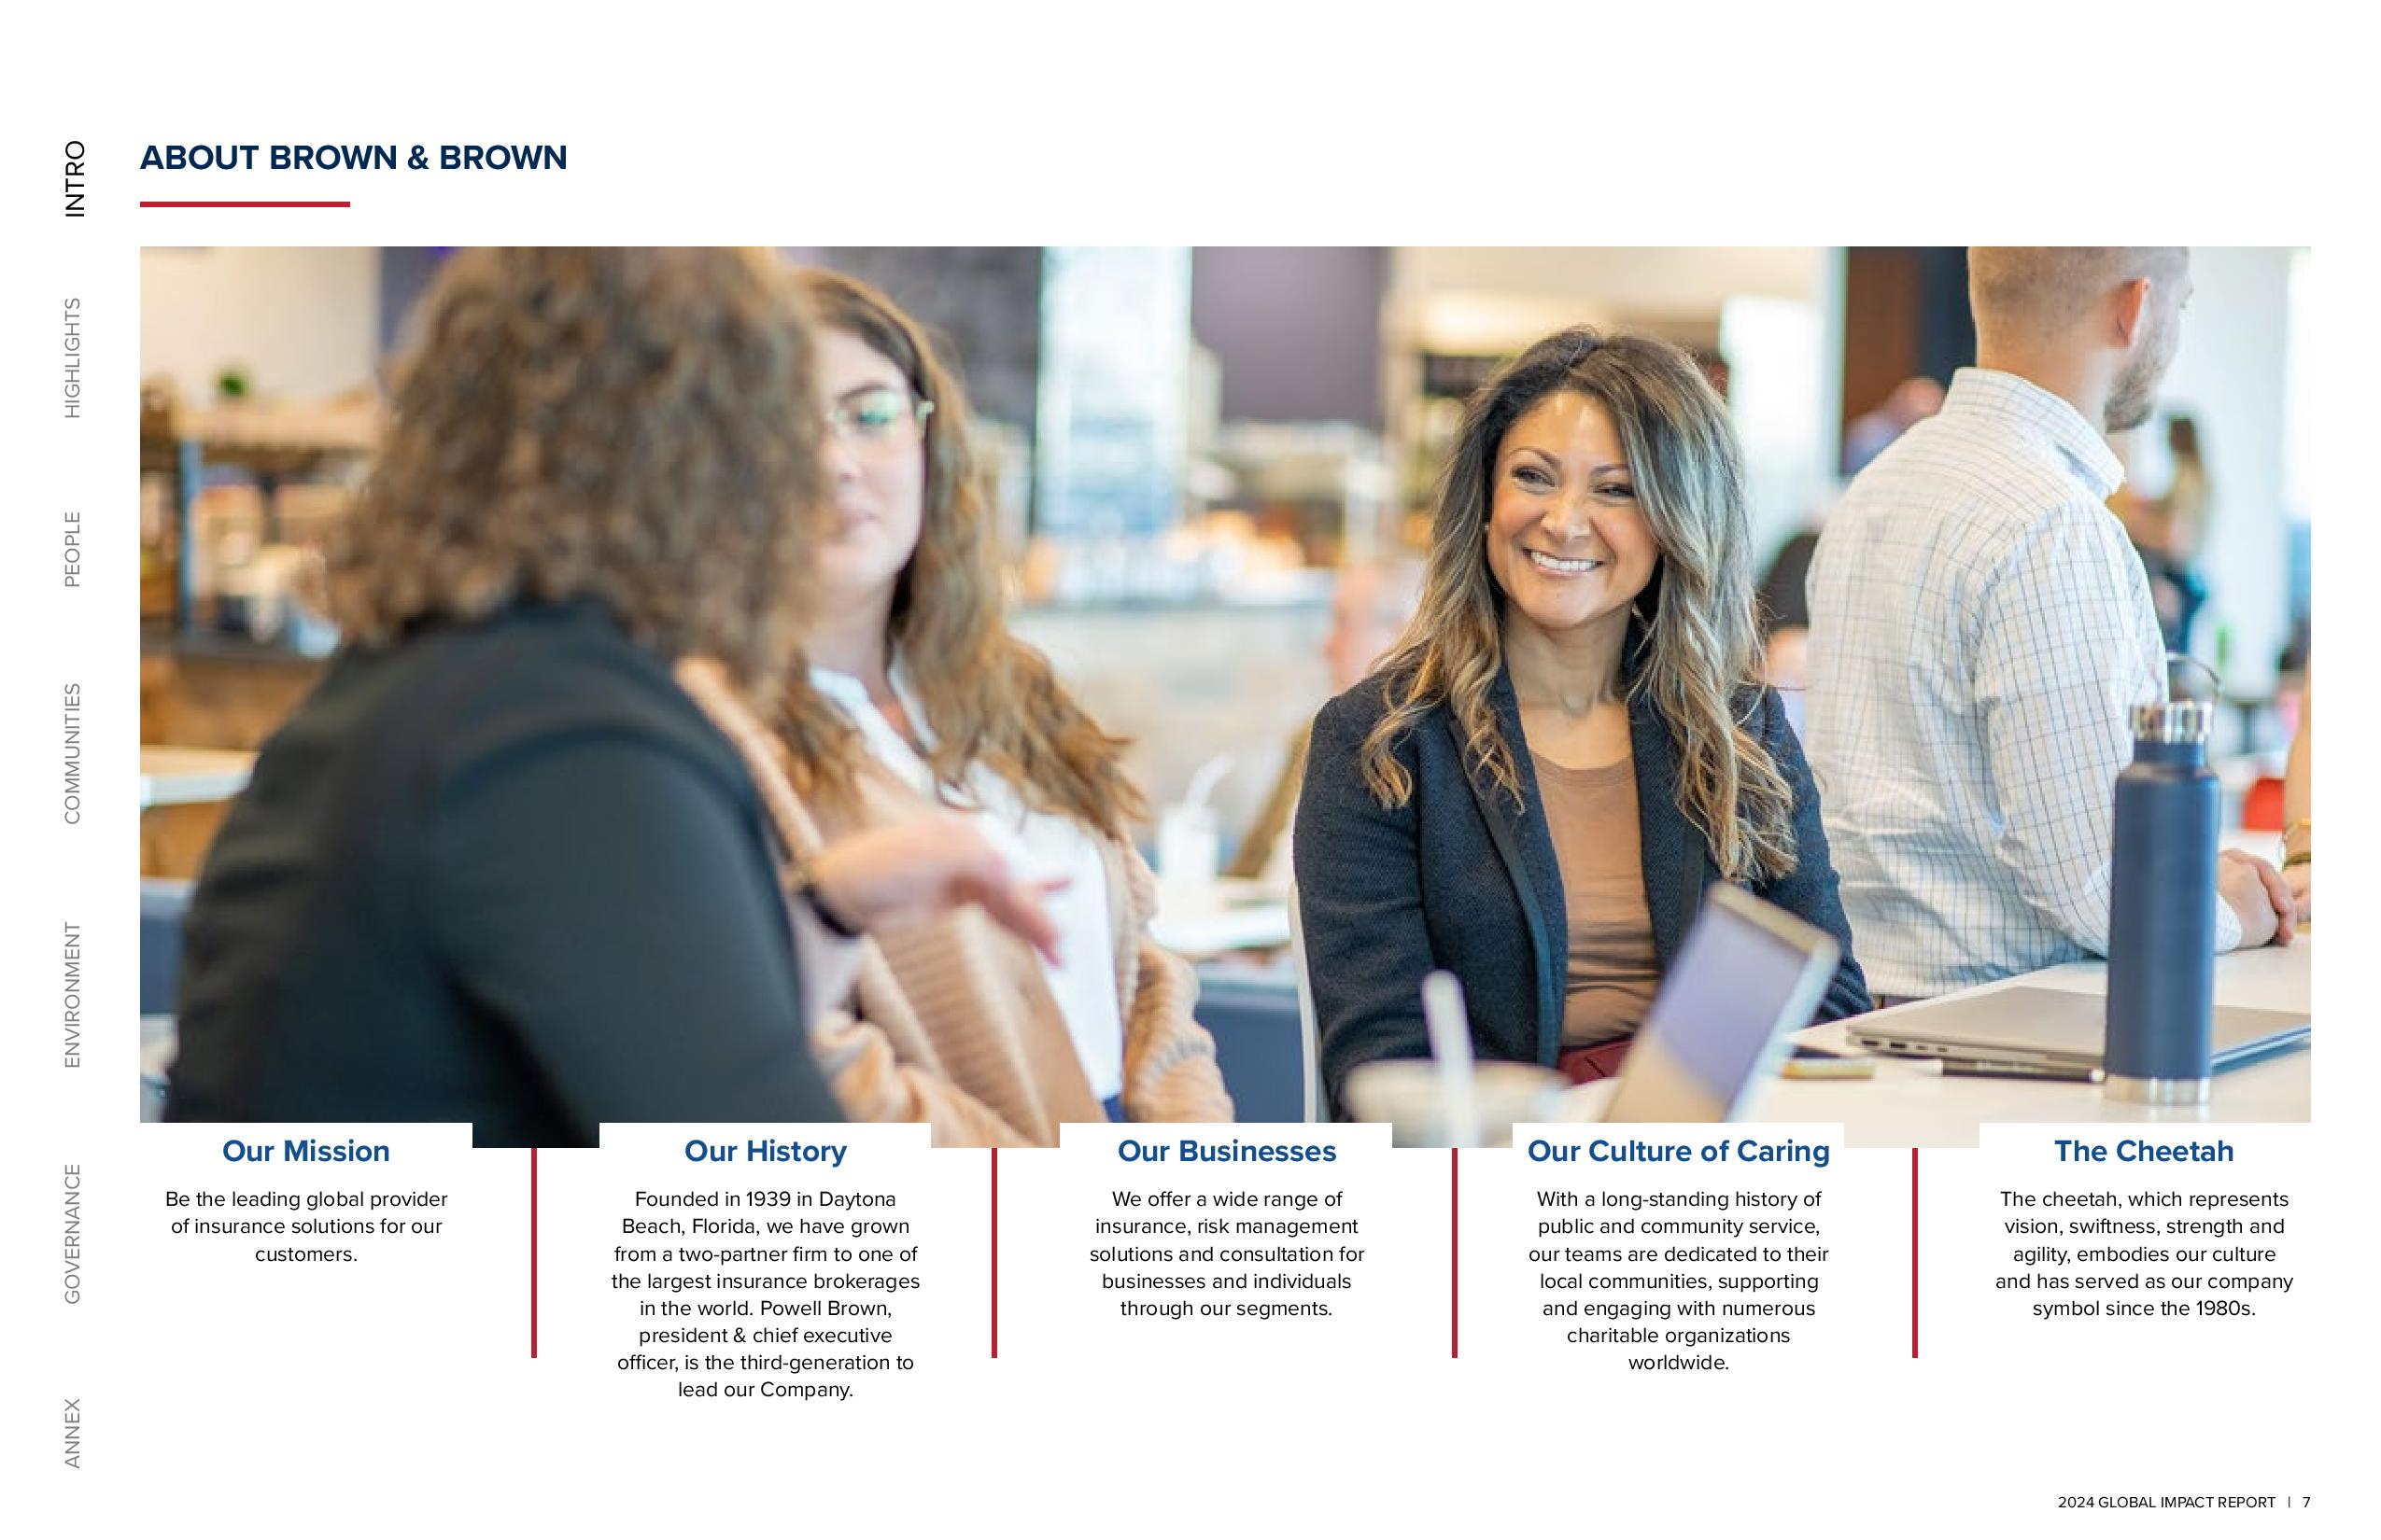
ANNEX GOVERNANCE ENVIRONMENT COMMUNITIES PEOPLE HIGHLIGHTS INTRO ABOUT BROWN & BROWN Our Mission Be the leading global provider of insurance solutions for our customers. Our History Founded in 1939 in Daytona Beach, Florida, we have grown from a two-partner firm to one of the largest insurance brokerages in the world. Powell Brown, president & chief executive officer, is the third-generation to lead our Company. Our Businesses We offer a wide range of insurance, risk management solutions and consultation for businesses and individuals through our segments. Our Culture of Caring With a long-standing history of public and community service, our teams are dedicated to their local communities, supporting and engaging with numerous charitable organizations worldwide. The Cheetah The cheetah, which represents vision, swiftness, strength and agility, embodies our culture and has served as our company symbol since the 1980s. 2024 GLOBAL IMPACT REPORT | 7

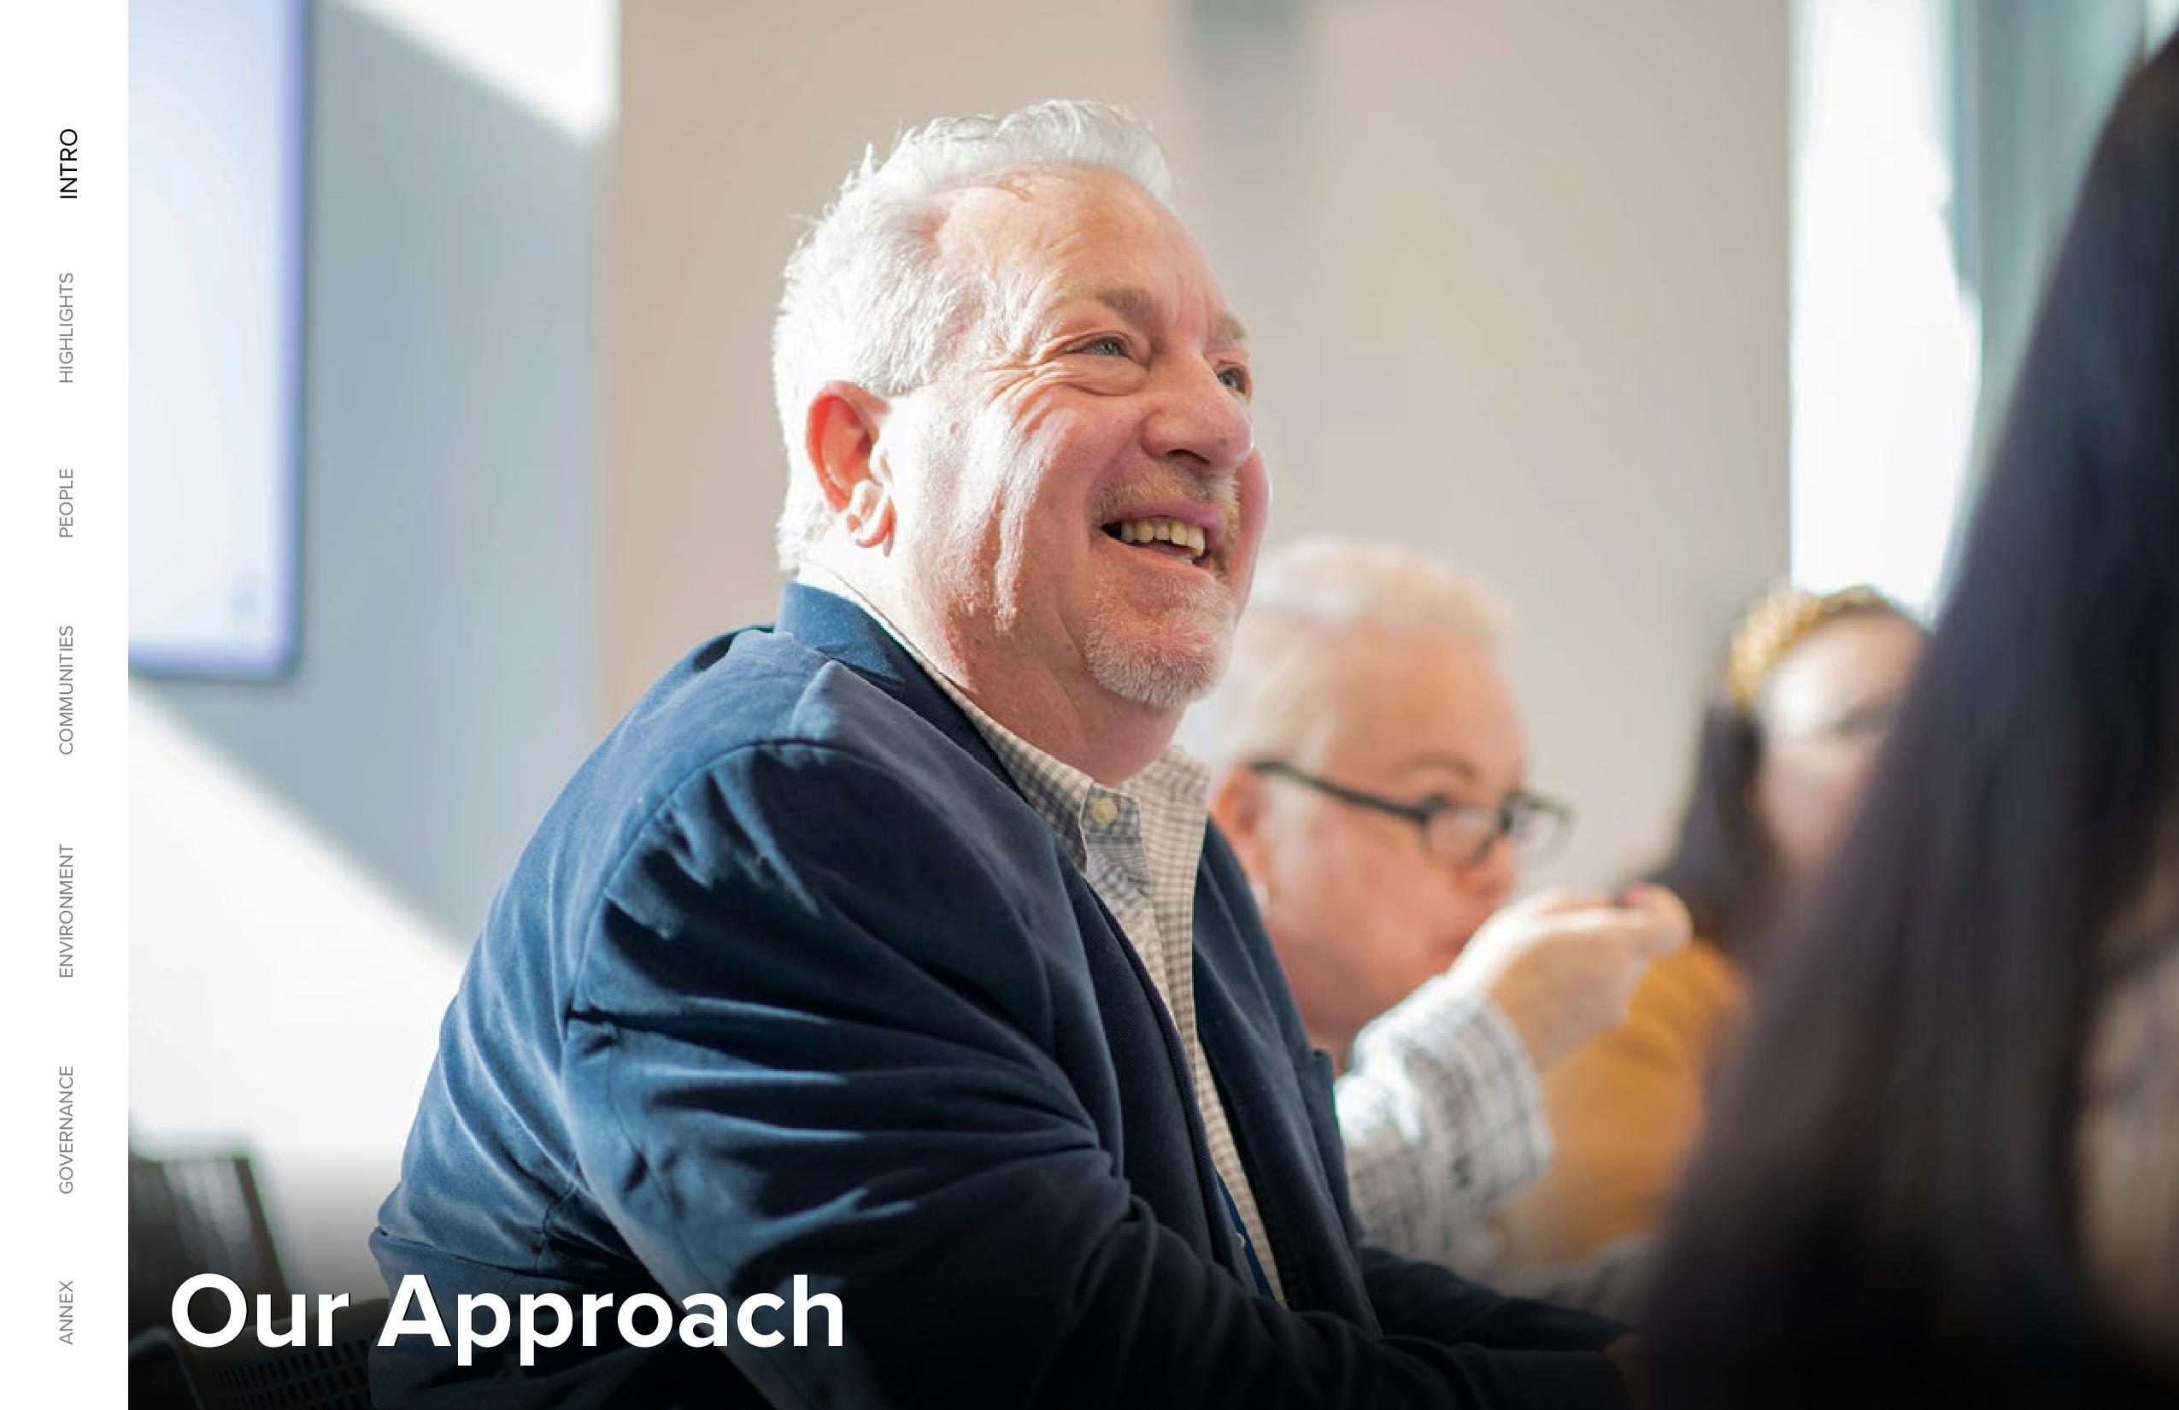
ANNEX GOVERNANCE ENVIRONMENT COMMUNITIES PEOPLE HIGHLIGHTS INTRO Our Approach

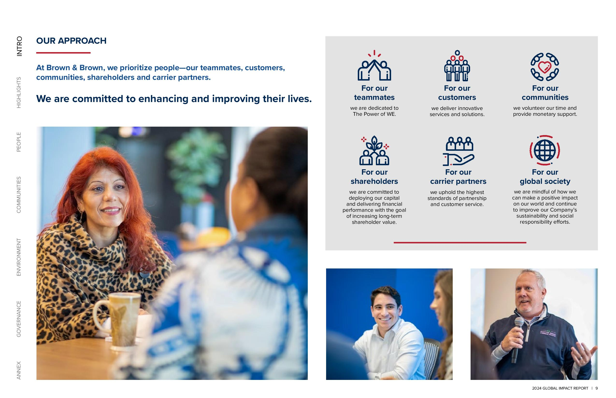
ANNEX GOVERNANCE ENVIRONMENT COMMUNITIES PEOPLE HIGHLIGHTS INTRO OUR APPROACH At Brown & Brown, we prioritize people—our teammates, customers, communities, shareholders and carrier partners. We are committed to enhancing and improving their lives. For our teammates we are dedicated to The Power of WE. For our customers we deliver innovative services and solutions. For our communities we volunteer our time and provide monetary support. 2024 GLOBAL IMPACT REPORT | 9

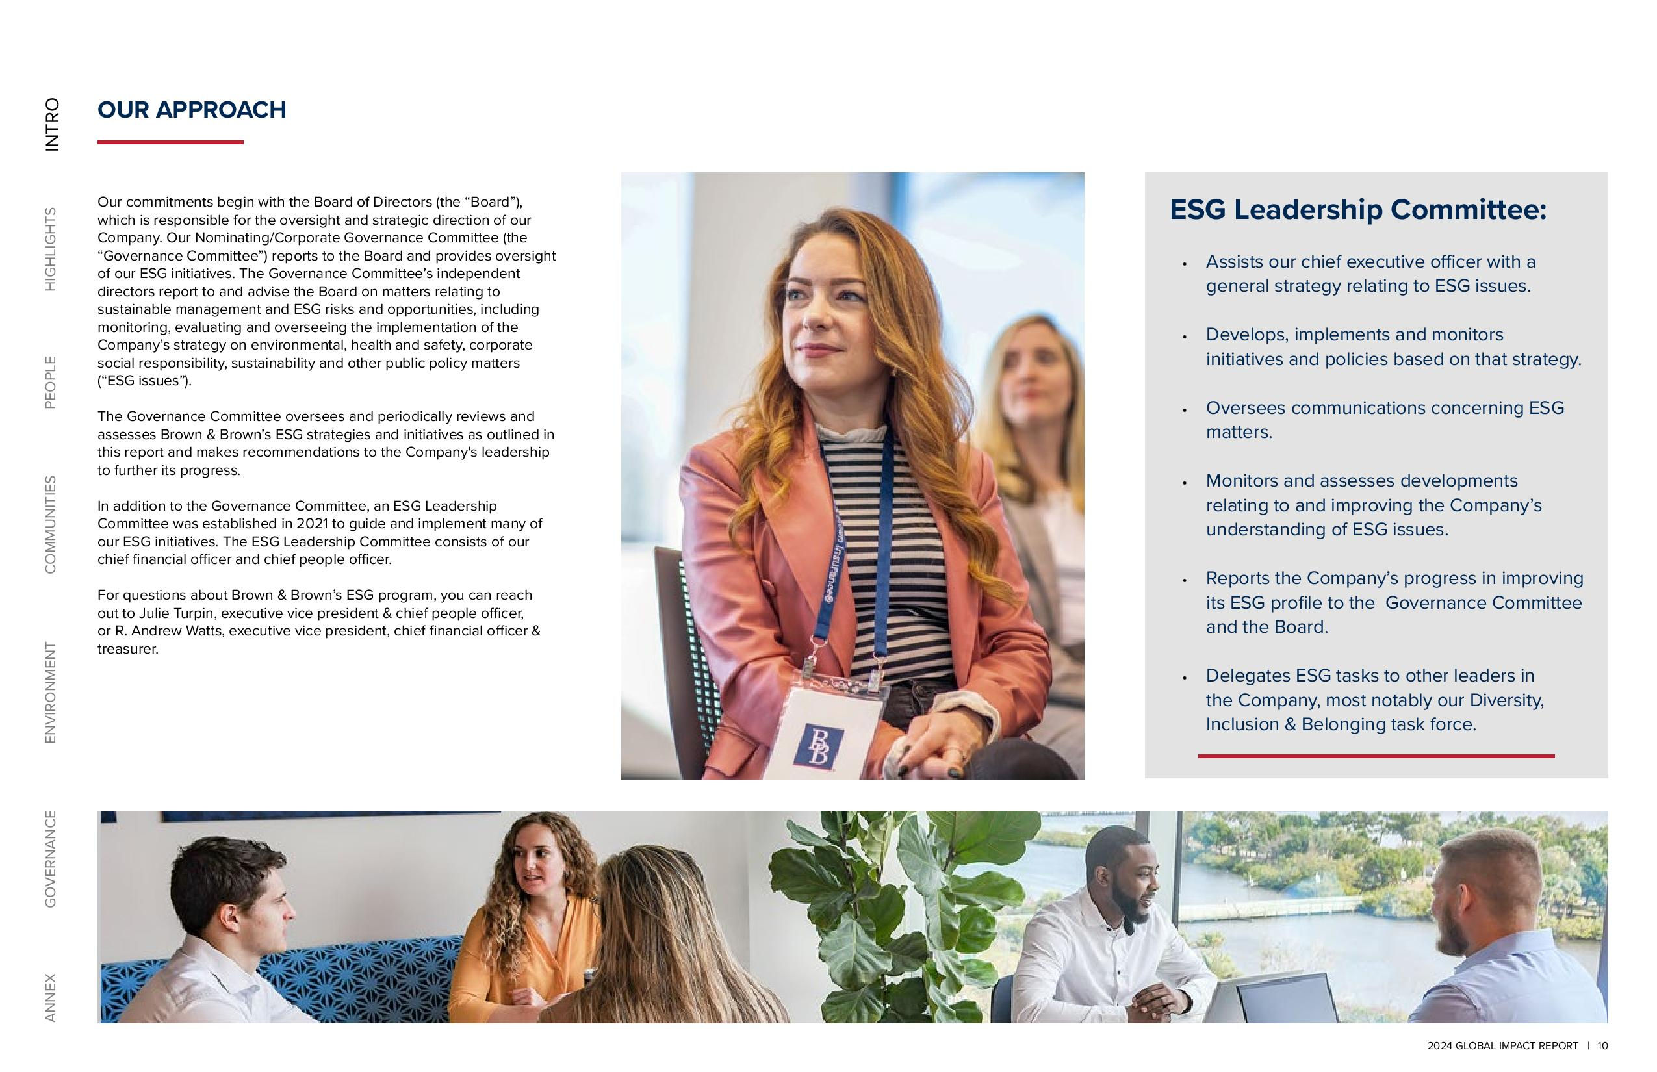
ANNEX GOVERNANCE ENVIRONMENT COMMUNITIES PEOPLE HIGHLIGHTS INTRO OUR APPROACH Our commitments begin with the Board of Directors (the “Board”), which is responsible for the oversight and strategic direction of our Company. Our Nominating/Corporate Governance Committee (the “Governance Committee”) reports to the Board and provides oversight of our ESG initiatives. The Governance Committee’s independent directors report to and advise the Board on matters relating to sustainable management and ESG risks and opportunities, including monitoring, evaluating and overseeing the implementation of the Company’s strategy on environmental, health and safety, corporate social responsibility, sustainability and other public policy matters (“ESG issues”). The Governance Committee oversees and periodically reviews and assesses Brown & Brown’s ESG strategies and initiatives as outlined in this report and makes recommendations to the Company's leadership to further its progress. In addition to the Governance Committee, an ESG Leadership Committee was established in 2021 to guide and implement many of our ESG initiatives. The ESG Leadership Committee consists of our chief financial officer and chief people officer. For questions about Brown & Brown’s ESG program, you can reach out to Julie Turpin, executive vice president & chief people officer, or R. Andrew Watts, executive vice president, chief financial officer & treasurer. ESG Leadership Committee: Assists our chief executive officer with a general strategy relating to ESG issues. Develops, implements and monitors initiatives and policies based on that strategy. Oversees communications concerning ESG matters. Monitors and assesses developments relating to and improving the Company’s understanding of ESG issues. Reports the Company’s progress in improving its ESG profile to the Governance Committee and the Board. Delegates ESG tasks to other leaders in the Company, most notably our Diversity, Inclusion & Belonging task force. 2024 GLOBAL IMPACT REPORT 10

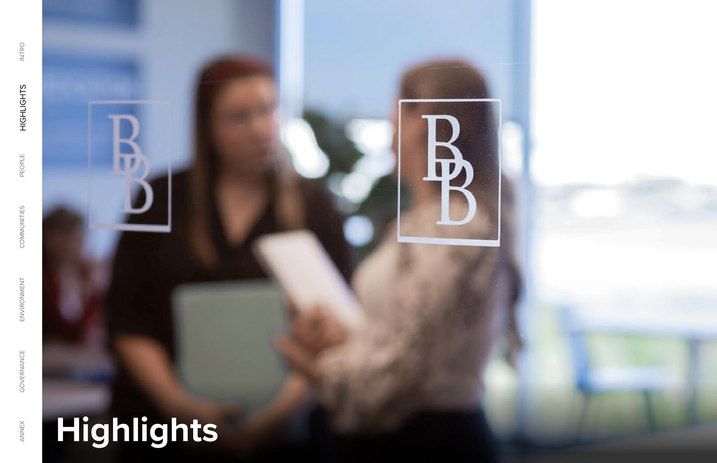
Highlights Governance Environment Communities Communities Highlights Intro Annex

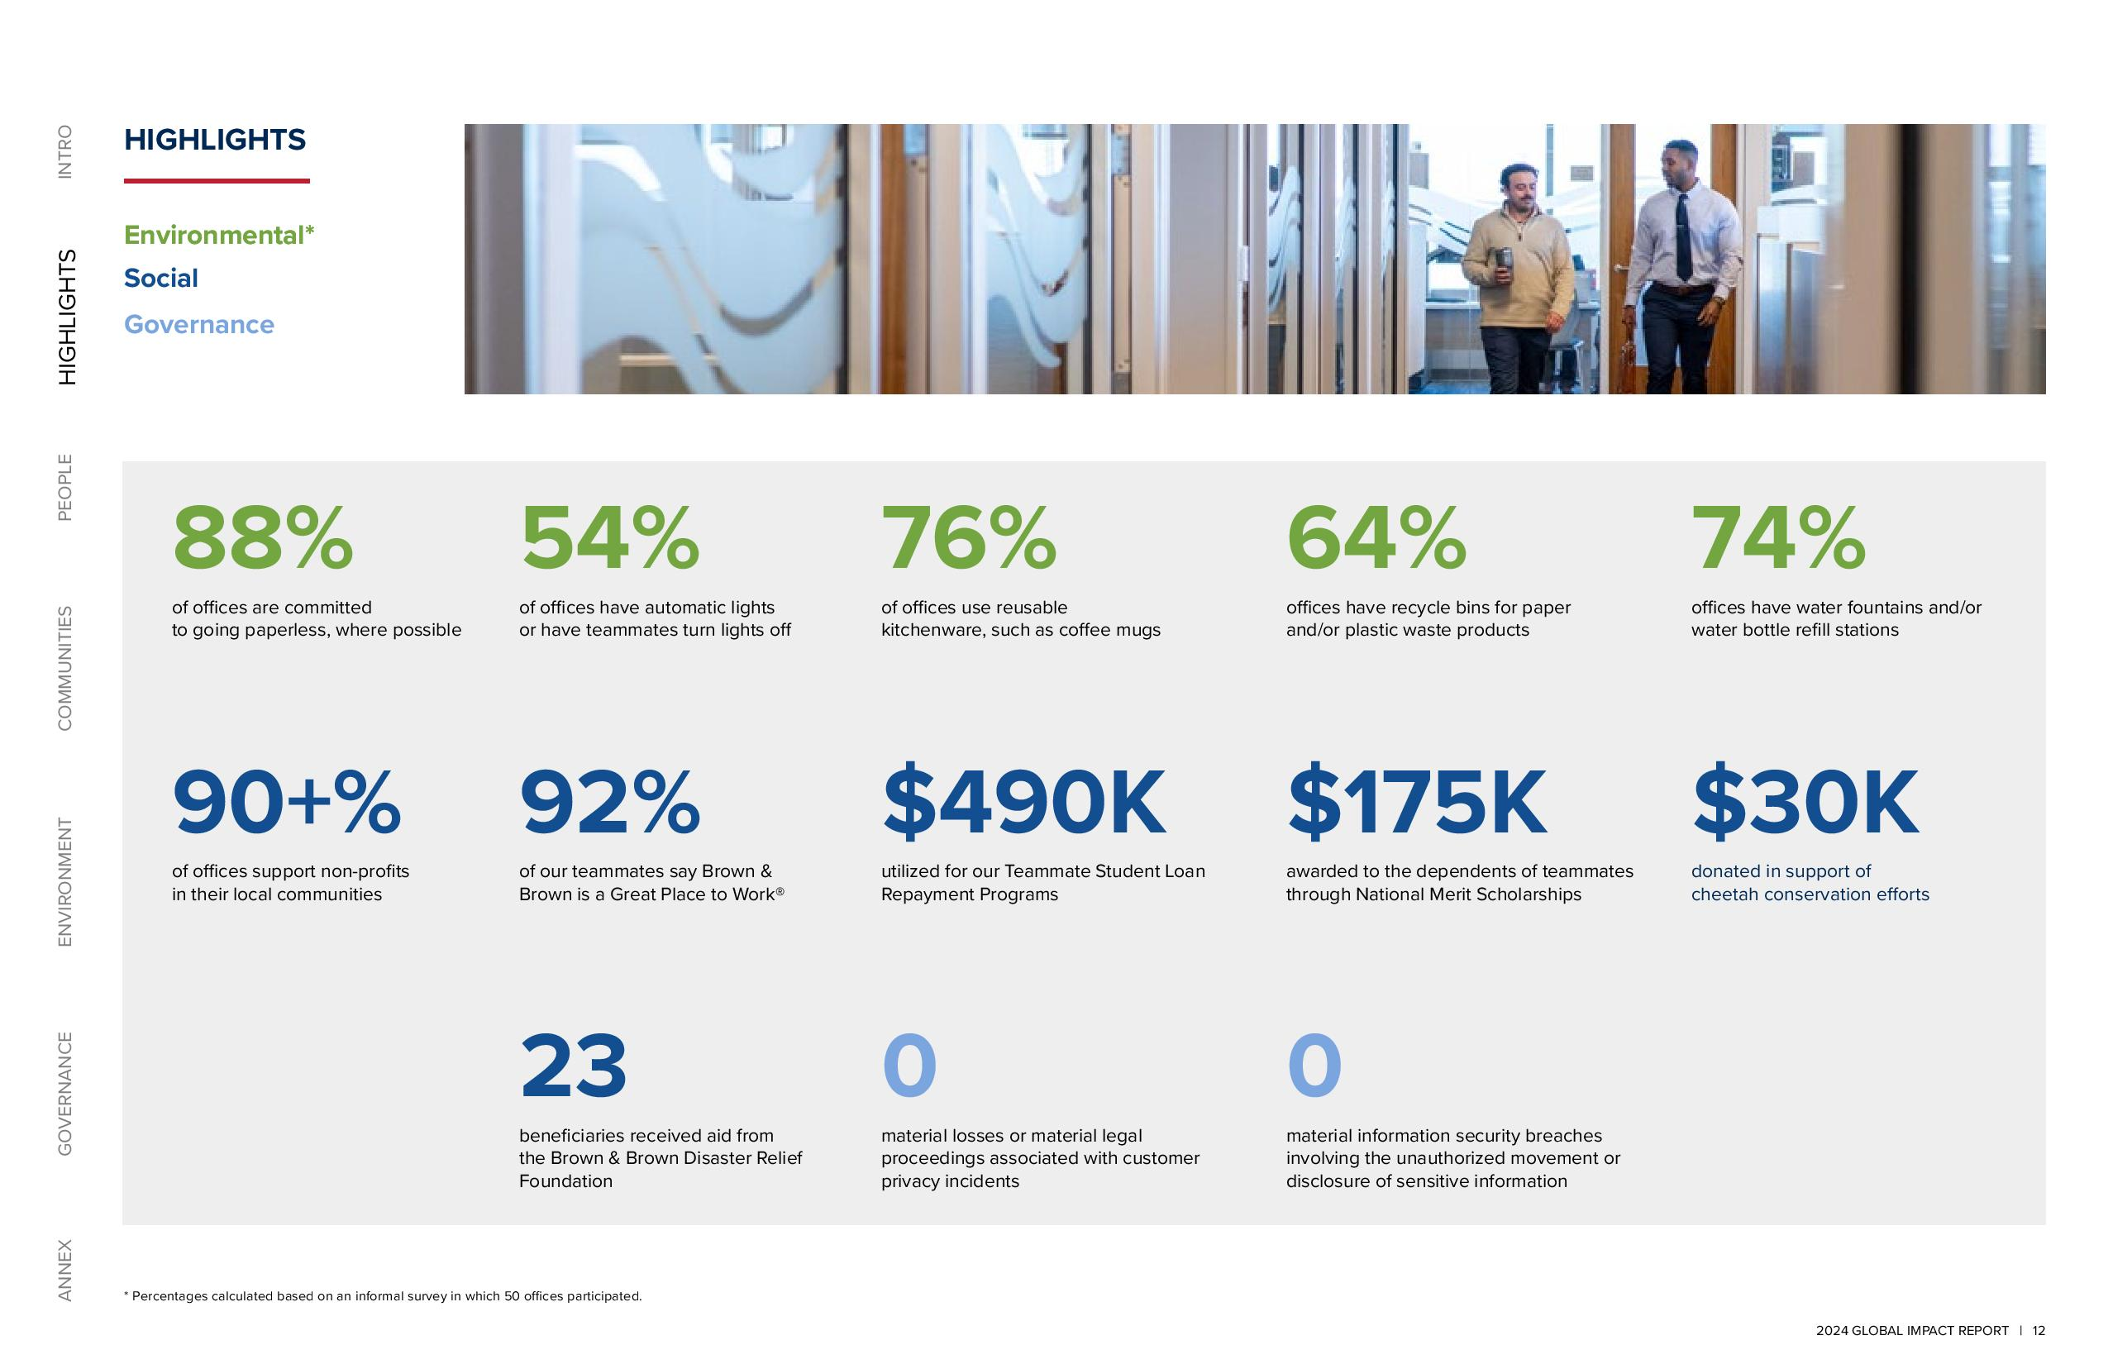
Environmental Social Governance 88% Of Offices Are Committed To Going Paperless, Where Possible 90+% Of Offices Support Non-Profits In Their Local Communities Of Offices Have Automatic Lights Or Have Teammates Turn Lights Off 92% Of Our Teammates Say Brown & Brown Is A Great Place To Work® 23 Beneficiaries Received Aid From The Brown & Brown Disaster Relief Foundation Of Offices Use Reusable Kitchenware, Such As Coffee Mugs $490K Utilized For Our Teammate Student Loan Repayment Programs 0 Material Losses Or Material Legal Proceedings Associated With Customer Privacy Incidents Offices Have Recycle Bins For Paper And/Or Plastic Waste Products $175K Awarded To The Dependents Of Teammates Through National Merit Scholarships 0 Material Information Security Breaches Involving The Unauthorized Movement Or Disclosure Of Sensitive Information 74% Offices Have Water Fountains And/Or Water Bottle Refill Stations $30K Donated In Support Of Cheetah Conservation Efforts * Percentages Calculated Based On An Informal Survey In Which 50 Offices Participated 2024 GLOBAL IMPACT REPORT 12

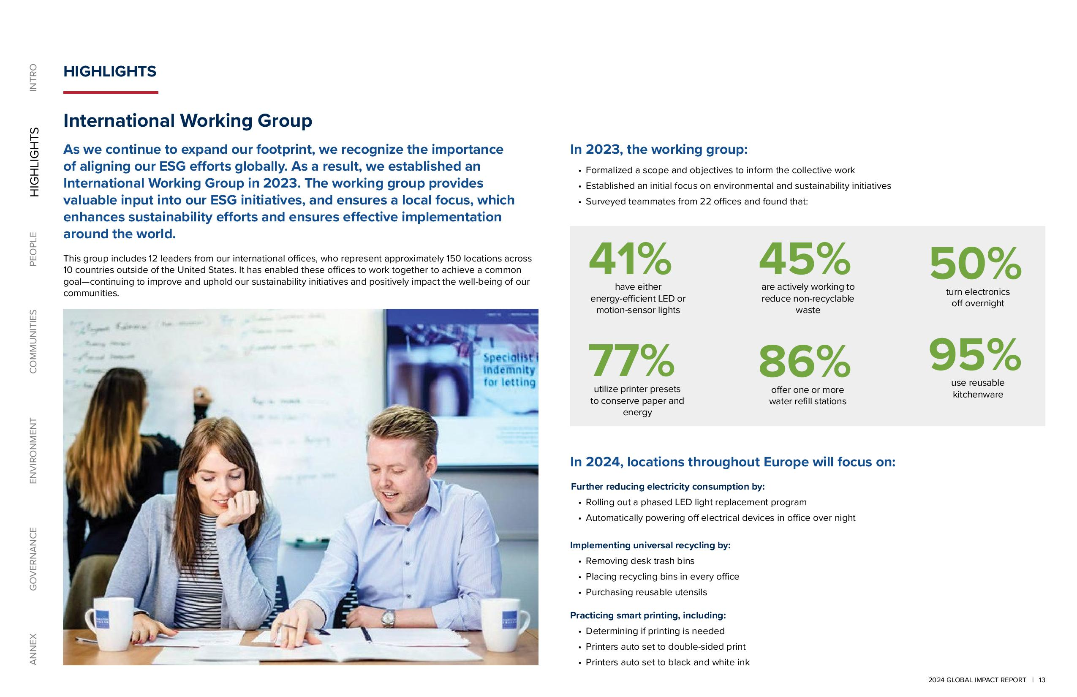
2024 GLOBAL IMPACT REPORT 13 ANNEX GOVERNANCE ENVIRONMENT COMMUNITIES PEOPLE HIGHLIGHTS INTRO As We Continue To Expand Our Footprint, We Recognize The Importance Of Aligning Our ESG Efforts Globally. As A Result, We Established An International Working Group In 2023. The Working Group Provides Valuable Input Into Our ESG Initiatives, And Ensures A Local Focus, Which Enhances Sustainability Efforts And Ensures Effective Implementation Around The World. This Group Includes 12 Leaders From Our International Offices, Who Represent Approximately 150 Locations Across 10 Countries Outside Of The United States. It Has Enabled These Offices To Work Together To Achieve A Common Goal Continuing To Improve And Uphold Our Sustainability Initiatives And Positively Impact The Well-Being Of Our Communities. HIGHLIGHTS International Working Group In 2023, The Working Group Formalized A Scope And Objectives To Inform The Collective Work Established An Initial Focus On Environmental And Sustainability Initiatives Surveyed Teammates From 22 Offices And Found That In 2024, Locations Throughout Europe Will Focus On Further Reducing Electricity Consumption By Rolling Out A Phased LED Light Replacement Program Automatically Powering Off Electrical Devices In Office Over Night Implementing Universal Recycling By Removing Desk Trash Bins Placing Recycling Bins In Every Office Purchasing Reusable Utensils Practicing Smart Printing, Including Determining If Printing Is Needed Printers Auto Set To Double-Sided Print Printers Auto Set To Black And White Ink 41% Have Either Energy-Efficient LED Or Motion-Sensor Lights 95% Use Reusable Kitchenware 86% Offer One Or More Water Refill Stations 50% Turn Electronics Off Overnight 45% Are Actively Working To Reduce Non-Recyclable Waste 77% Utilize Printer Presets To Conserve Paper And Energy

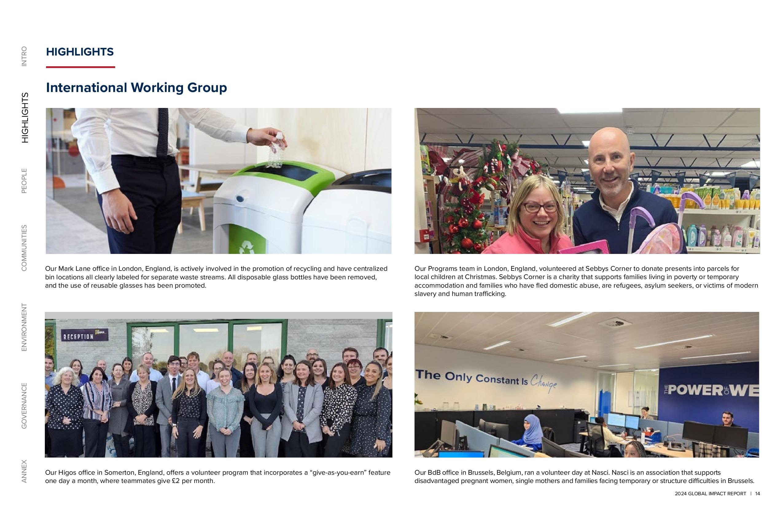
2024 GLOBAL IMPACT REPORT 14 ANNEX GOVERNANCE ENVIRONMENT COMMUNITIES PEOPLE HIGHLIGHTS INTRO Our BdB office in Brussels, Belgium, ran a volunteer day at Nasci. Nasci is an association that supports disadvantaged pregnant women, single mothers and families facing temporary or structure difficulties in Brussels. Our Higos office in Somerton, England, offers a volunteer program that incorporates a “give-as-you-earn” feature one day a month, where teammates give £2 per month. Our Programs team in London, England, volunteered at Sebbys Corner to donate presents into parcels for local children at Christmas. Sebbys Corner is a charity that supports families living in poverty or temporary accommodation and families who have fled domestic abuse, are refugees, asylum seekers, or victims of modern slavery and human trafficking. Our Mark Lane office in London, England, is actively involved in the promotion of recycling and have centralized bin locations all clearly labeled for separate waste streams. All disposable glass bottles have been removed, and the use of reusable glasses has been promoted. HIGHLIGHTS International Working Group

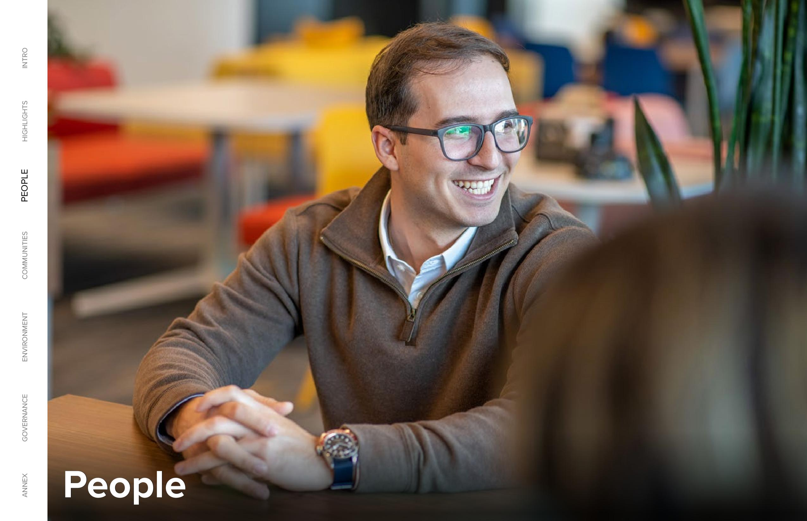

2024 Global Impact Report 15 Annex Governance Environment Communities People Highlights Intro People

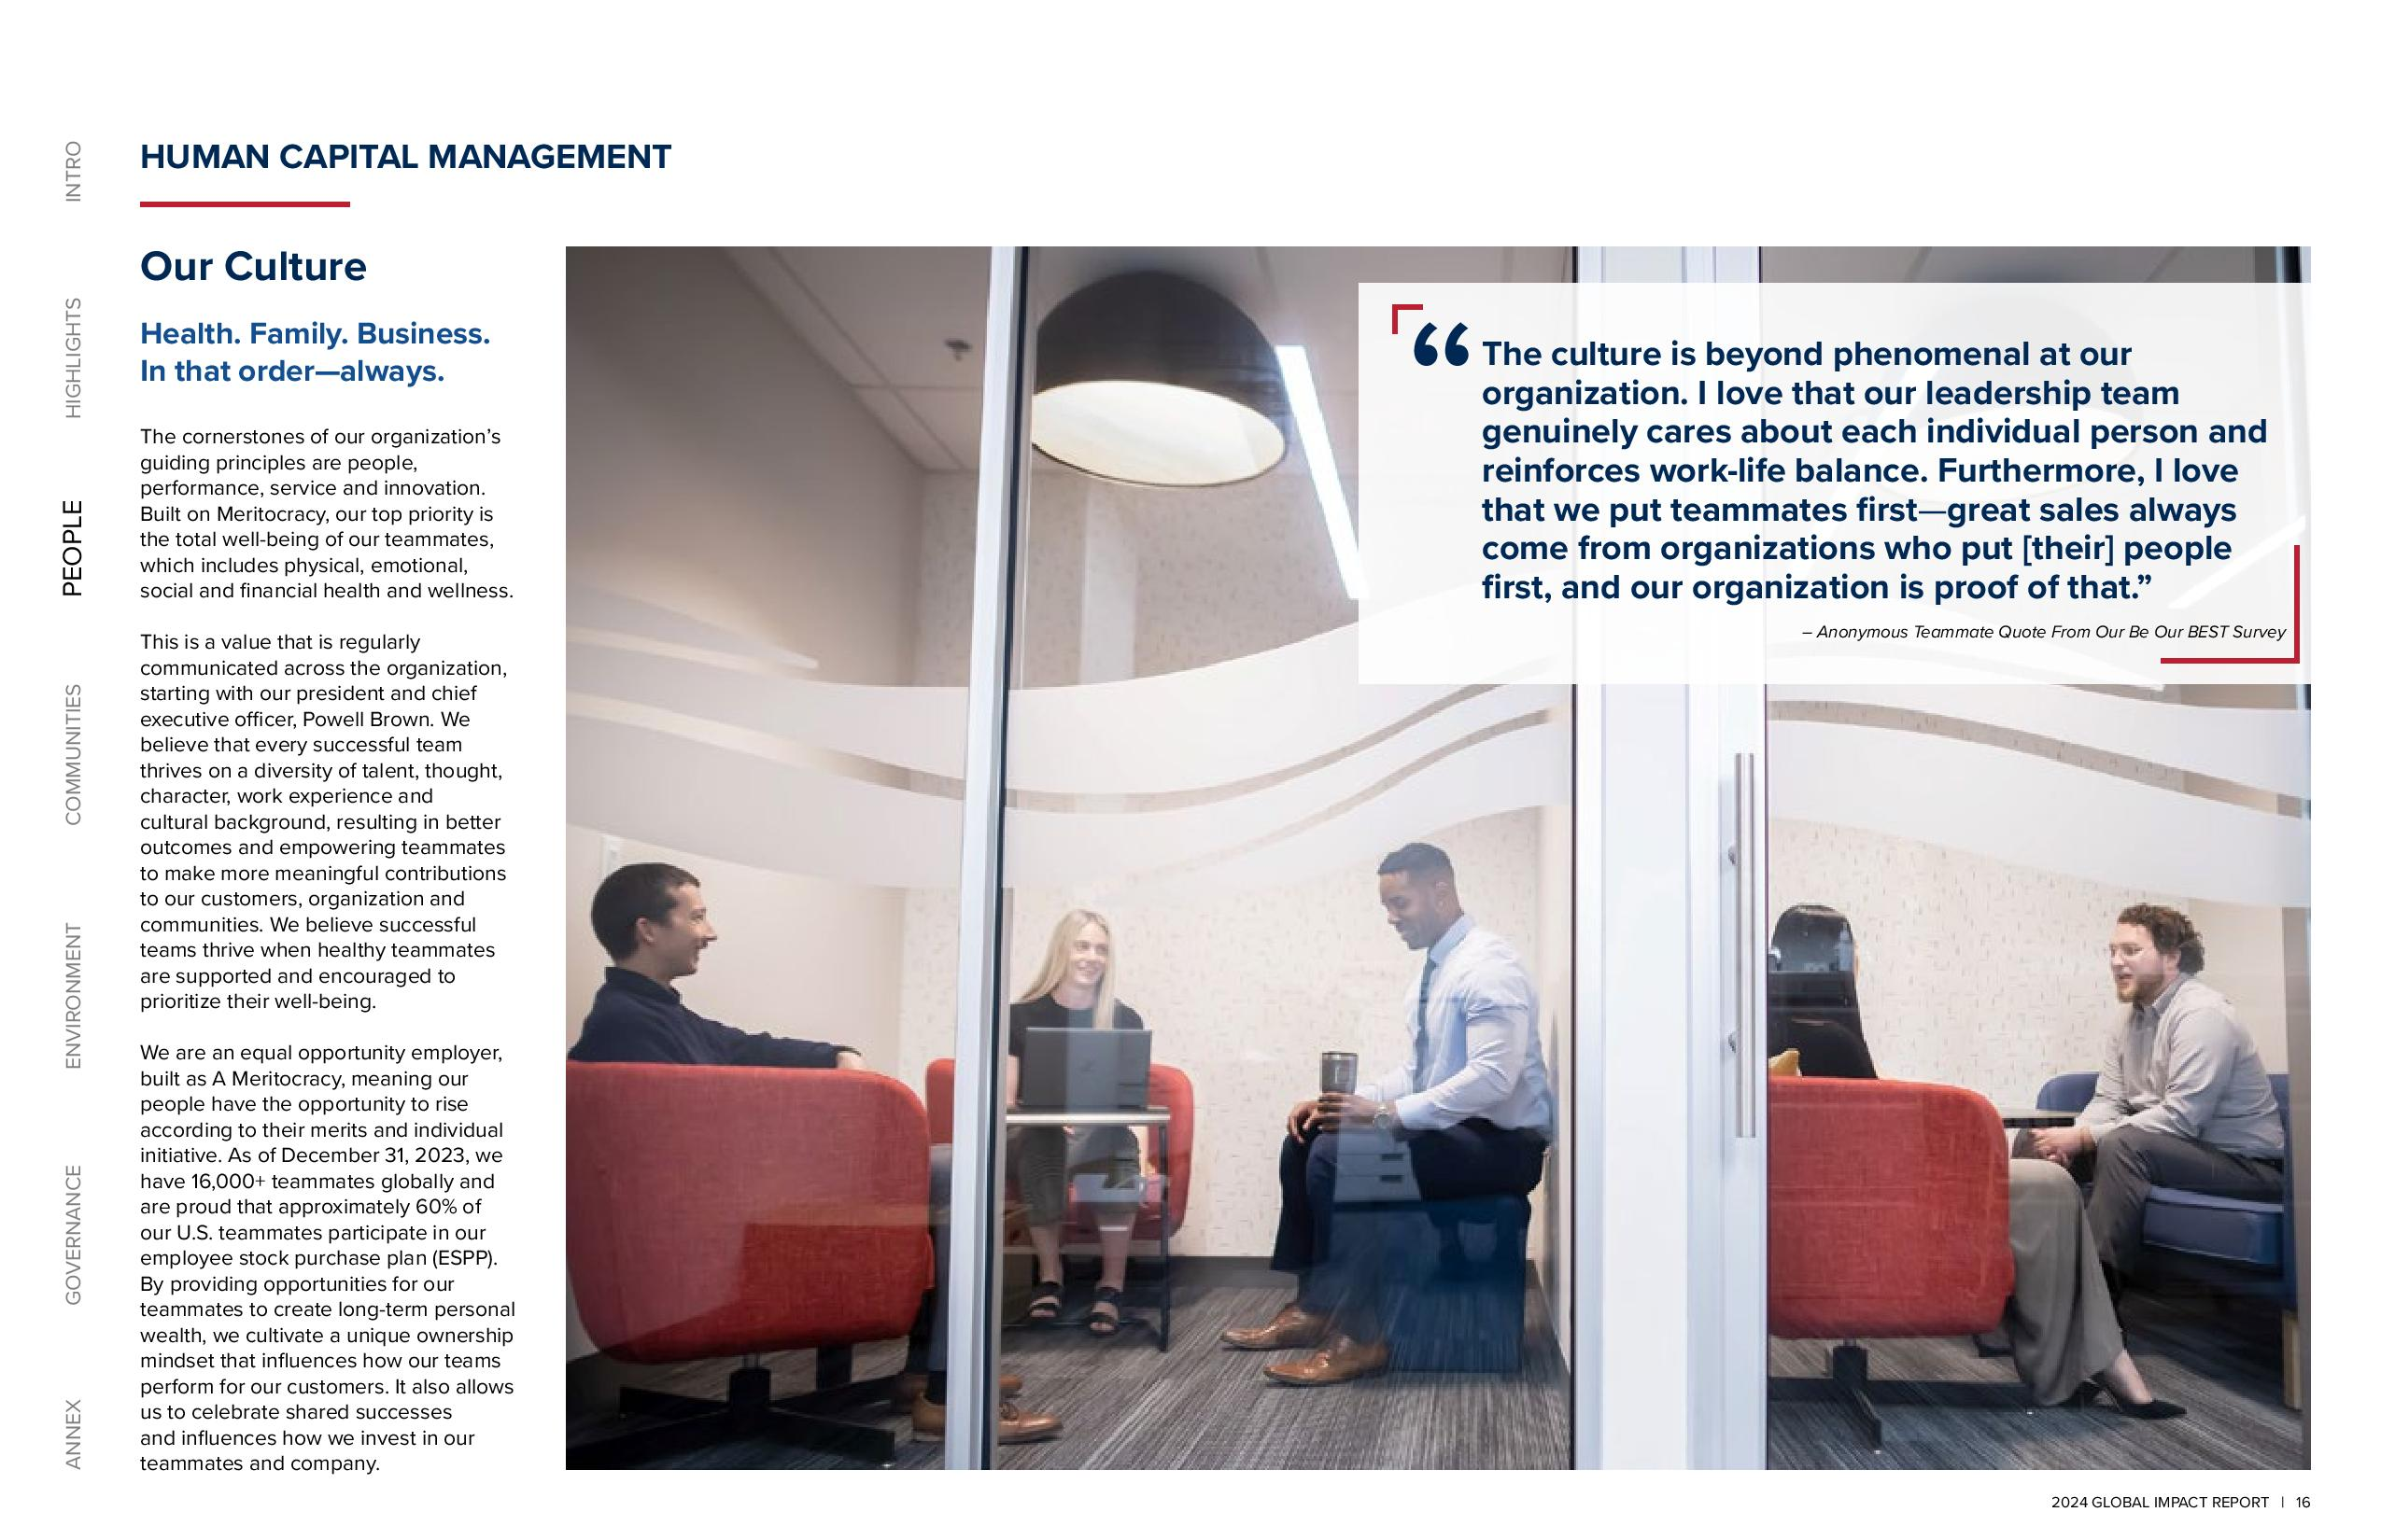

2024 GLOBAL IMPACT REPORT 16 ANNEX GOVERNANCE ENVIRONMENT COMMUNITIES PEOPLE HIGHLIGHTS INTRO Our Culture Health. Family. Business. In that order always. The cornerstones of our organization’s guiding principles are people, performance, service and innovation. Built on Meritocracy, our top priority is the total well-being of our teammates, which includes physical, emotional, social and financial health and wellness. This is a value that is regularly communicated across the organization, starting with our president and chief executive officer, Powell Brown. We believe that every successful team thrives on a diversity of talent, thought, character, work experience and cultural background, resulting in better outcomes and empowering teammates to make more meaningful contributions to our customers, organization and communities. We believe successful teams thrive when healthy teammates are supported and encouraged to prioritize their well-being. We are an equal opportunity employer, built as A Meritocracy, meaning our people have the opportunity to rise according to their merits and individual initiative. As of December 31, 2023, we have 16,000+ teammates globally and are proud that approximately 60% of our U.S. teammates participate in our employee stock purchase plan (ESPP). By providing opportunities for our teammates to create long-term personal wealth, we cultivate a unique ownership mindset that influences how our teams perform for our customers. It also allows us to celebrate shared successes and influences how we invest in our teammates and company. HUMAN CAPITAL MANAGEMENT The culture is beyond phenomenal at our organization. I love that our leadership team genuinely cares about each individual person and reinforces work-life balance. Furthermore, I love that we put teammates first great sales always come from organizations who put [their] people first, and our organization is proof of that Anonymous Teammate Quote From Our Be Our BEST Survey

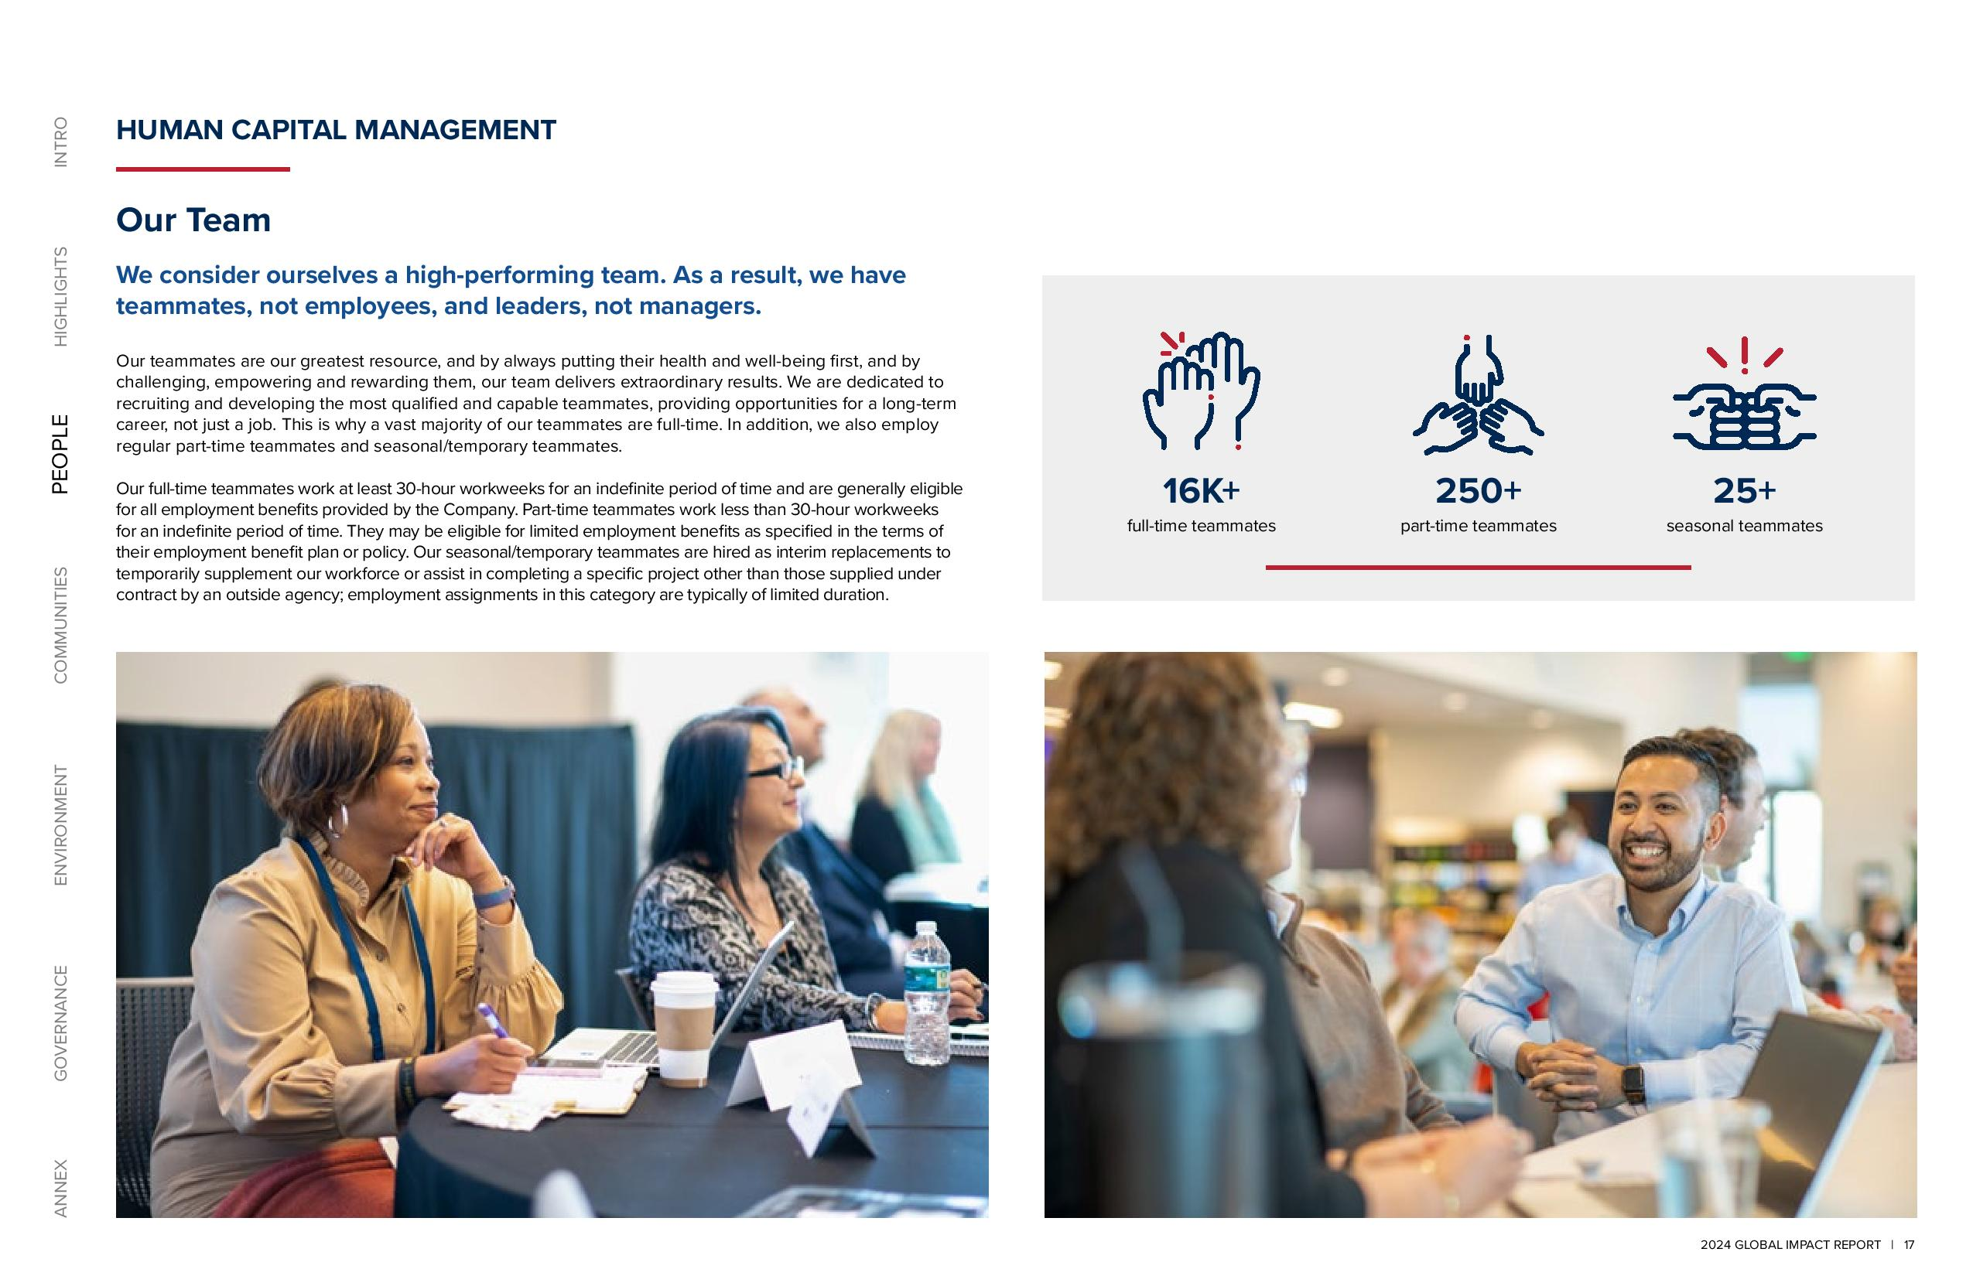

2024 GLOBAL IMPACT REPORT 17 ANNEX GOVERNANCE ENVIRONMENT COMMUNITIES PEOPLE HIGHLIGHTS INTRO HUMAN CAPITAL MANAGEMENT Our Team We consider ourselves a high-performing team. As a result, we have teammates, not employees, and leaders, not managers. Our teammates are our greatest resource, and by always putting their health and well-being first, and by challenging, empowering and rewarding them, our team delivers extraordinary results. We are dedicated to recruiting and developing the most qualified and capable teammates, providing opportunities for a long-term career, not just a job. This is why a vast majority of our teammates are full-time. In addition, we also employ regular part-time teammates and seasonal/temporary teammates. Our full-time teammates work at least 30-hour workweeks for an indefinite period of time and are generally eligible for all employment benefits provided by the Company. Part-time teammates work less than 30-hour workweeks for an indefinite period of time. They may be eligible for limited employment benefits as specified in the terms of their employment benefit plan or policy. Our seasonal/temporary teammates are hired as interim replacements to temporarily supplement our workforce or assist in completing a specific project other than those supplied under contract by an outside agency; employment assignments in this category are typically of limited duration. 16K+ full-time teammates 250+ part-time teammates 25+ seasonal teammates

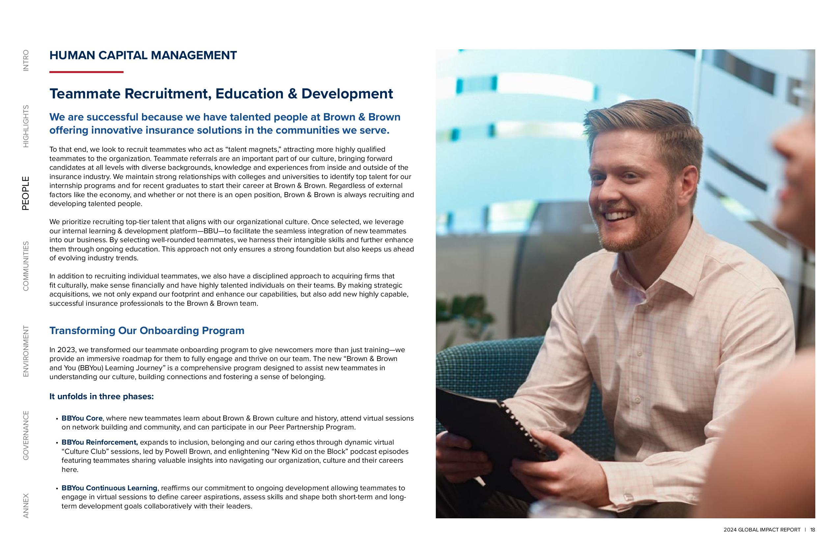

2024 GLOBAL IMPACT REPORT 18 ANNEX GOVERNANCE ENVIRONMENT COMMUNITIES PEOPLE HIGHLIGHTS INTRO HUMAN CAPITAL MANAGEMENT Teammate Recruitment, Education & Development We are successful because we have talented people at Brown & Brown offering innovative insurance solutions in the communities we serve. To that end, we look to recruit teammates who act as “talent magnets,” attracting more highly qualified teammates to the organization. Teammate referrals are an important part of our culture, bringing forward candidates at all levels with diverse backgrounds, knowledge and experiences from inside and outside of the insurance industry. We maintain strong relationships with colleges and universities to identify top talent for our internship programs and for recent graduates to start their career at Brown & Brown. Regardless of external factors like the economy, and whether or not there is an open position, Brown & Brown is always recruiting and developing talented people. We prioritize recruiting top-tier talent that aligns with our organizational culture. Once selected, we leverage our internal learning & development platform BBU to facilitate the seamless integration of new teammates into our business. By selecting well-rounded teammates, we harness their intangible skills and further enhance them through ongoing education. This approach not only ensures a strong foundation but also keeps us ahead of evolving industry trends. In addition to recruiting individual teammates, we also have a disciplined approach to acquiring firms that fit culturally, make sense financially and have highly talented individuals on their teams. By making strategic acquisitions, we not only expand our footprint and enhance our capabilities, but also add new highly capable, successful insurance professionals to the Brown & Brown team. Transforming Our Onboarding Program In 2023, we transformed our teammate onboarding program to give newcomers more than just training we provide an immersive roadmap for them to fully engage and thrive on our team. The new “Brown & Brown and You (BBYou) Learning Journey” is a comprehensive program designed to assist new teammates in understanding our culture, building connections and fostering a sense of belonging. It unfolds in three phases BB You Core, where new teammates learn about Brown & Brown culture and history, attend virtual sessions on network building and community, and can participate in our Peer Partnership Program. BBYou Reinforcement, expands to inclusion, belonging and our caring ethos through dynamic virtual “Culture Club” sessions, led by Powell Brown, and enlightening “New Kid on the Block” podcast episodes featuring teammates sharing valuable insights into navigating our organization, culture and their careers here. BB You Continuous Learning, reaffirms our commitment to ongoing development allowing teammates to engage in virtual sessions to define career aspirations, assess skills and shape both short-term and long term development goals collaboratively with their leaders.

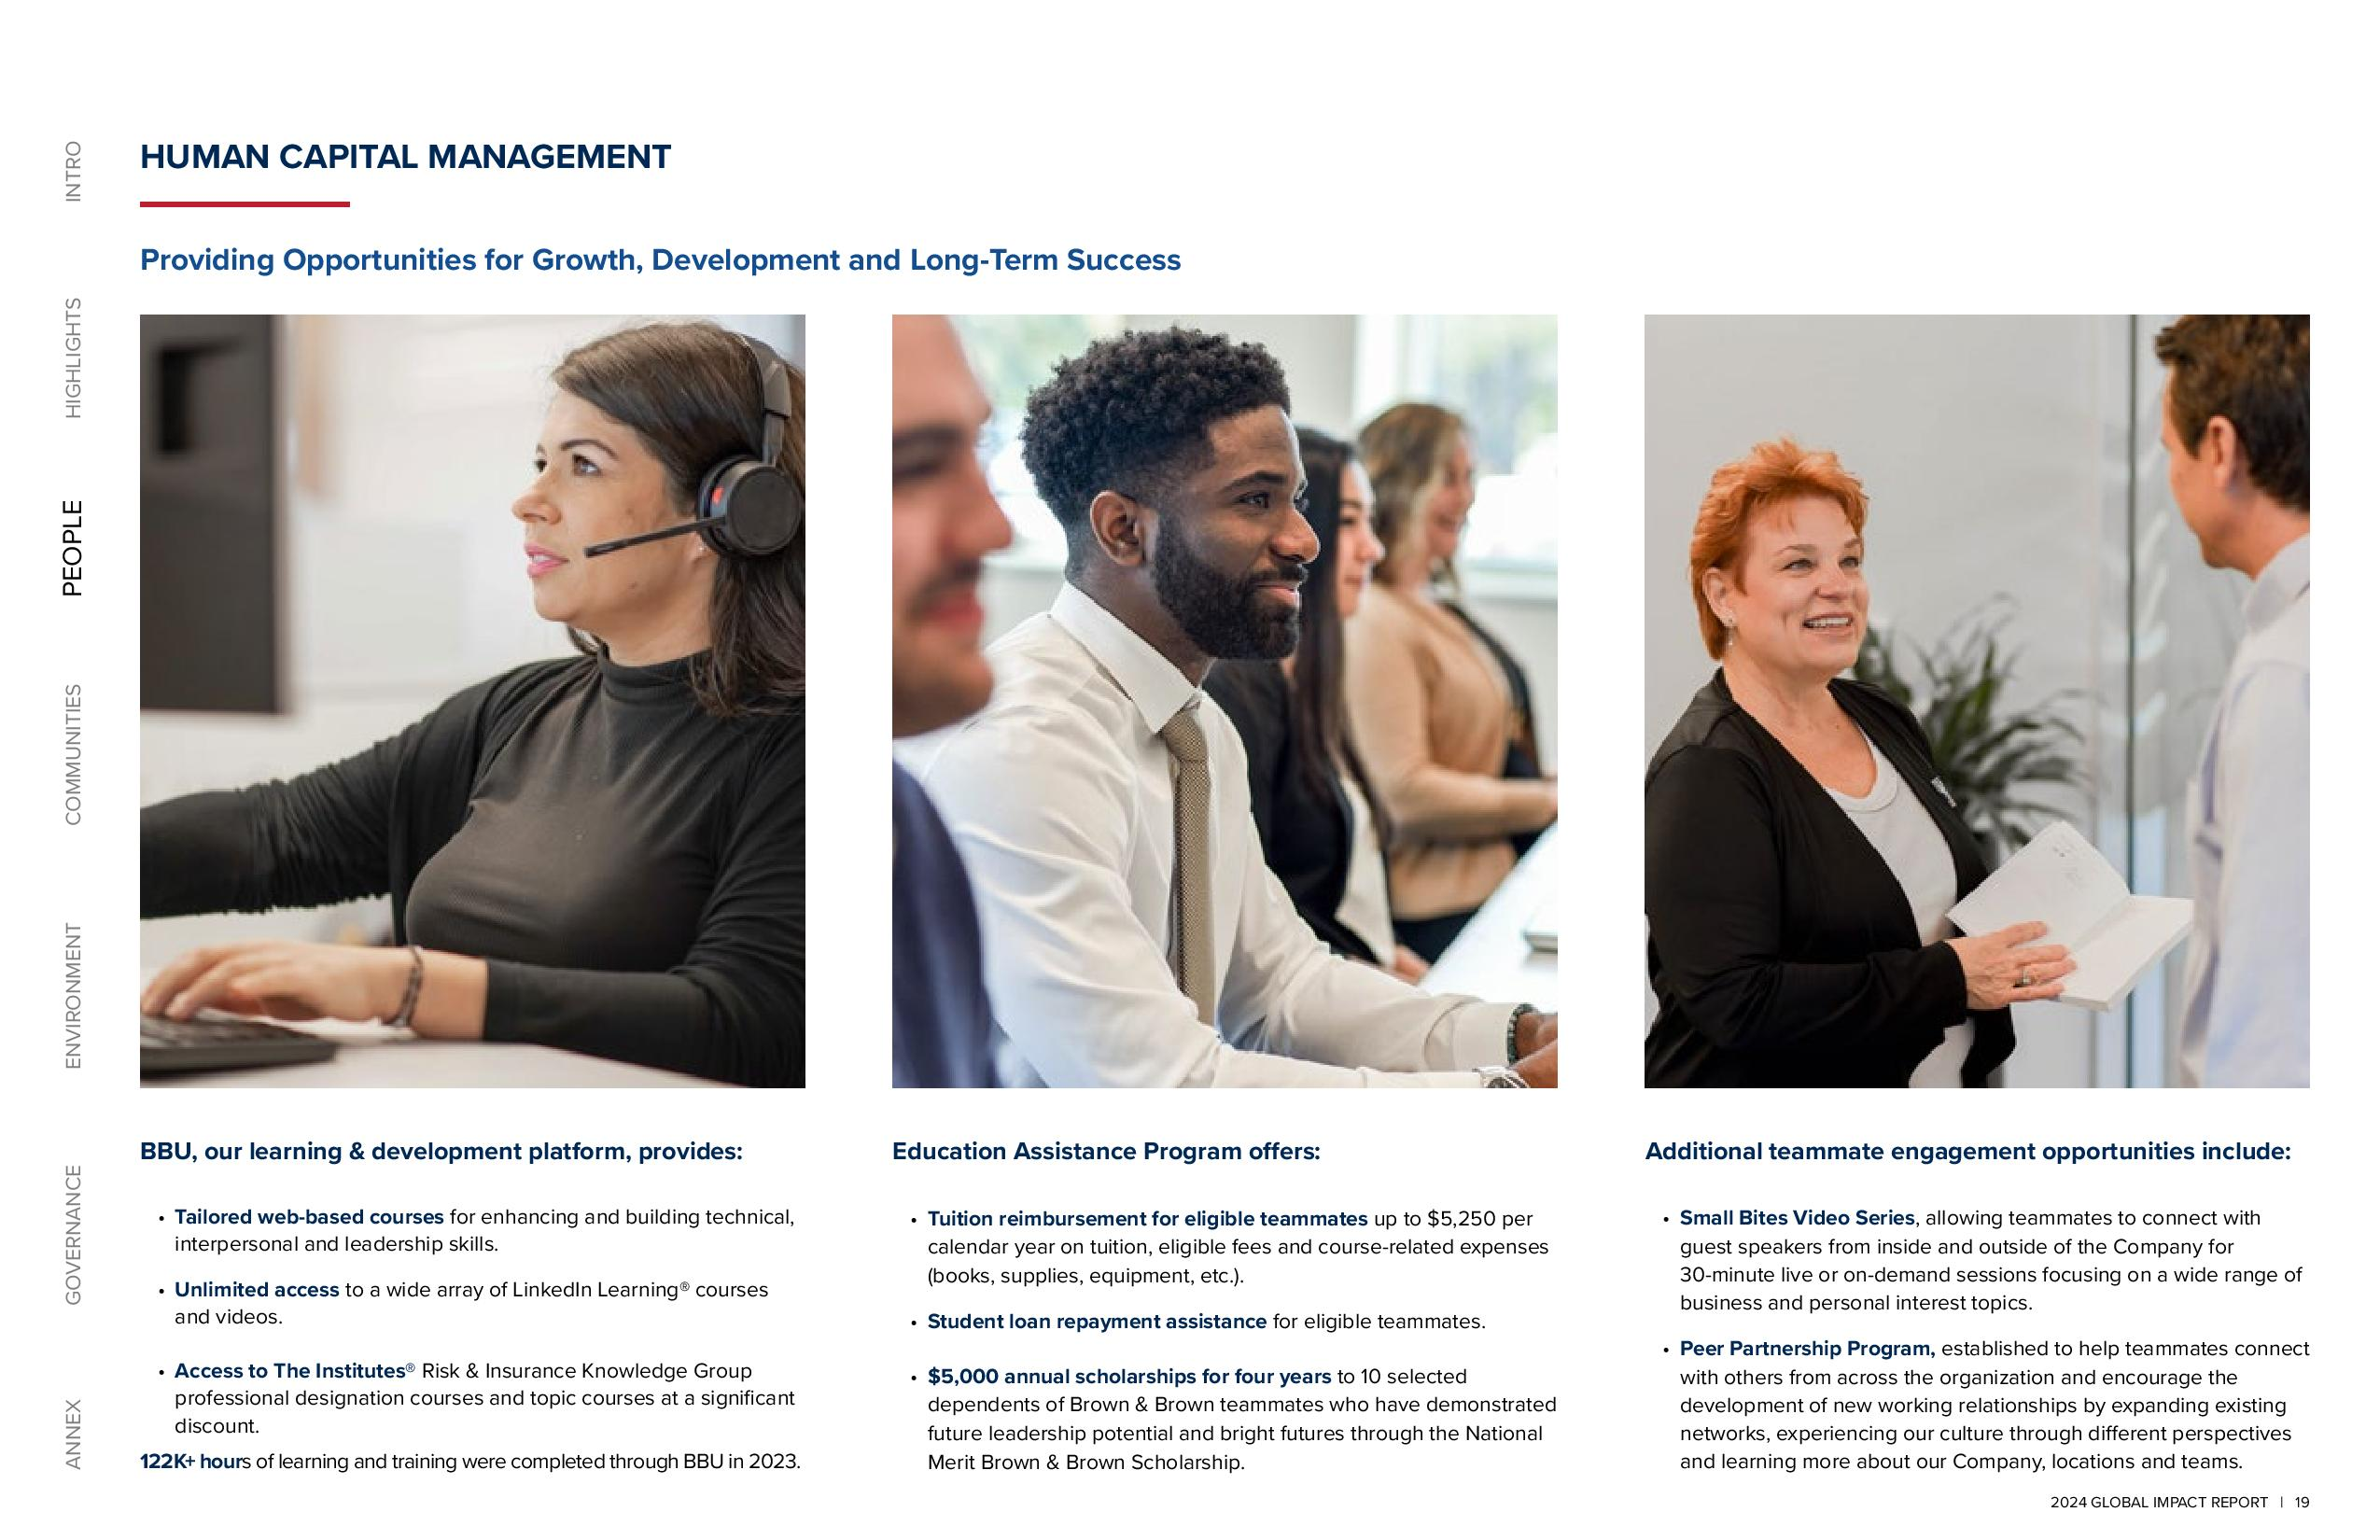

2024 GLOBAL IMPACT REPORT 19 ANNEX GOVERNANCE ENVIRONMENT COMMUNITIES PEOPLE HIGHLIGHTS INTRO HUMAN CAPITAL MANAGEMENT Providing Opportunities for Growth, Development and Long-Term Success BBU, our learning & development platform, provides Tailored web-based courses for enhancing and building technical, interpersonal and leadership skills. Unlimited access to a wide array of LinkedIn Learning® courses and videos. Access to The Institutes® Risk & Insurance Knowledge Group professional designation courses and topic courses at a significant discount. 122K+ hours of learning and training were completed through BBU in 2023. Education Assistance Program offers Tuition reimbursement for eligible teammates up to $5,250 per calendar year on tuition, eligible fees and course-related expenses (books, supplies, equipment, etc.). Student loan repayment assistance for eligible teammates. $5,000 annual scholarships for four years to 10 selected dependents of Brown & Brown teammates who have demonstrated future leadership potential and bright futures through the National Merit Brown & Brown Scholarship. Additional teammate engagement opportunities include Small Bites Video Series, allowing teammates to connect with guest speakers from inside and outside of the Company for 30-minute live or on-demand sessions focusing on a wide range of business and personal interest topics. Peer Partnership Program, established to help teammates connect with others from across the organization and encourage the development of new working relationships by expanding existing networks, experiencing our culture through different perspectives and learning more about our Company, locations and teams.

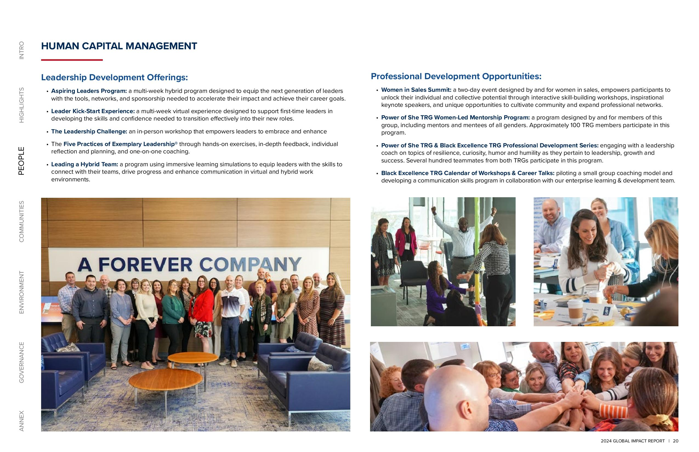

2024 GLOBAL IMPACT REPORT 20 ANNEX GOVERNANCE ENVIRONMENT COMMUNITIES PEOPLE HIGHLIGHTS INTRO HUMAN CAPITAL MANAGEMENT Leadership Development Offerings Aspiring Leaders Program: a multi-week hybrid program designed to equip the next generation of leaders with the tools, networks, and sponsorship needed to accelerate their impact and achieve their career goals. Leader Kick-Start Experience: a multi-week virtual experience designed to support first-time leaders in developing the skills and confidence needed to transition effectively into their new roles. The Leadership Challenge: an in-person workshop that empowers leaders to embrace and enhance The Five Practices of Exemplary Leadership® through hands-on exercises, in-depth feedback, individual reflection and planning, and one-on-one coaching. Leading a Hybrid Team: a program using immersive learning simulations to equip leaders with the skills to connect with their teams, drive progress and enhance communication in virtual and hybrid work environments. Professional Development Opportunities Women in Sales Summit: a two-day event designed by and for women in sales, empowers participants to unlock their individual and collective potential through interactive skill-building workshops, inspirational keynote speakers, and unique opportunities to cultivate community and expand professional networks. Power of She TRG Women-Led Mentorship Program: a program designed by and for members of this group, including mentors and mentees of all genders. Approximately 100 TRG members participate in this program. Power of She TRG & Black Excellence TRG Professional Development Series: engaging with a leadership coach on topics of resilience, curiosity, humor and humility as they pertain to leadership, growth and success. Several hundred teammates from both TRGs participate in this program. Black Excellence TRG Calendar of Workshops & Career Talks: piloting a small group coaching model and developing a communication skills program in collaboration with our enterprise learning & development team.

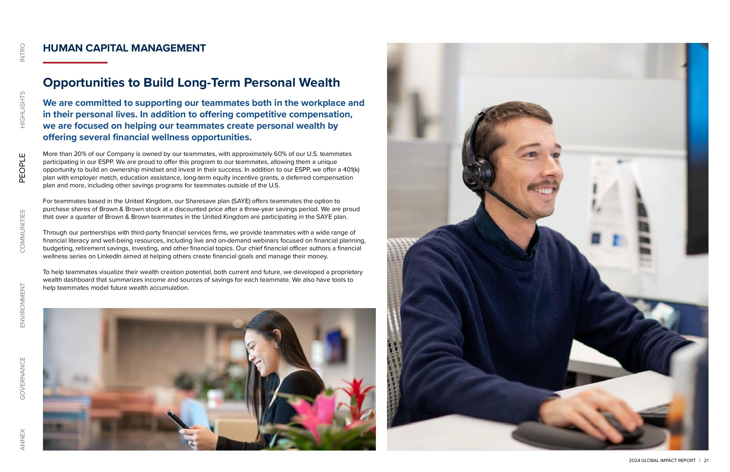

2024 GLOBAL IMPACT REPORT 21 ANNEX GOVERNANCE ENVIRONMENT COMMUNITIES PEOPLE HIGHLIGHTS INTRO HUMAN CAPITAL MANAGEMENT Opportunities to Build Long-Term Personal Wealth We are committed to supporting our teammates both in the workplace and in their personal lives. In addition to offering competitive compensation, we are focused on helping our teammates create personal wealth by offering several financial wellness opportunities. More than 20% of our Company is owned by our teammates, with approximately 60% of our U.S. teammates participating in our ESPP. We are proud to offer this program to our teammates, allowing them a unique opportunity to build an ownership mindset and invest in their success. In addition to our ESPP, we offer a 401(k) plan with employer match, education assistance, long-term equity incentive grants, a deferred compensation plan and more, including other savings programs for teammates outside of the U.S. For teammates based in the United Kingdom, our Sharesave plan (SAYE) offers teammates the option to purchase shares of Brown & Brown stock at a discounted price after a three-year savings period. We are proud that over a quarter of Brown & Brown teammates in the United Kingdom are participating in the SAYE plan. Through our partnerships with third-party financial services firms, we provide teammates with a wide range of financial literacy and well-being resources, including live and on-demand webinars focused on financial planning, budgeting, retirement savings, investing, and other financial topics. Our chief financial officer authors a financial wellness series on LinkedIn aimed at helping others create financial goals and manage their money. To help teammates visualize their wealth creation potential, both current and future, we developed a proprietary wealth dashboard that summarizes income and sources of savings for each teammate. We also have tools to help teammates model future wealth accumulation.

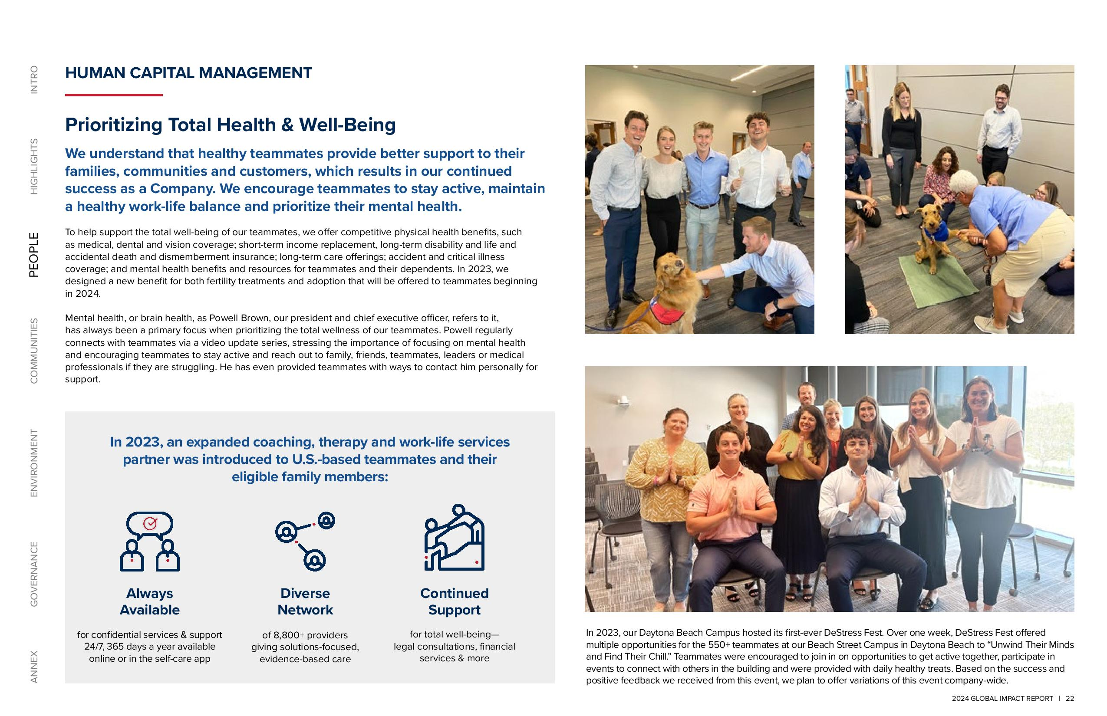

2024 GLOBAL IMPACT REPORT 22 ANNEX GOVERNANCE ENVIRONMENT COMMUNITIES PEOPLE HIGHLIGHTS INTRO HUMAN CAPITAL MANAGEMENT Prioritizing Total Health & Well-Being We understand that healthy teammates provide better support to their families, communities and customers, which results in our continued success as a Company. We encourage teammates to stay active, maintain a healthy work-life balance and prioritize their mental health. To help support the total well-being of our teammates, we offer competitive physical health benefits, such as medical, dental and vision coverage; short-term income replacement, long-term disability and life and accidental death and dismemberment insurance; long-term care offerings; accident and critical illness coverage; and mental health benefits and resources for teammates and their dependents. In 2023, we designed a new benefit for both fertility treatments and adoption that will be offered to teammates beginning in 2024. Mental health, or brain health, as Powell Brown, our president and chief executive officer, refers to it, has always been a primary focus when prioritizing the total wellness of our teammates. Powell regularly connects with teammates via a video update series, stressing the importance of focusing on mental health and encouraging teammates to stay active and reach out to family, friends, teammates, leaders or medical professionals if they are struggling. He has even provided teammates with ways to contact him personally for support. In 2023, an expanded coaching, therapy and work-life services partner was introduced to U.S.-based teammates and their eligible family members for confidential services & support 24/7, 365 days a year available online or in the self-care app of 8,800+ providers giving solutions-focused, evidence-based care for total well-being legal consultations, financial services & more Always Available Diverse Network Continued Support In 2023, our Daytona Beach Campus hosted its first-ever DeStress Fest. Over one week, DeStress Fest offered multiple opportunities for the 550+ teammates at our Beach Street Campus in Daytona Beach to “Unwind Their Minds and Find Their Chill.” Teammates were encouraged to join in on opportunities to get active together, participate in events to connect with others in the building and were provided with daily healthy treats. Based on the success and positive feedback we received from this event, we plan to offer variations of this event company-wide.

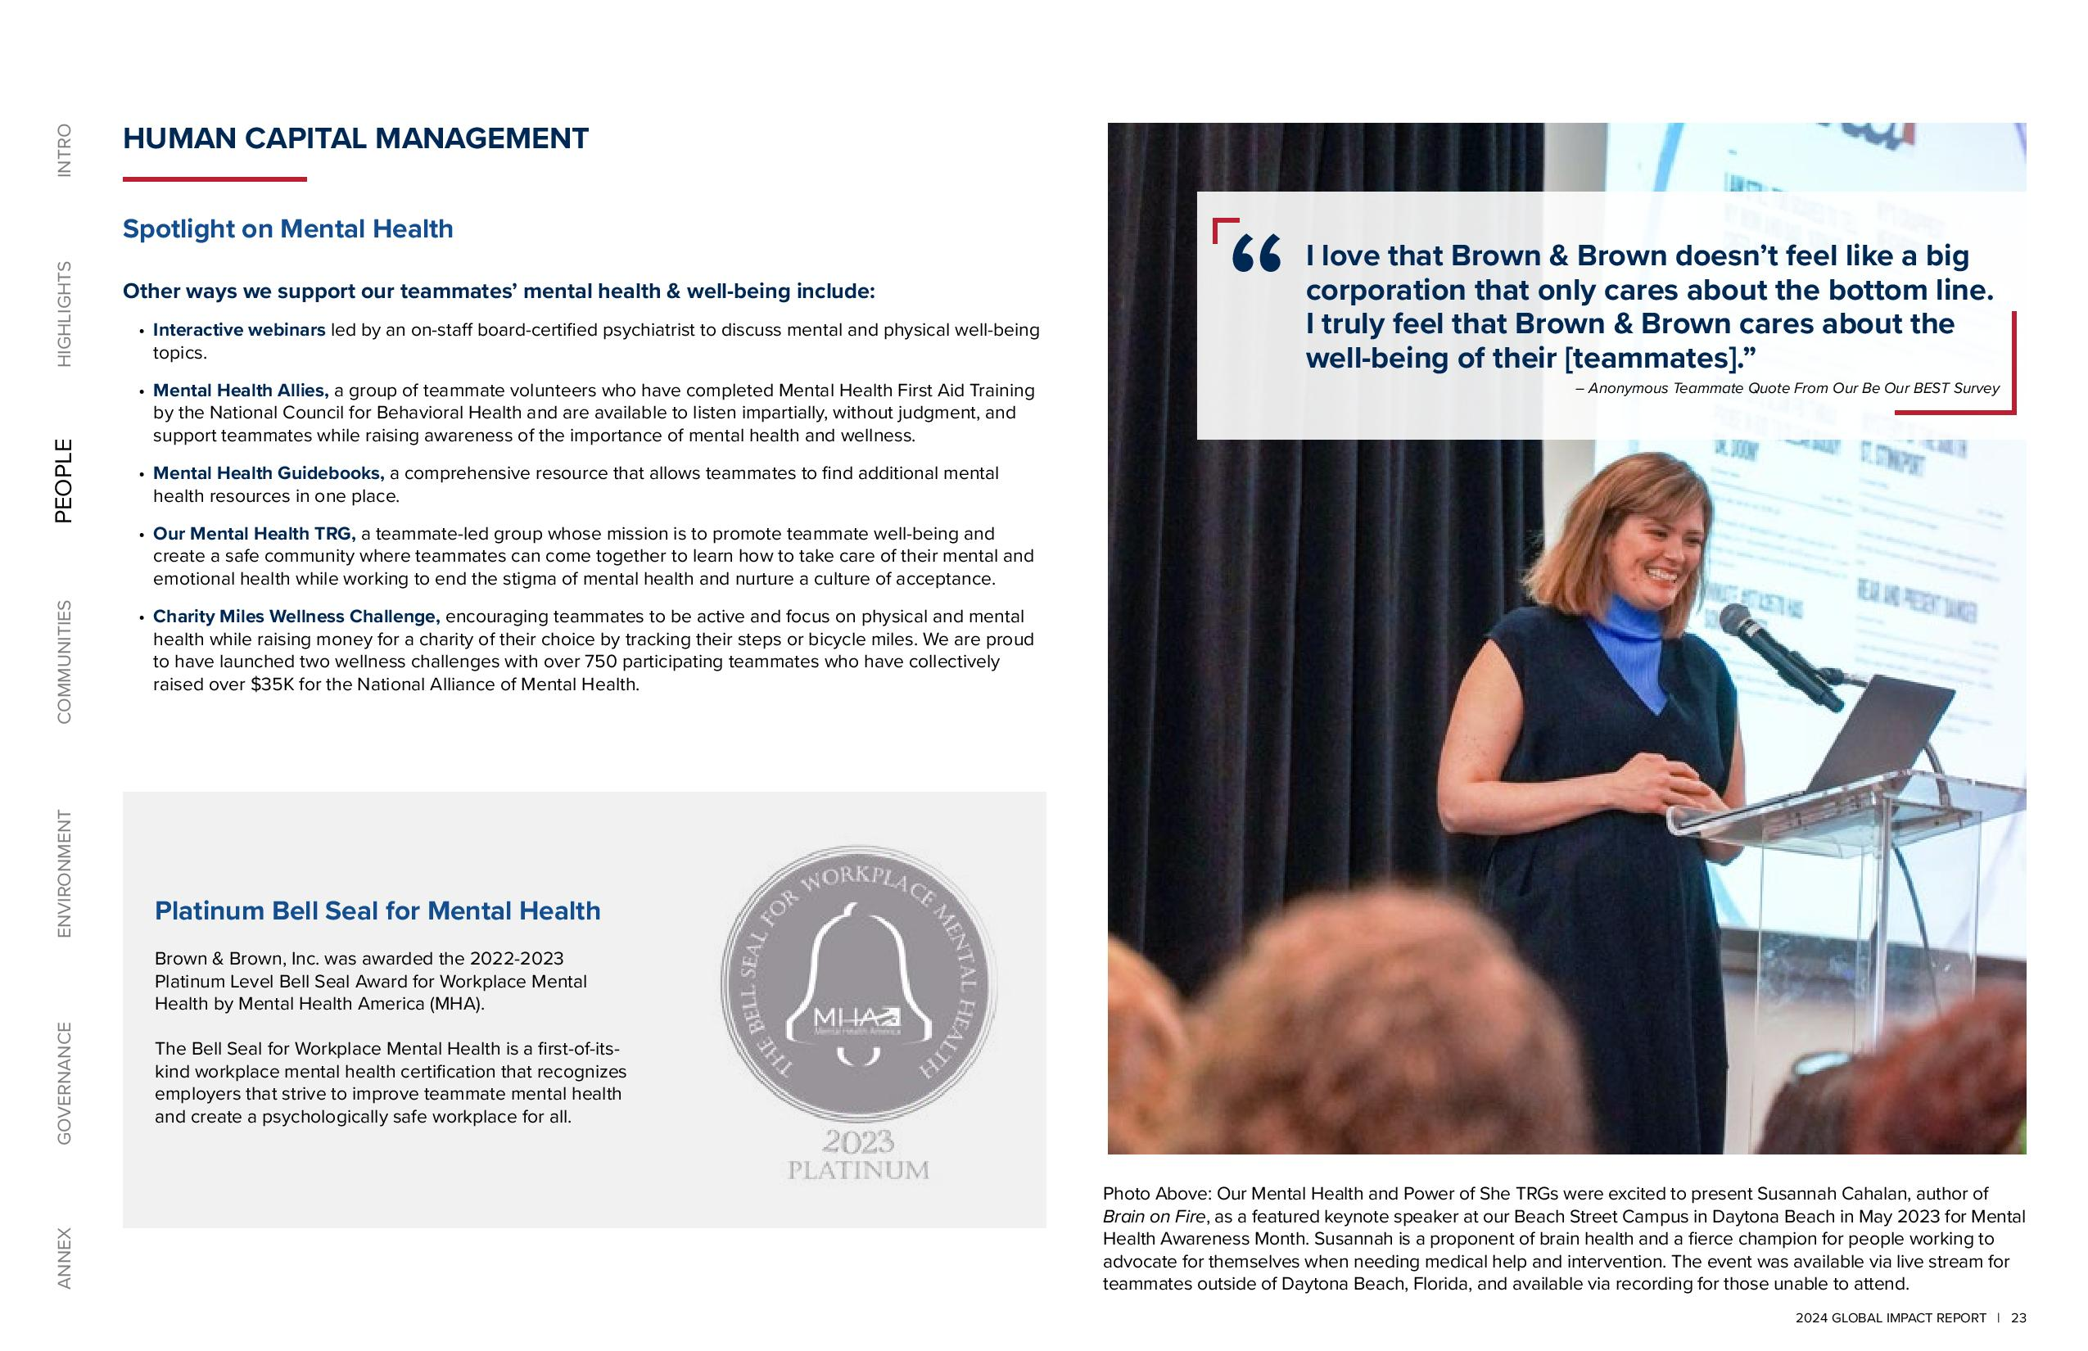

2024 GLOBAL IMPACT REPORT 23 ANNEX GOVERNANCE ENVIRONMENT COMMUNITIES PEOPLE HIGHLIGHTS INTRO Spotlight on Mental Health Other ways we support our teammates’ mental health & well-being include Interactive webinars led by an on-staff board-certified psychiatrist to discuss mental and physical well-being topics. Mental Health Allies, a group of teammate volunteers who have completed Mental Health First Aid Training by the National Council for Behavioral Health and are available to listen impartially, without judgment, and support teammates while raising awareness of the importance of mental health and wellness. Mental Health Guidebooks, a comprehensive resource that allows teammates to find additional mental health resources in one place. Our Mental Health TRG, a teammate-led group whose mission is to promote teammate well-being and create a safe community where teammates can come together to learn how to take care of their mental and emotional health while working to end the stigma of mental health and nurture a culture of acceptance. Charity Miles Wellness Challenge, encouraging teammates to be active and focus on physical and mental health while raising money for a charity of their choice by tracking their steps or bicycle miles. We are proud to have launched two wellness challenges with over 750 participating teammates who have collectively raised over $35K for the National Alliance of Mental Health. HUMAN CAPITAL MANAGEMENT Photo Above: Our Mental Health and Power of She TRGs were excited to present Susannah Cahalan, author of Brain on Fire, as a featured keynote speaker at our Beach Street Campus in Daytona Beach in May 2023 for Mental Health Awareness Month. Susannah is a proponent of brain health and a fierce champion for people working to advocate for themselves when needing medical help and intervention. The event was available via live stream for teammates outside of Daytona Beach, Florida, and available via recording for those unable to attend. Platinum Bell Seal for Mental Health Brown & Brown, Inc. was awarded the 2022-2023 Platinum Level Bell Seal Award for Workplace Mental Health by Mental Health America (MHA). The Bell Seal for Workplace Mental Health is a first-of-itskind workplace mental health certification that recognizes employers that strive to improve teammate mental health and create a psychologically safe workplace for all. I love that Brown & Brown doesn’t feel like a big corporation that only cares about the bottom line. I truly feel that Brown & Brown cares about the well-being of their [teammates] Anonymous Teammate Quote From Our Be Our BEST Survey

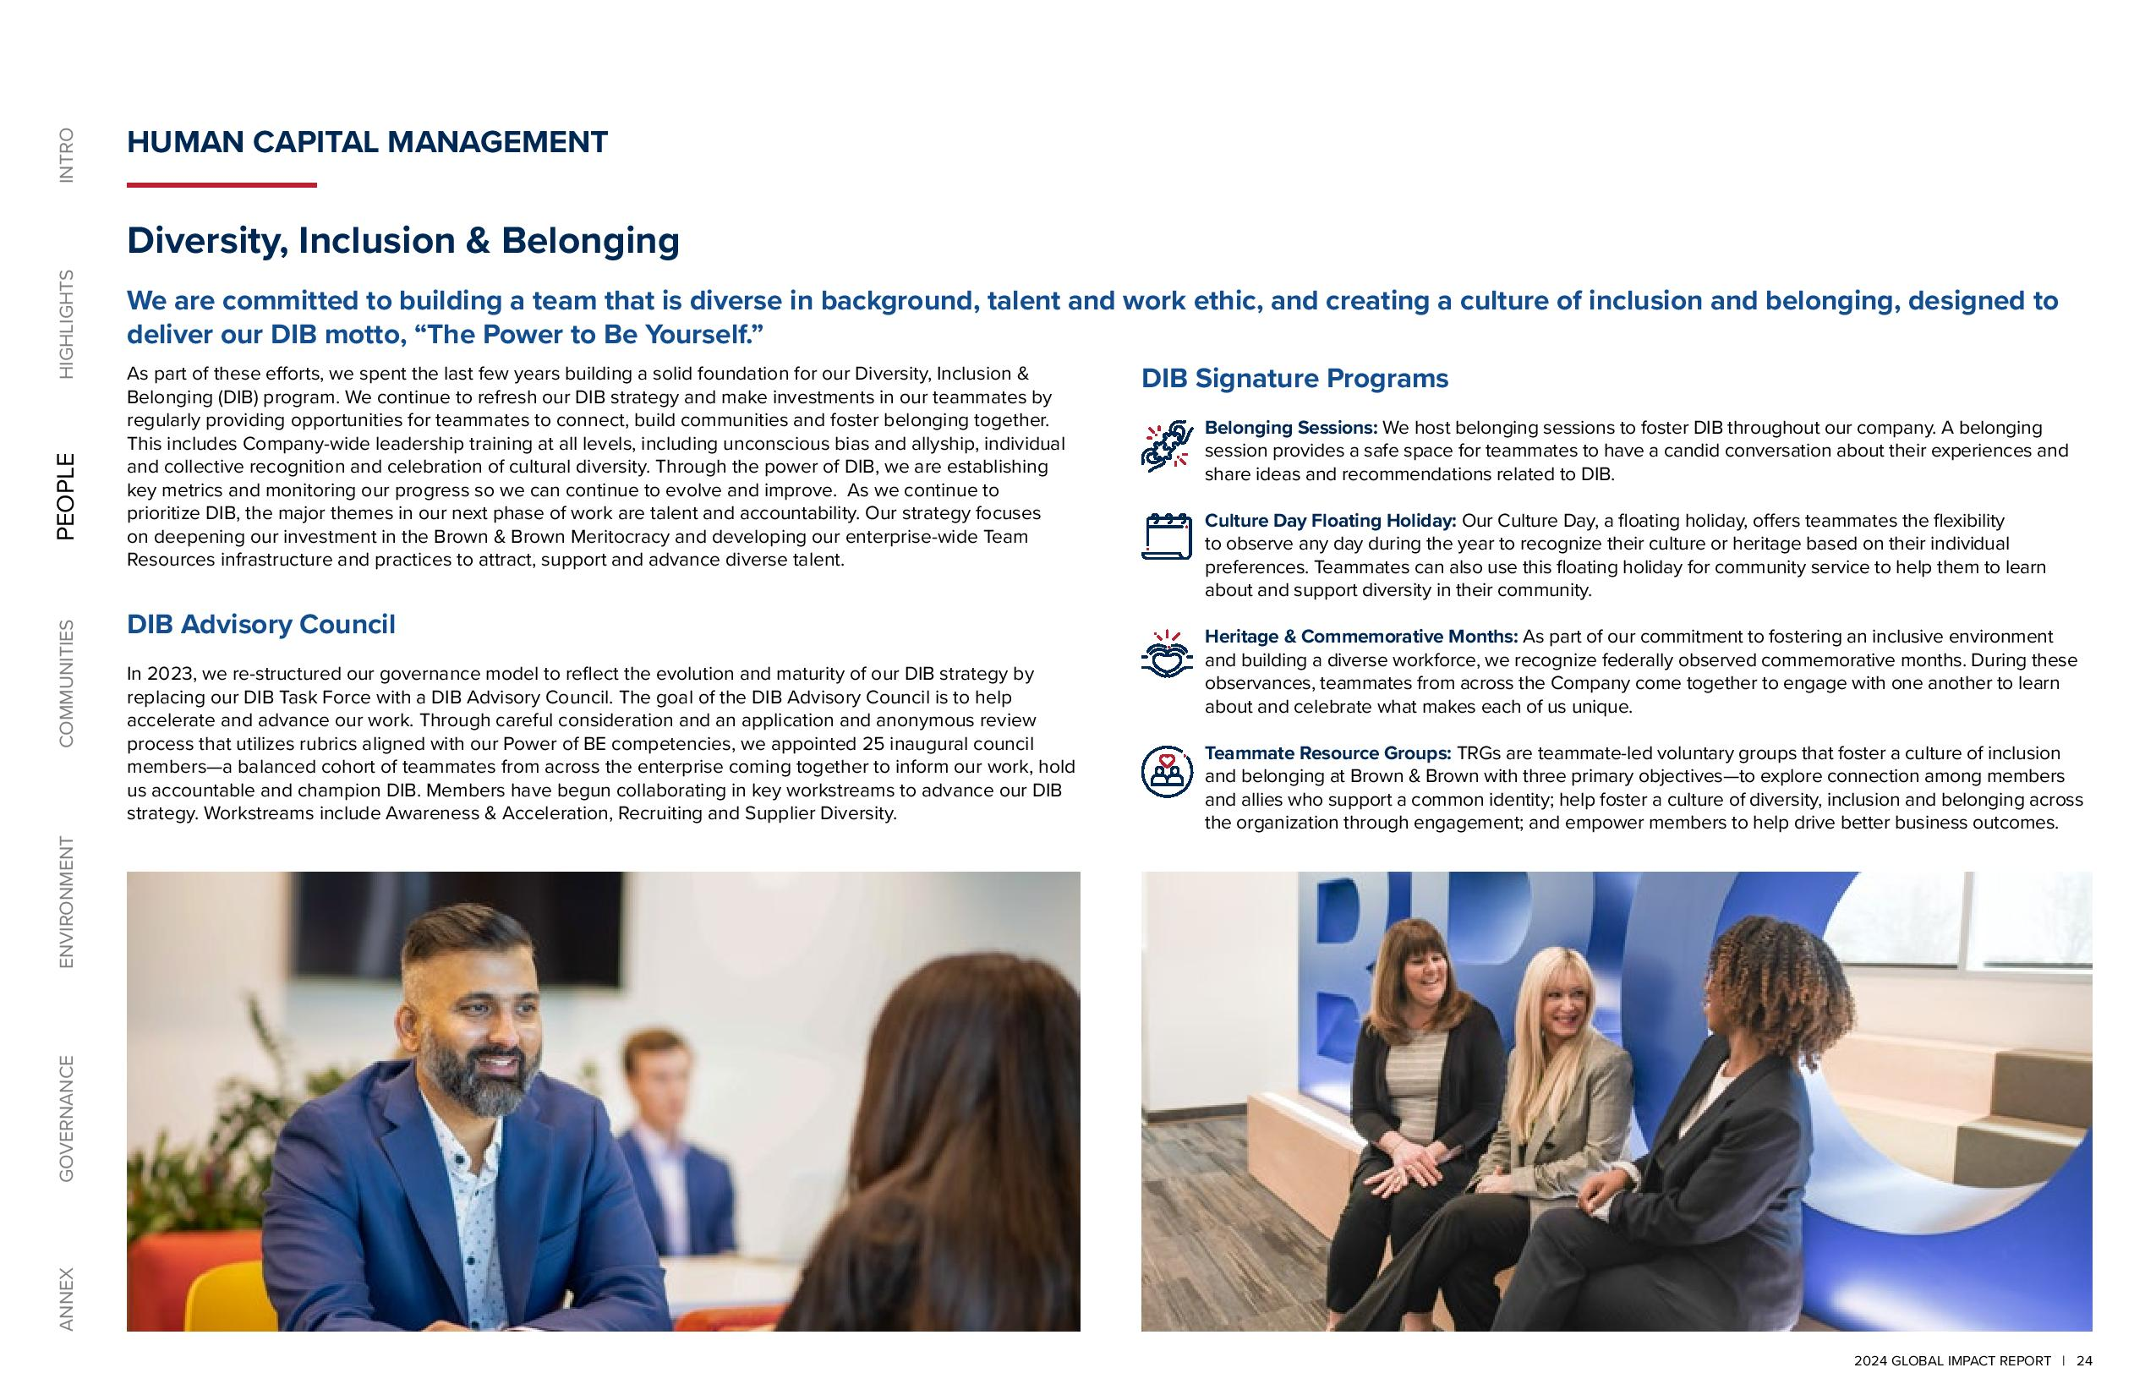

2024 GLOBAL IMPACT REPORT 24 ANNEX GOVERNANCE ENVIRONMENT COMMUNITIES PEOPLE HIGHLIGHTS INTRO HUMAN CAPITAL MANAGEMENT Diversity, Inclusion & Belonging We are committed to building a team that is diverse in background, talent and work ethic, and creating a culture of inclusion and belonging, designed to deliver our DIB motto, “The Power to Be Yourself.” As part of these efforts, we spent the last few years building a solid foundation for our Diversity, Inclusion & Belonging (DIB) program. We continue to refresh our DIB strategy and make investments in our teammates by regularly providing opportunities for teammates to connect, build communities and foster belonging together. This includes Company-wide leadership training at all levels, including unconscious bias and allyship, individual and collective recognition and celebration of cultural diversity. Through the power of DIB, we are establishing key metrics and monitoring our progress so we can continue to evolve and improve. As we continue to prioritize DIB, the major themes in our next phase of work are talent and accountability. Our strategy focuses on deepening our investment in the Brown & Brown Meritocracy and developing our enterprise-wide Team Resources infrastructure and practices to attract, support and advance diverse talent. DIB Advisory Council In 2023, we re-structured our governance model to reflect the evolution and maturity of our DIB strategy by replacing our DIB Task Force with a DIB Advisory Council. The goal of the DIB Advisory Council is to help accelerate and advance our work. Through careful consideration and an application and anonymous review process that utilizes rubrics aligned with our Power of BE competencies, we appointed 25 inaugural council members a balanced cohort of teammates from across the enterprise coming together to inform our work, hold us accountable and champion DIB. Members have begun collaborating in key workstreams to advance our DIB strategy. Workstreams include Awareness & Acceleration, Recruiting and Supplier Diversity. DIB Signature Programs Belonging Sessions: We host belonging sessions to foster DIB throughout our company. A belonging session provides a safe space for teammates to have a candid conversation about their experiences and share ideas and recommendations related to DIB. Culture Day Floating Holiday: Our Culture Day, a floating holiday, offers teammates the flexibility to observe any day during the year to recognize their culture or heritage based on their individual preferences. Teammates can also use this floating holiday for community service to help them to learn about and support diversity in their community. Heritage & Commemorative Months: As part of our commitment to fostering an inclusive environment and building a diverse workforce, we recognize federally observed commemorative months. During these observances, teammates from across the Company come together to engage with one another to learn about and celebrate what makes each of us unique. Teammate Resource Groups: TRGs are teammate-led voluntary groups that foster a culture of inclusion and belonging at Brown & Brown with three primary objectives to explore connection among members and allies who support a common identity; help foster a culture of diversity, inclusion and belonging across the organization through engagement; and empower members to help drive better business outcomes.

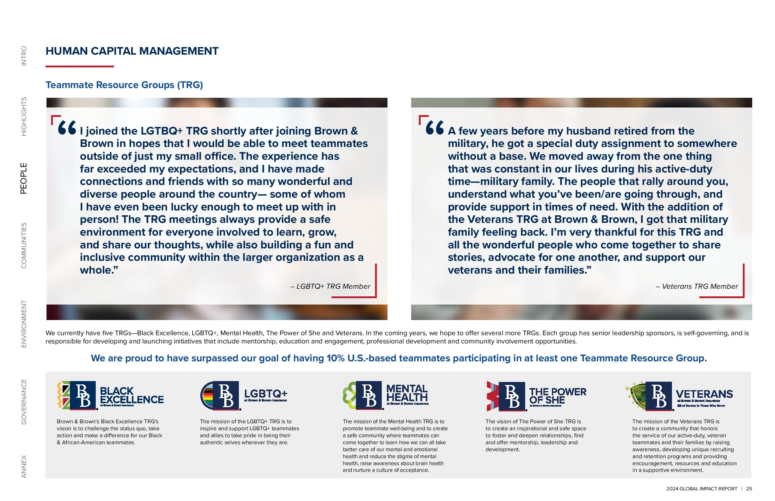

2024 GLOBAL IMPACT REPORT 25 ANNEX GOVERNANCE ENVIRONMENT COMMUNITIES PEOPLE HIGHLIGHTS INTRO Brown & Brown’s Black Excellence TRG's vision is to challenge the status quo, take action and make a difference for our Black & African American teammates. The mission of the Mental Health TRG is to promote teammate well-being and to create a safe community where teammates can come together to learn how we can all take better care of our mental and emotional health and reduce the stigma of mental health, raise awareness about brain health and nurture a culture of acceptance. The vision of The Power of She TRG is to create an inspirational and safe space to foster and deepen relationships, find and offer mentorship, leadership and development. The mission of the Veterans TRG is to create a community that honors the service of our active-duty, veteran teammates and their families by raising awareness, developing unique recruiting and retention programs and providing encouragement, resources and education in a supportive environment. The mission of the LGBTQ+ TRG is to inspire and support LGBTQ+ teammates and allies to take pride in being their authentic selves wherever they are. I joined the LGTBQ+ TRG shortly after joining Brown & Brown in hopes that I would be able to meet teammates outside of just my small office. The experience has far exceeded my expectations, and I have made connections and friends with so many wonderful and diverse people around the country some of whom I have even been lucky enough to meet up with in person! The TRG meetings always provide a safe environment for everyone involved to learn, grow, and share our thoughts, while also building a fun and inclusive community within the larger organization as a whole. LGBTQ+ TRG Member A few years before my husband retired from the military, he got a special duty assignment to somewhere without a base. We moved away from the one thing that was constant in our lives during his active-duty time military family. The people that rally around you, understand what you’ve been/are going through, and provide support in times of need. With the addition of the Veterans TRG at Brown & Brown, I got that military family feeling back. I’m very thankful for this TRG and all the wonderful people who come together to share stories, advocate for one another, and support our veterans and their families. Veterans TRG Member HUMAN CAPITAL MANAGEMENT Teammate Resource Groups (TRG) We currently have five TRGs Black Excellence, LGBTQ+, Mental Health, The Power of She and Veterans. In the coming years, we hope to offer several more TRGs. Each group has senior leadership sponsors, is self-governing, and is responsible for developing and launching initiatives that include mentorship, education and engagement, professional development and community involvement opportunities. We are proud to have surpassed our goal of having 10% U.S.-based teammates participating in at least one Teammate Resource Group.

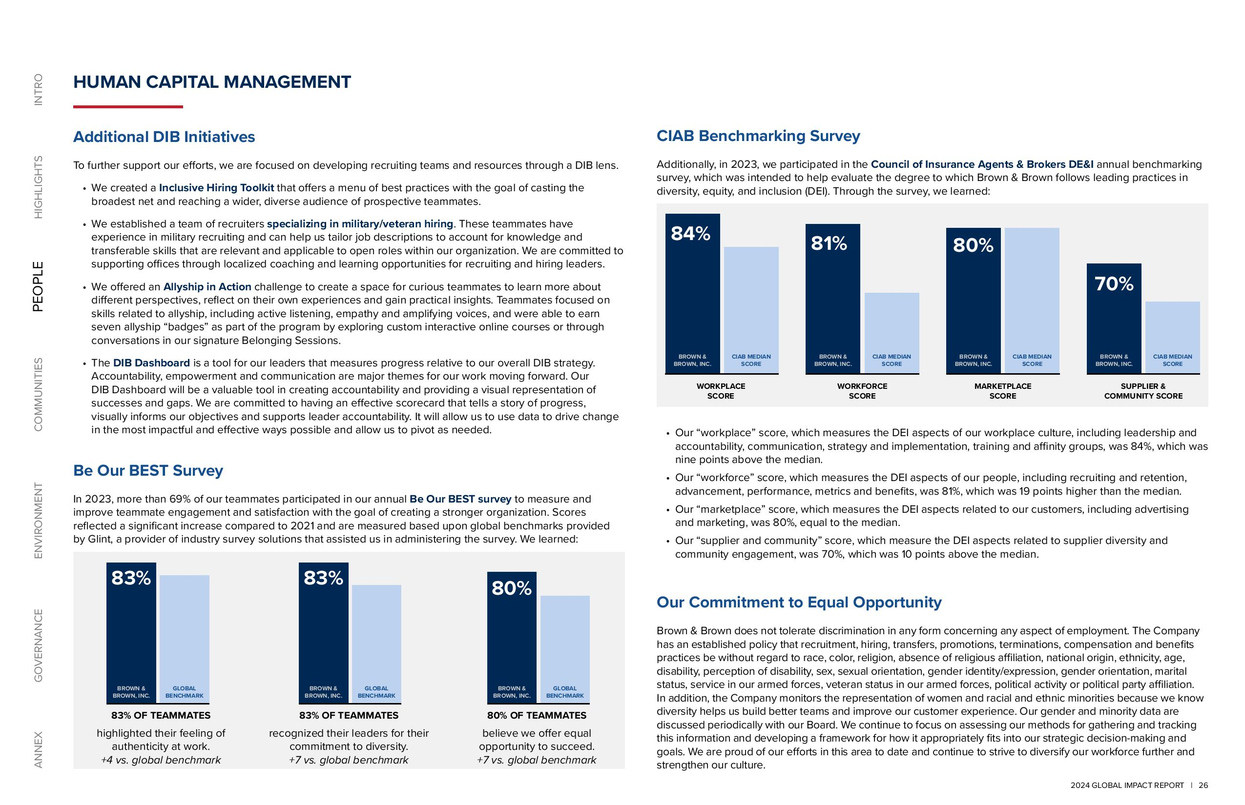

2024 GLOBAL IMPACT REPORT 26 ANNEX GOVERNANCE ENVIRONMENT COMMUNITIES PEOPLE HIGHLIGHTS INTRO CIAB Benchmarking Survey Additionally, in 2023, we participated in the Council of Insurance Agents & Brokers DE&I annual benchmarking survey, which was intended to help evaluate the degree to which Brown & Brown follows leading practices in diversity, equity, and inclusion (DEI). Through the survey, we learned: Our “workplace” score, which measures the DEI aspects of our workplace culture, including leadership and accountability, communication, strategy and implementation, training and affinity groups, was 84%, which was nine points above the median. Our “workforce” score, which measures the DEI aspects of our people, including recruiting and retention, advancement, performance, metrics and benefits, was 81%, which was 19 points higher than the median. Our “marketplace” score, which measures the DEI aspects related to our customers, including advertising and marketing, was 80%, equal to the median. Our “supplier and community” score, which measure the DEI aspects related to supplier diversity and community engagement, was 70%, which was 10 points above the median. HUMAN CAPITAL MANAGEMENT Additional DIB Initiatives To further support our efforts, we are focused on developing recruiting teams and resources through a DIB lens. We created a Inclusive Hiring Toolkit that offers a menu of best practices with the goal of casting the broadest net and reaching a wider, diverse audience of prospective teammates. We established a team of recruiters specializing in military/veteran hiring. These teammates have experience in military recruiting and can help us tailor job descriptions to account for knowledge and transferable skills that are relevant and applicable to open roles within our organization. We are committed to supporting offices through localized coaching and learning opportunities for recruiting and hiring leaders. We offered an Allyship in Action challenge to create a space for curious teammates to learn more about different perspectives, reflect on their own experiences and gain practical insights. Teammates focused on skills related to allyship, including active listening, empathy and amplifying voices, and were able to earn seven allyship “badges” as part of the program by exploring custom interactive online courses or through conversations in our signature Belonging Sessions. The DIB Dashboard is a tool for our leaders that measures progress relative to our overall DIB strategy. Accountability, empowerment and communication are major themes for our work moving forward. Our DIB Dashboard will be a valuable tool in creating accountability and providing a visual representation of successes and gaps. We are committed to having an effective scorecard that tells a story of progress, visually informs our objectives and supports leader accountability. It will allow us to use data to drive change in the most impactful and effective ways possible and allow us to pivot as needed. Be Our BEST Survey In 2023, more than 69% of our teammates participated in our annual Be Our BEST survey to measure and improve teammate engagement and satisfaction with the goal of creating a stronger organization. Scores reflected a significant increase compared to 2021 and are measured based upon global benchmarks provided by Glint, a provider of industry survey solutions that assisted us in administering the survey. We learned: 83% OF TEAMMATES highlighted their feeling of authenticity at work. +4 vs. global benchmark 83% OF TEAMMATES recognized their leaders for their commitment to diversity. +7 vs. global benchmark 80% OF TEAMMATES believe we offer equal opportunity to succeed. +7 vs. global benchmark 83% 83% 80% GLOBAL BENCHMARK BROWN & BROWN, INC. GLOBAL BENCHMARK BROWN & BROWN, INC. GLOBAL BENCHMARK BROWN & BROWN, INC. Our Commitment to Equal Opportunity Brown & Brown does not tolerate discrimination in any form concerning any aspect of employment. The Company has an established policy that recruitment, hiring, transfers, promotions, terminations, compensation and benefits practices be without regard to race, color, religion, absence of religious affiliation, national origin, ethnicity, age, disability, perception of disability, sex, sexual orientation, gender identity/expression, gender orientation, marital status, service in our armed forces, veteran status in our armed forces, political activity or political party affiliation. In addition, the Company monitors the representation of women and racial and ethnic minorities because we know diversity helps us build better teams and improve our customer experience. Our gender and minority data are discussed periodically with our Board. We continue to focus on assessing our methods for gathering and tracking this information and developing a framework for how it appropriately fits into our strategic decision-making and goals. We are proud of our efforts in this area to date and continue to strive to diversify our workforce further and strengthen our culture. WORKPLACE SCORE 84% CIAB MEDIAN SCORE BROWN & BROWN, INC. 81% CIAB MEDIAN SCORE BROWN & BROWN, INC. 80% CIAB MEDIAN SCORE BROWN & BROWN, INC. 70% CIAB MEDIAN SCORE BROWN & BROWN, INC. WORKFORCE SCORE MARKETPLACE SCORE SUPPLIER & COMMUNITY SCORE

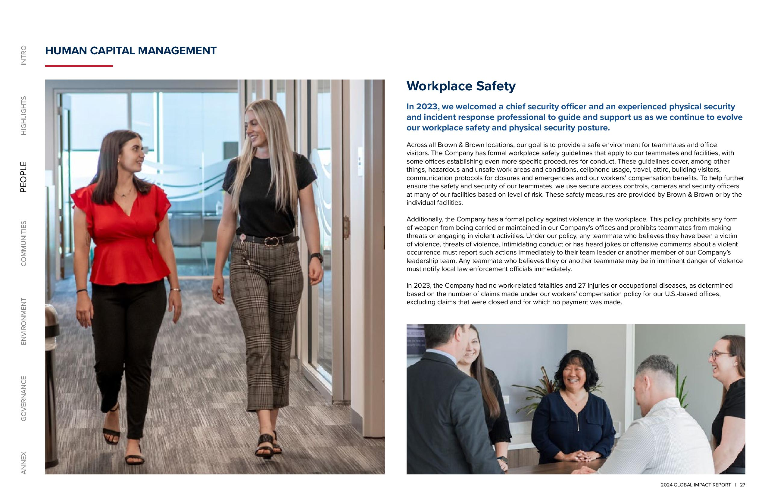

2024 GLOBAL IMPACT REPORT 27 ANNEX GOVERNANCE ENVIRONMENT COMMUNITIES PEOPLE HIGHLIGHTS INTRO HUMAN CAPITAL MANAGEMENT Workplace Safety In 2023, we welcomed a chief security officer and an experienced physical security and incident response professional to guide and support us as we continue to evolve our workplace safety and physical security posture. Across all Brown & Brown locations, our goal is to provide a safe environment for teammates and office visitors. The Company has formal workplace safety guidelines that apply to our teammates and facilities, with some offices establishing even more specific procedures for conduct. These guidelines cover, among other things, hazardous and unsafe work areas and conditions, cellphone usage, travel, attire, building visitors, communication protocols for closures and emergencies and our workers’ compensation benefits. To help further ensure the safety and security of our teammates, we use secure access controls, cameras and security officers at many of our facilities based on level of risk. These safety measures are provided by Brown & Brown or by the individual facilities. Additionally, the Company has a formal policy against violence in the workplace. This policy prohibits any form of weapon from being carried or maintained in our Company’s offices and prohibits teammates from making threats or engaging in violent activities. Under our policy, any teammate who believes they have been a victim of violence, threats of violence, intimidating conduct or has heard jokes or offensive comments about a violent occurrence must report such actions immediately to their team leader or another member of our Company’s leadership team. Any teammate who believes they or another teammate may be in imminent danger of violence must notify local law enforcement officials immediately. In 2023, the Company had no work-related fatalities and 27 injuries or occupational diseases, as determined based on the number of claims made under our workers’ compensation policy for our U.S.-based offices, excluding claims that were closed and for which no payment was made.

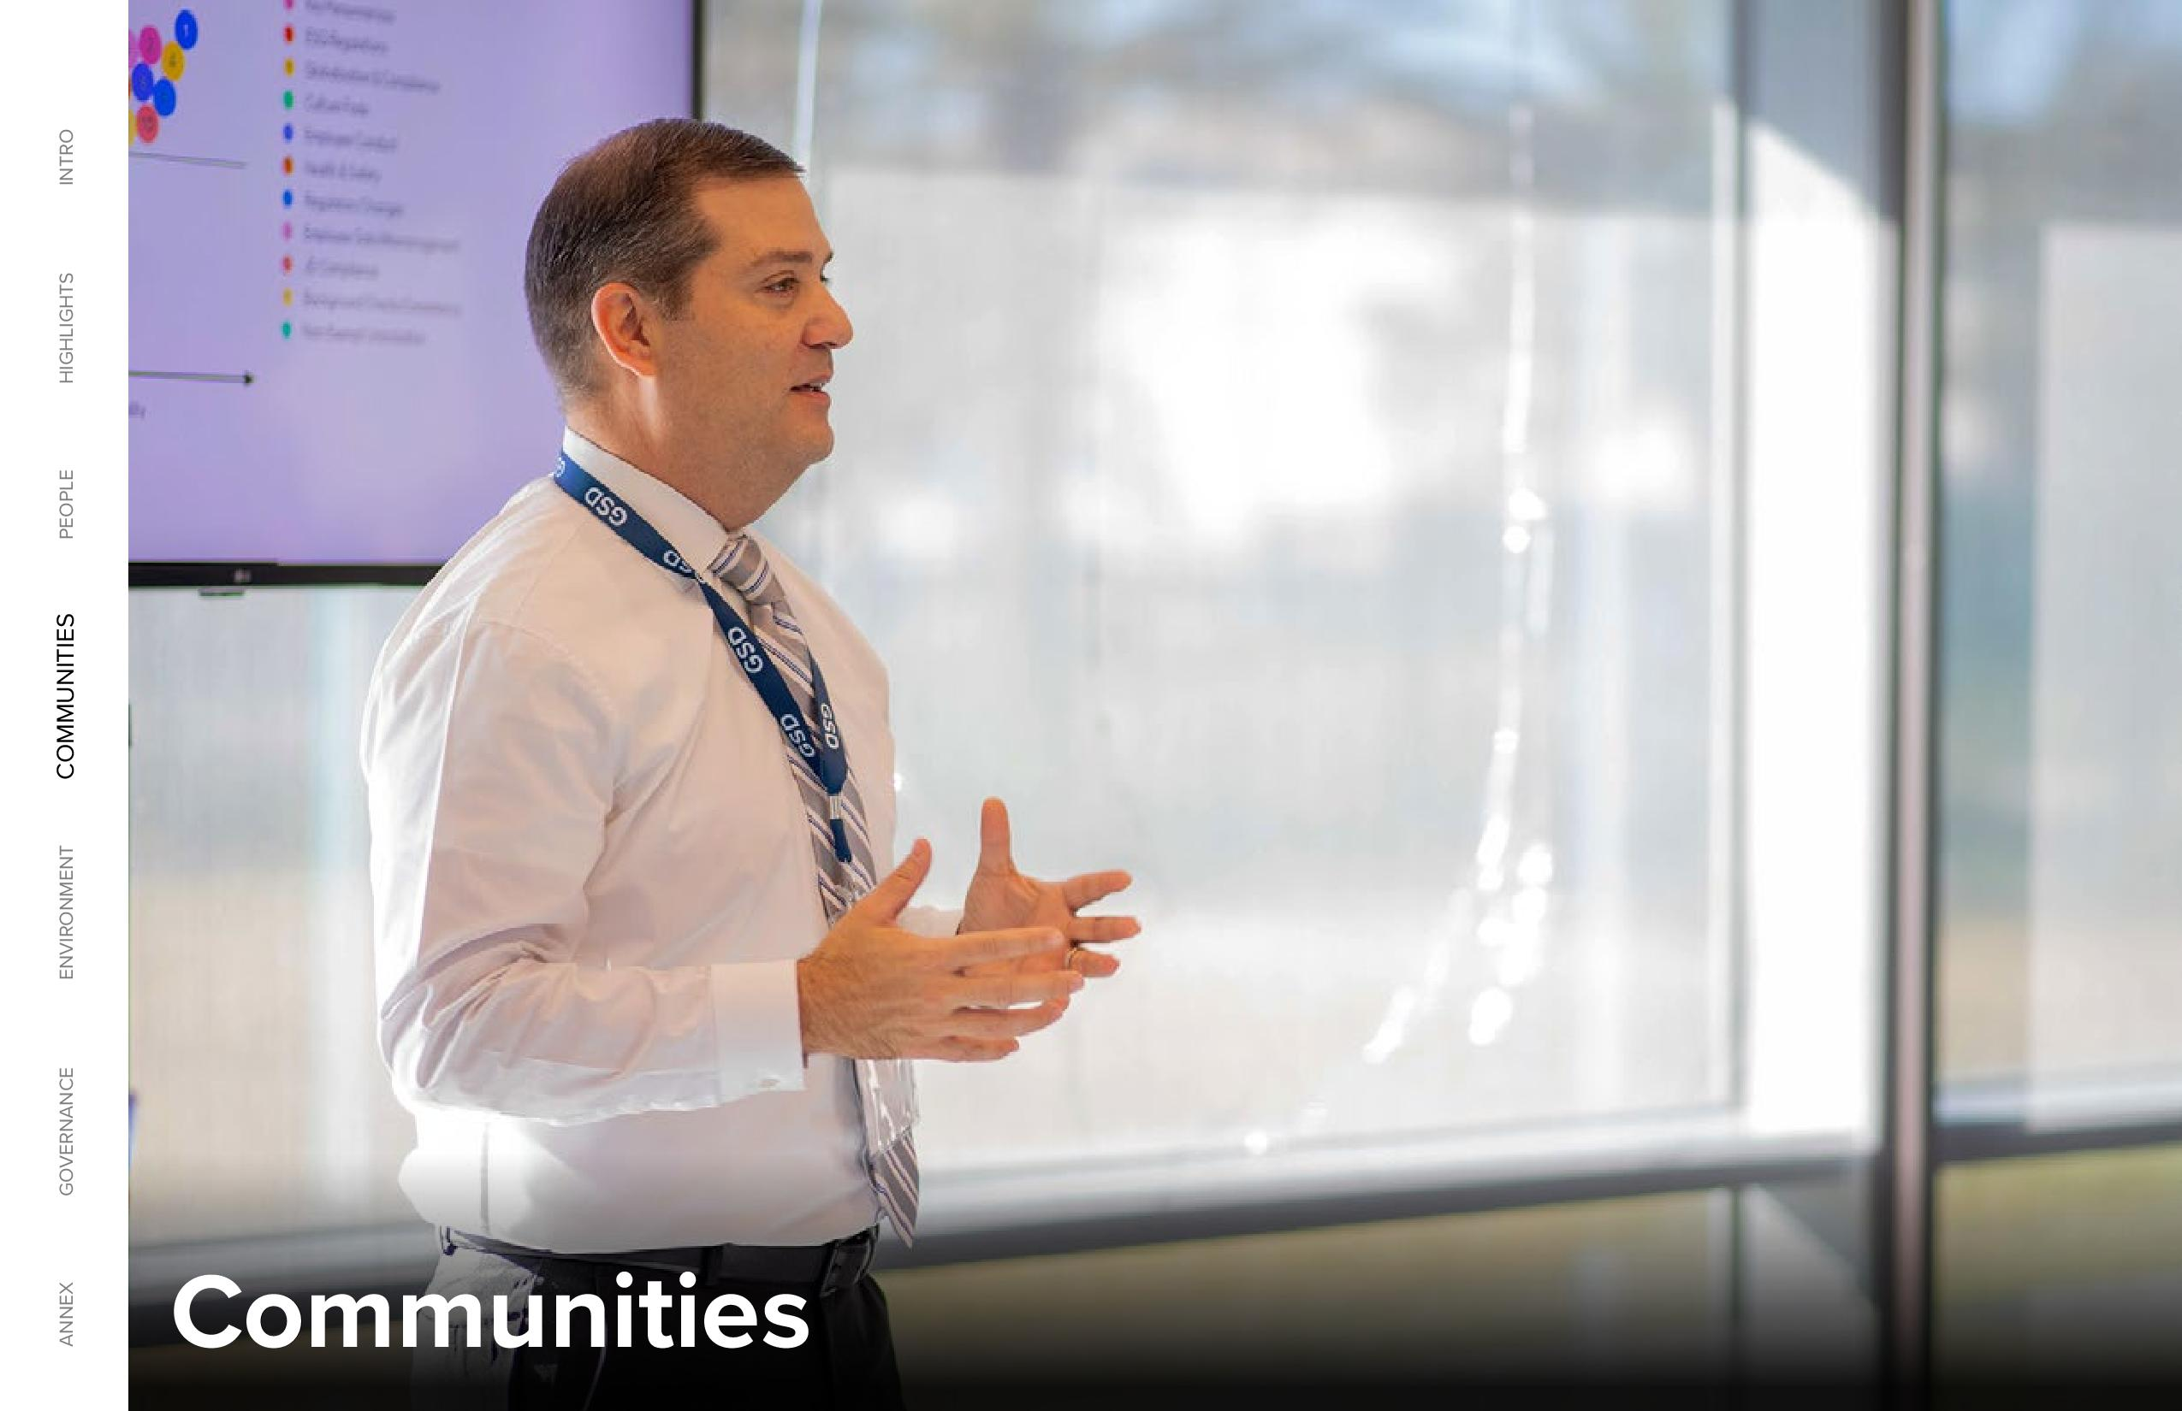

2024 GLOBAL IMPACT REPORT 28 ANNEX GOVERNANCE ENVIRONMENT COMMUNITIES PEOPLE HIGHLIGHTS INTRO Communities

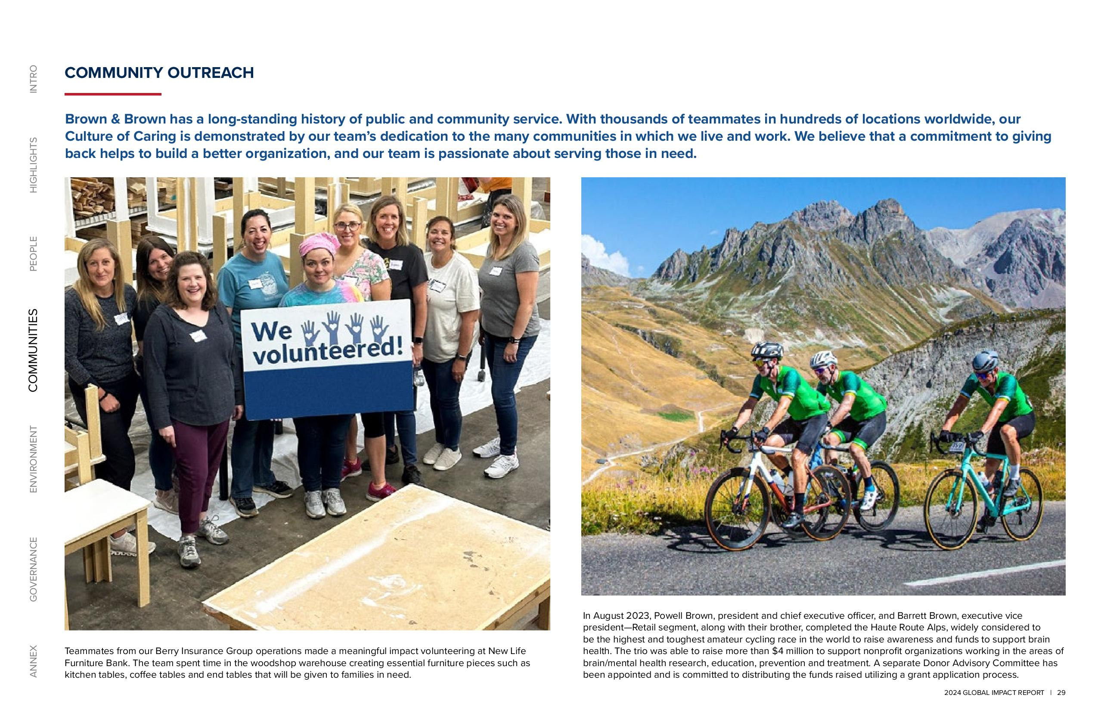

2024 GLOBAL IMPACT REPORT 29 ANNEX GOVERNANCE ENVIRONMENT COMMUNITIES PEOPLE HIGHLIGHTS INTRO In August 2023, Powell Brown, president and chief executive officer, and Barrett Brown, executive vice president Retail segment, along with their brother, completed the Haute Route Alps, widely considered to be the highest and toughest amateur cycling race in the world to raise awareness and funds to support brain health. The trio was able to raise more than $4 million to support nonprofit organizations working in the areas of brain/mental health research, education, prevention and treatment. A separate Donor Advisory Committee has been appointed and is committed to distributing the funds raised utilizing a grant application process. COMMUNITY OUTREACH Brown & Brown has a long-standing history of public and community service. With thousands of teammates in hundreds of locations worldwide, our Culture of Caring is demonstrated by our team’s dedication to the many communities in which we live and work. We believe that a commitment to giving back helps to build a better organization, and our team is passionate about serving those in need. Teammates from our Berry Insurance Group operations made a meaningful impact volunteering at New Life Furniture Bank. The team spent time in the woodshop warehouse creating essential furniture pieces such as kitchen tables, coffee tables and end tables that will be given to families in need.

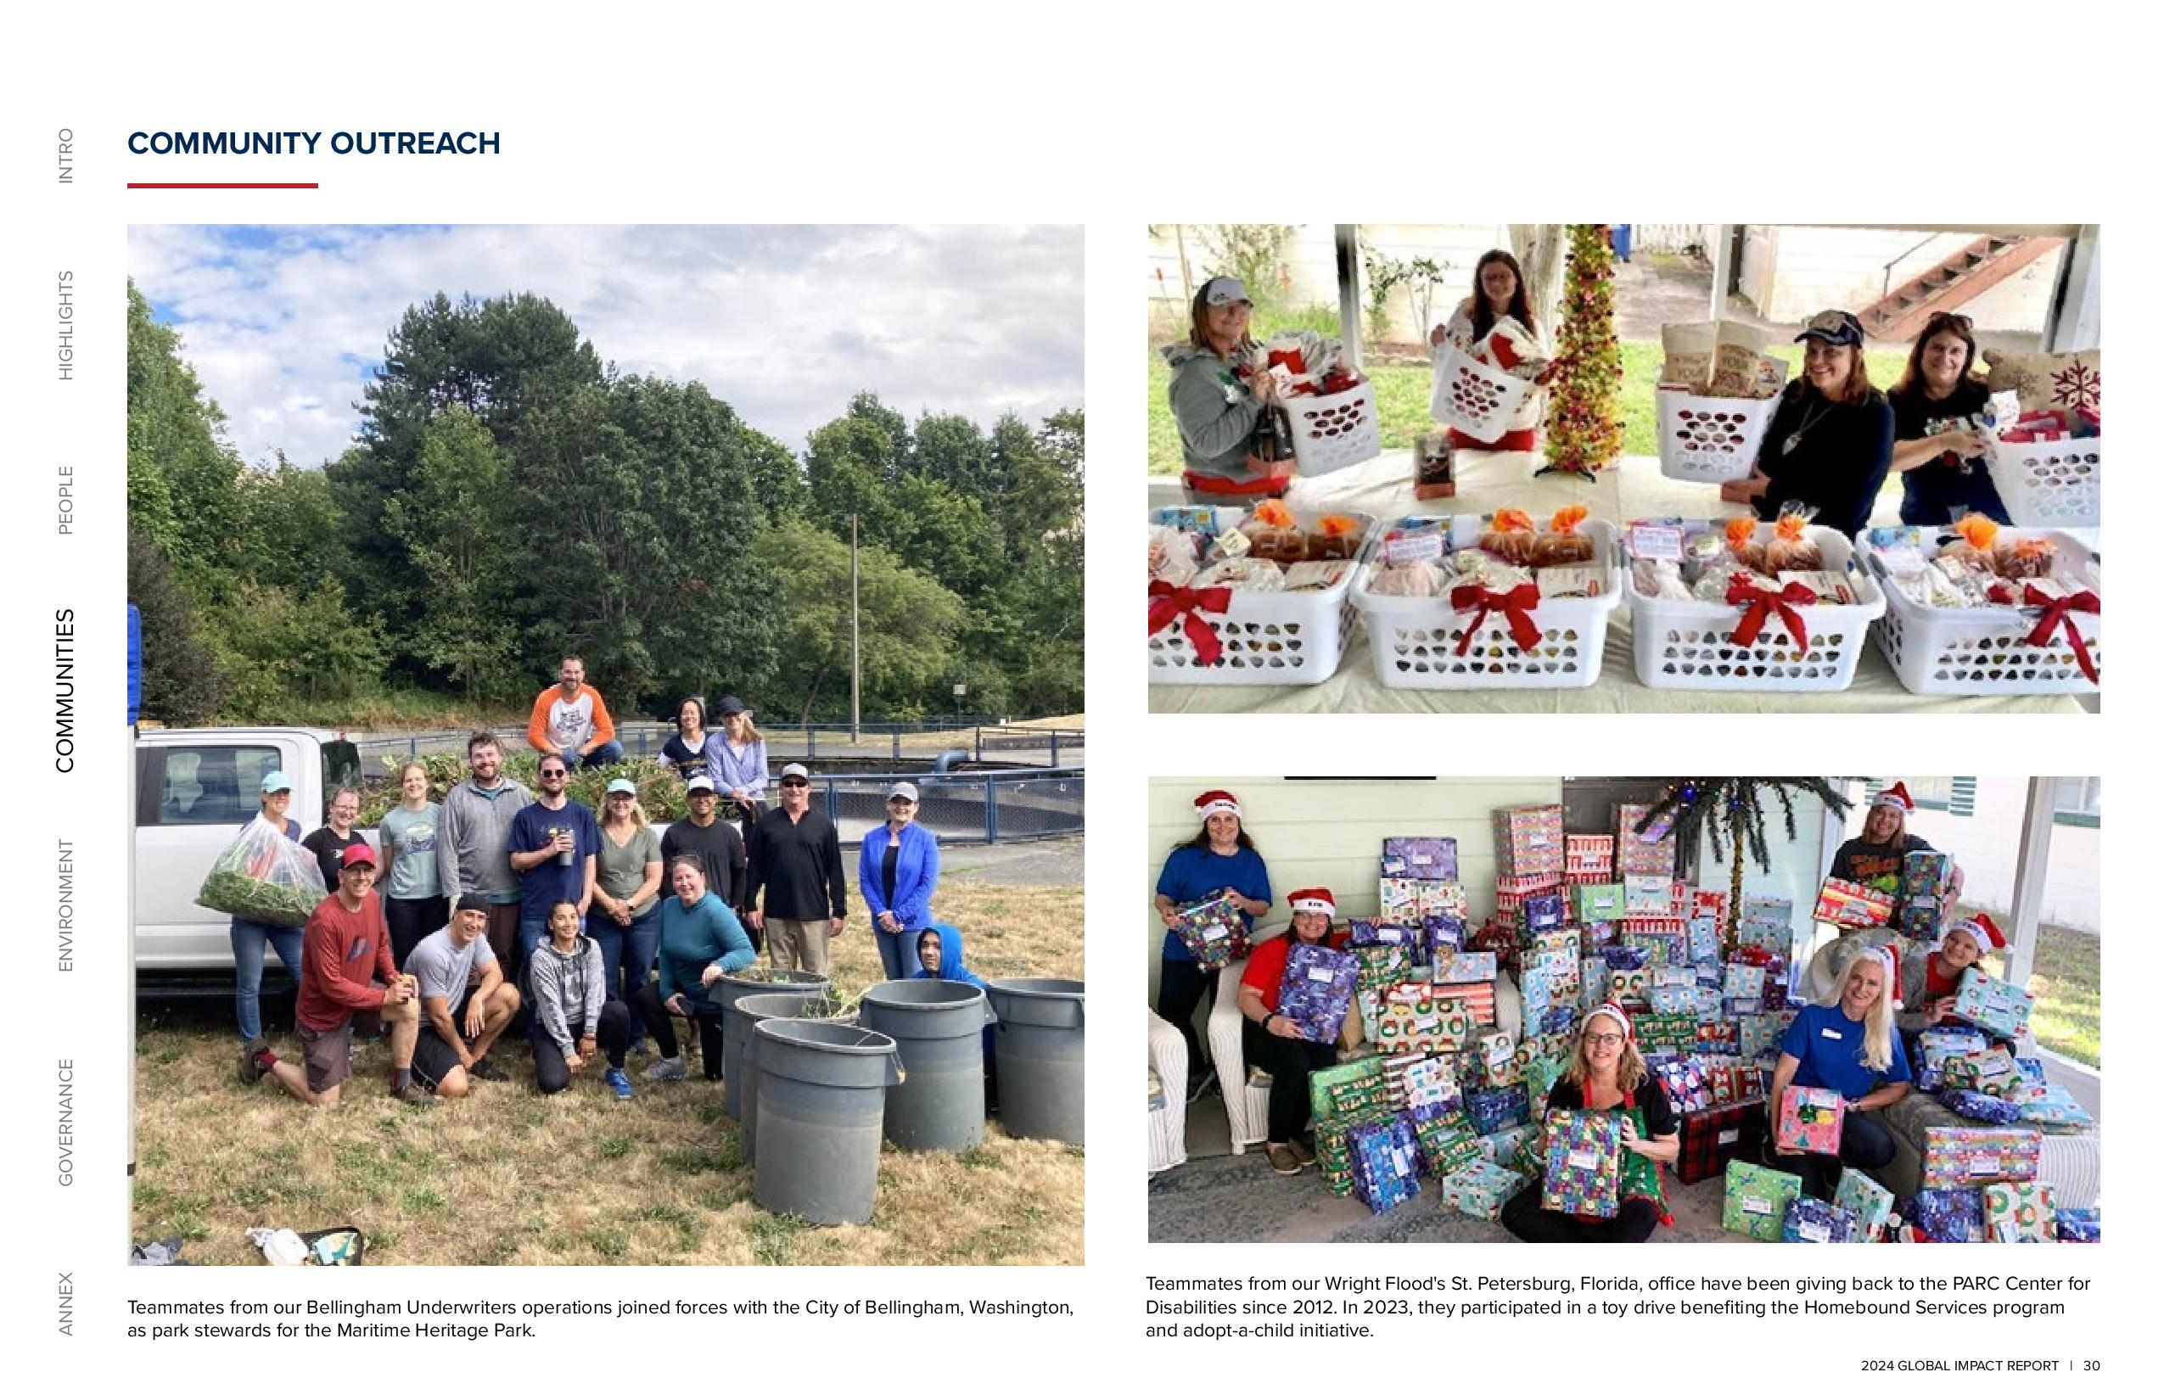

2024 GLOBAL IMPACT REPORT 30 ANNEX GOVERNANCE ENVIRONMENT COMMUNITIES PEOPLE HIGHLIGHTS INTRO COMMUNITY OUTREACH Teammates from our Wright Flood's St. Petersburg, Florida, office have been giving back to the PARC Center for Disabilities since 2012. In 2023, they participated in a toy drive benefiting the Homebound Services program and adopt-a-child initiative. Teammates from our Bellingham Underwriters operations joined forces with the City of Bellingham, Washington, as park stewards for the Maritime Heritage Park.

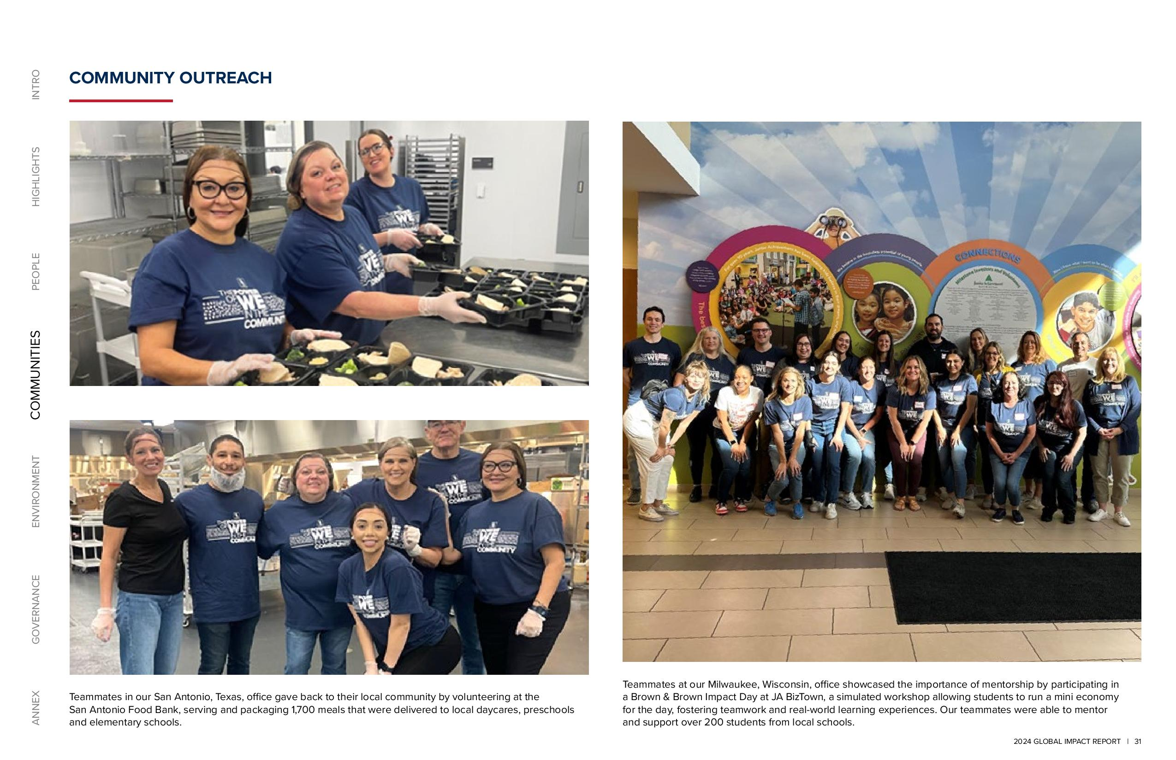

2024 GLOBAL IMPACT REPORT 31 ANNEX GOVERNANCE ENVIRONMENT COMMUNITIES PEOPLE HIGHLIGHTS INTRO COMMUNITY OUTREACH Teammates at our Milwaukee, Wisconsin, office showcased the importance of mentorship by participating in a Brown & Brown Impact Day at JA BizTown, a simulated workshop allowing students to run a mini economy for the day, fostering teamwork and real-world learning experiences. Our teammates were able to mentor and support over 200 students from local schools. Teammates in our San Antonio, Texas, office gave back to their local community by volunteering at the San Antonio Food Bank, serving and packaging 1,700 meals that were delivered to local daycares, preschools and elementary schools.

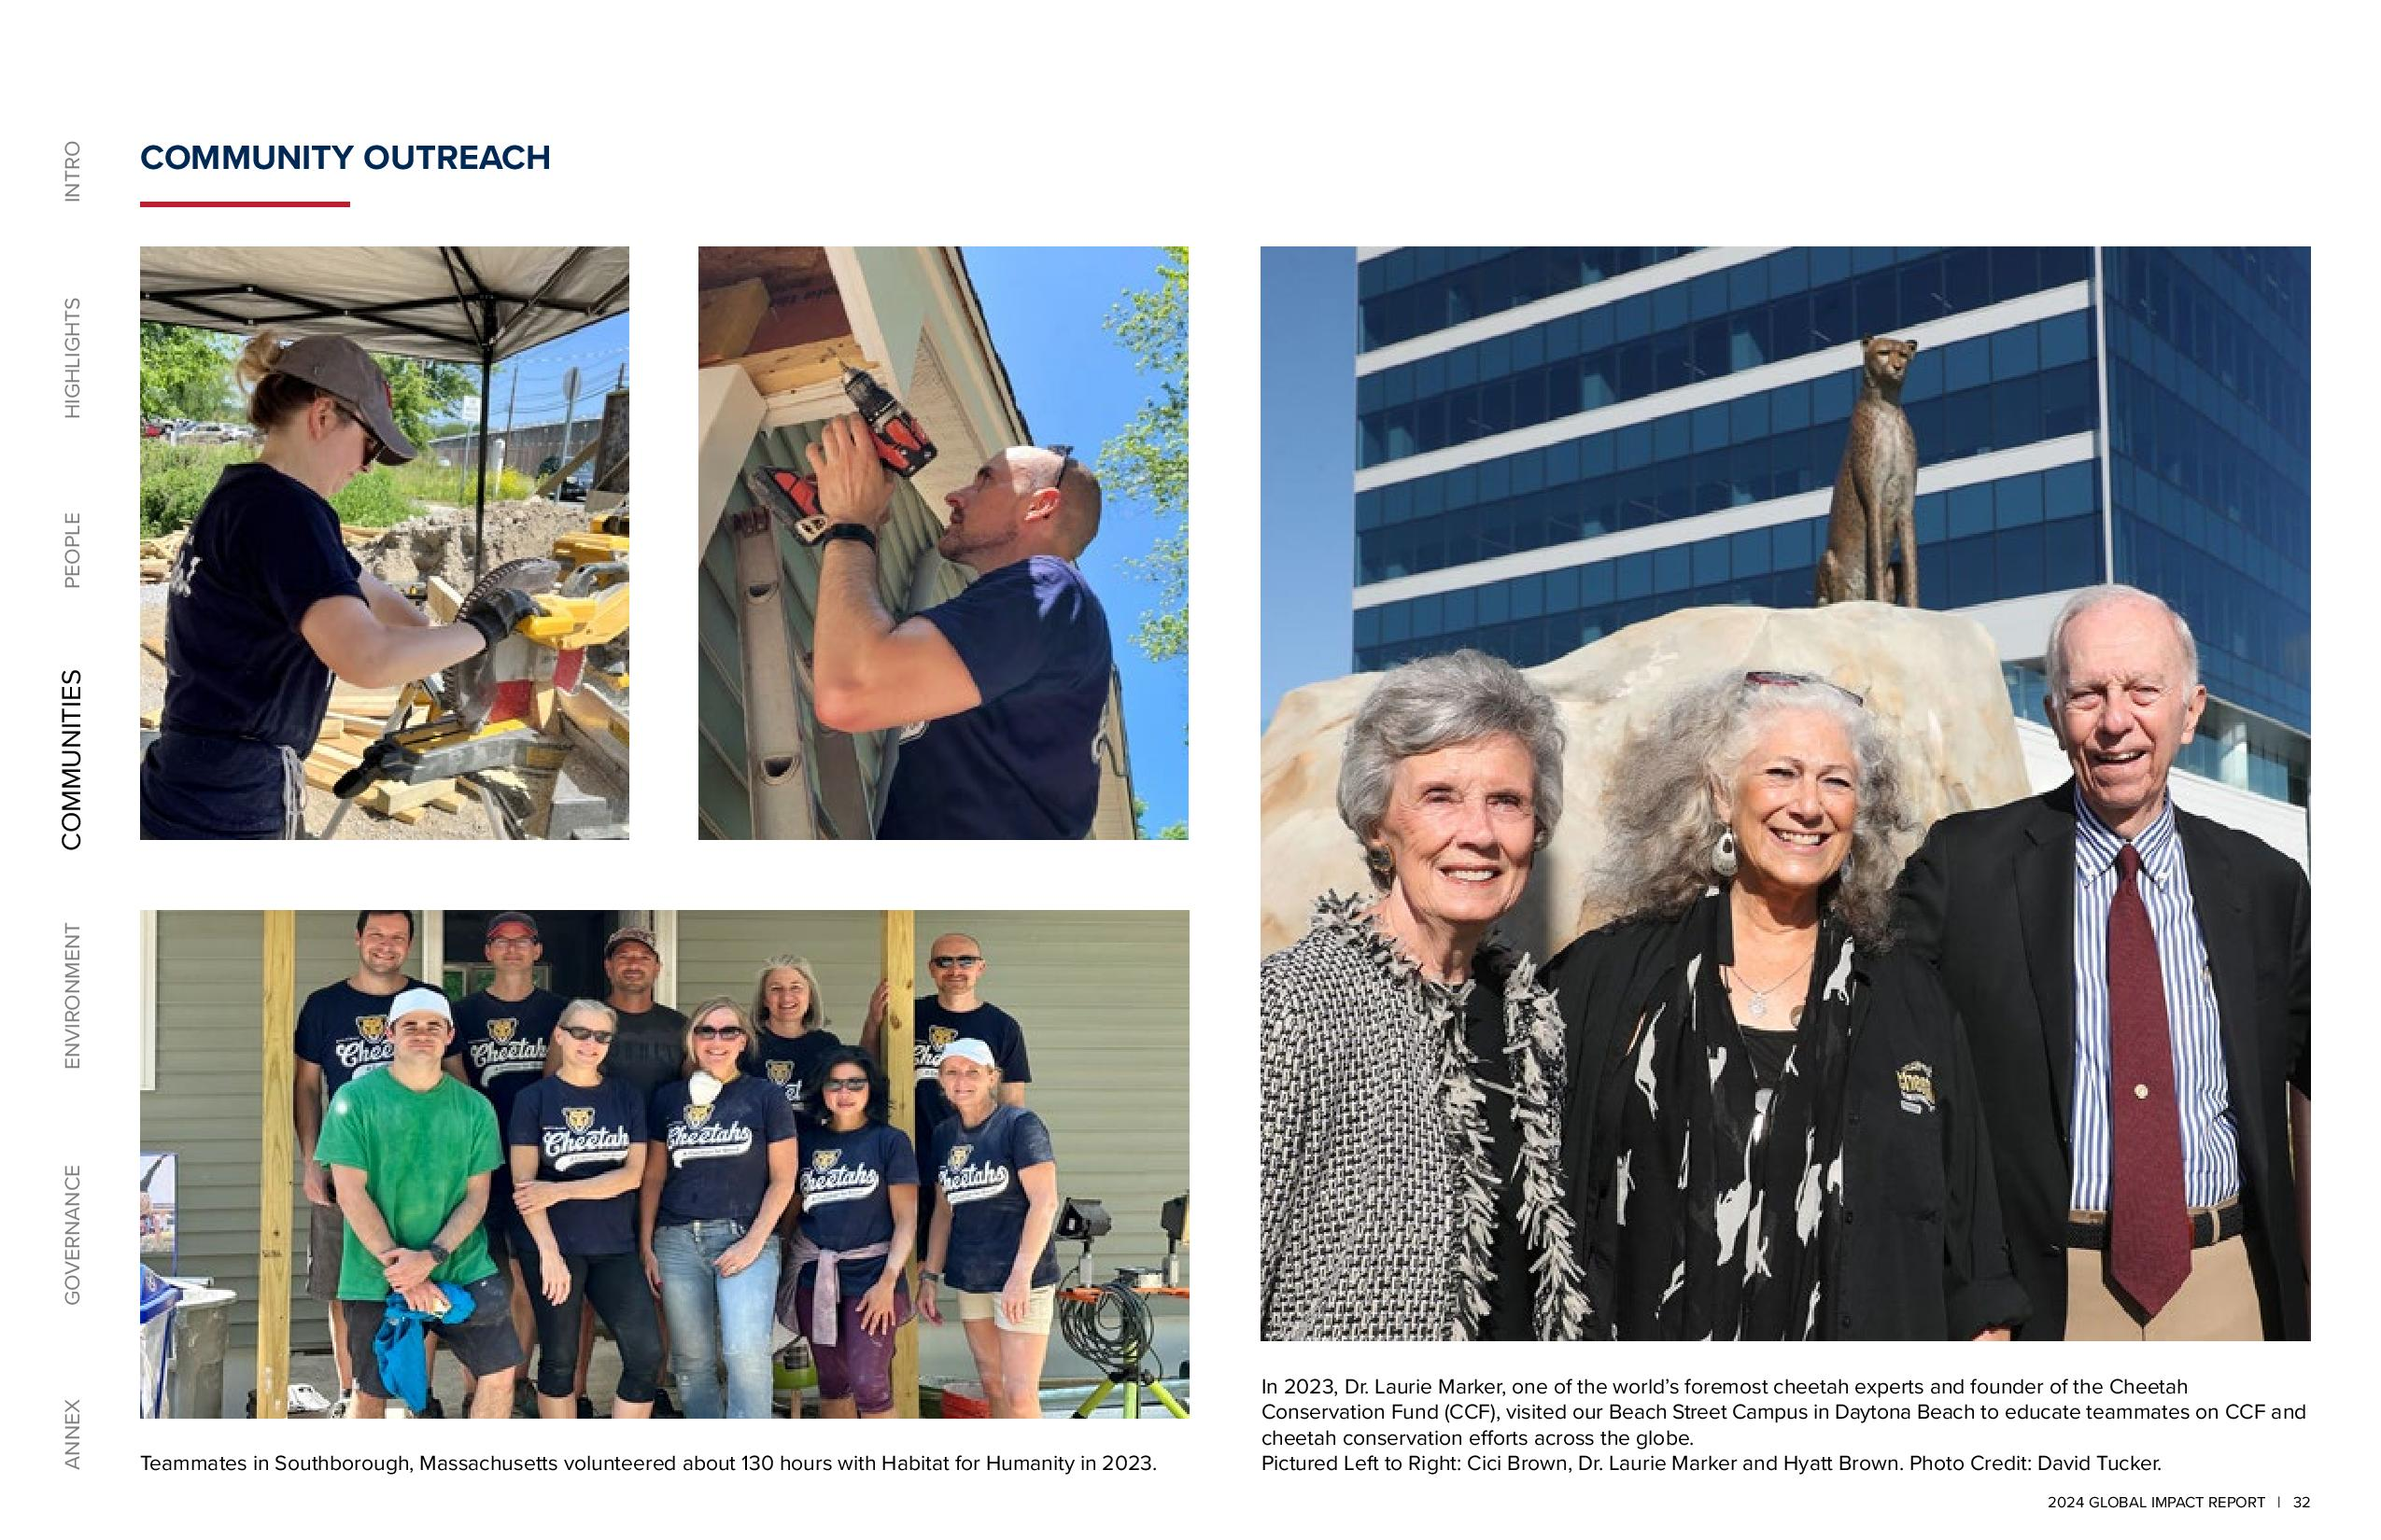

2024 GLOBAL IMPACT REPORT 32 ANNEX GOVERNANCE ENVIRONMENT COMMUNITIES PEOPLE HIGHLIGHTS INTRO COMMUNITY OUTREACH In 2023, Dr. Laurie Marker, one of the world’s foremost cheetah experts and founder of the Cheetah Conservation Fund (CCF), visited our Beach Street Campus in Daytona Beach to educate teammates on CCF and cheetah conservation efforts across the globe. Teammates in Southborough, Massachusetts volunteered about 130 hours with Habitat for Humanity in 2023. Pictured Left to Right: Cici Brown, Dr. Laurie Marker and Hyatt Brown. Photo Credit: David Tucker.

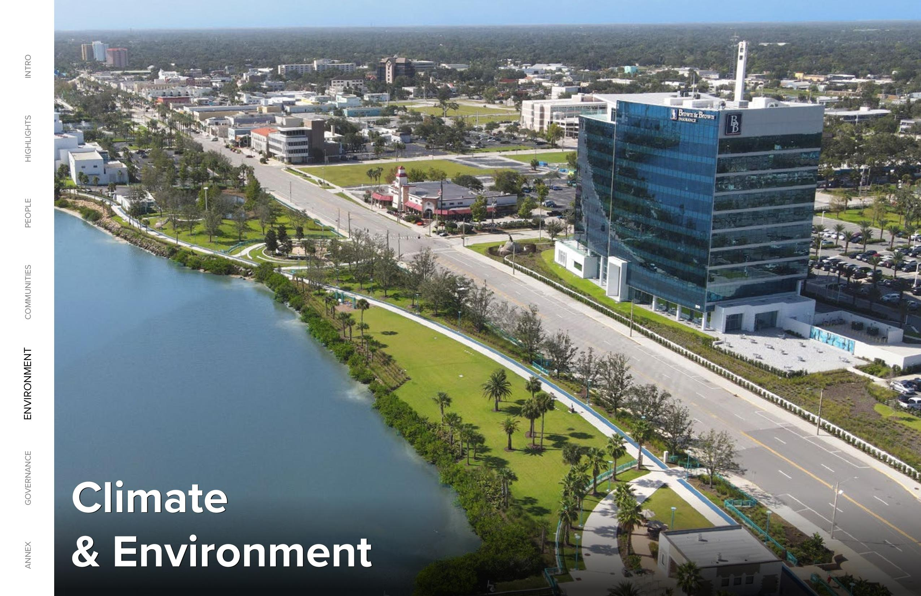

2024 GLOBAL IMPACT REPORT 33 ANNEX GOVERNANCE ENVIRONMENT COMMUNITIES PEOPLE HIGHLIGHTS INTRO Climate & Environment

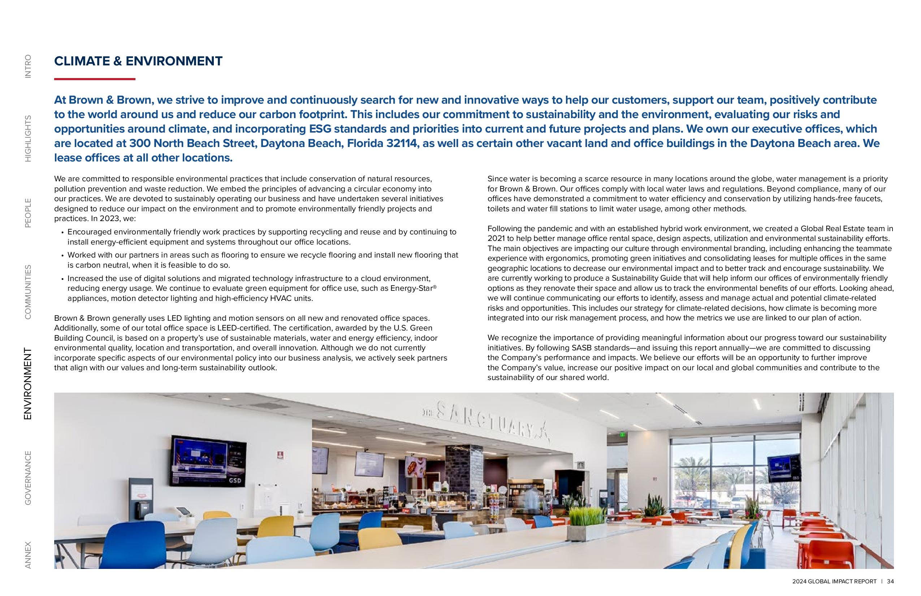

2024 GLOBAL IMPACT REPORT 34 ANNEX GOVERNANCE ENVIRONMENT COMMUNITIES PEOPLE HIGHLIGHTS INTRO CLIMATE & ENVIRONMENT At Brown & Brown, we strive to improve and continuously search for new and innovative ways to help our customers, support our team, positively contribute to the world around us and reduce our carbon footprint. This includes our commitment to sustainability and the environment, evaluating our risks and opportunities around climate, and incorporating ESG standards and priorities into current and future projects and plans. We own our executive offices, which are located at 300 North Beach Street, Daytona Beach, Florida 32114, as well as certain other vacant land and office buildings in the Daytona Beach area. We lease offices at all other locations. We are committed to responsible environmental practices that include conservation of natural resources, pollution prevention and waste reduction. We embed the principles of advancing a circular economy into our practices. We are devoted to sustainably operating our business and have undertaken several initiatives designed to reduce our impact on the environment and to promote environmentally friendly projects and practices. In 2023, we: Encouraged environmentally friendly work practices by supporting recycling and reuse and by continuing to install energy-efficient equipment and systems throughout our office locations. Worked with our partners in areas such as flooring to ensure we recycle flooring and install new flooring that is carbon neutral, when it is feasible to do so. Increased the use of digital solutions and migrated technology infrastructure to a cloud environment, reducing energy usage. We continue to evaluate green equipment for office use, such as Energy-Star® appliances, motion detector lighting and high-efficiency HVAC units. Brown & Brown generally uses LED lighting and motion sensors on all new and renovated office spaces. Additionally, some of our total office space is LEED-certified. The certification, awarded by the U.S. Green Building Council, is based on a property’s use of sustainable materials, water and energy efficiency, indoor environmental quality, location and transportation, and overall innovation. Although we do not currently incorporate specific aspects of our environmental policy into our business analysis, we actively seek partners that align with our values and long-term sustainability outlook. Since water is becoming a scarce resource in many locations around the globe, water management is a priority for Brown & Brown. Our offices comply with local water laws and regulations. Beyond compliance, many of our offices have demonstrated a commitment to water efficiency and conservation by utilizing hands-free faucets, toilets and water fill stations to limit water usage, among other methods. Following the pandemic and with an established hybrid work environment, we created a Global Real Estate team in 2021 to help better manage office rental space, design aspects, utilization and environmental sustainability efforts. The main objectives are impacting our culture through environmental branding, including enhancing the teammate experience with ergonomics, promoting green initiatives and consolidating leases for multiple offices in the same geographic locations to decrease our environmental impact and to better track and encourage sustainability. We are currently working to produce a Sustainability Guide that will help inform our offices of environmentally friendly options as they renovate their space and allow us to track the environmental benefits of our efforts. Looking ahead, we will continue communicating our efforts to identify, assess and manage actual and potential climate-related risks and opportunities. This includes our strategy for climate-related decisions, how climate is becoming more integrated into our risk management process, and how the metrics we use are linked to our plan of action. We recognize the importance of providing meaningful information about our progress toward our sustainability initiatives. By following SASB standards and issuing this report annually we are committed to discussing the Company’s performance and impacts. We believe our efforts will be an opportunity to further improve the Company’s value, increase our positive impact on our local and global communities and contribute to the sustainability of our shared world.

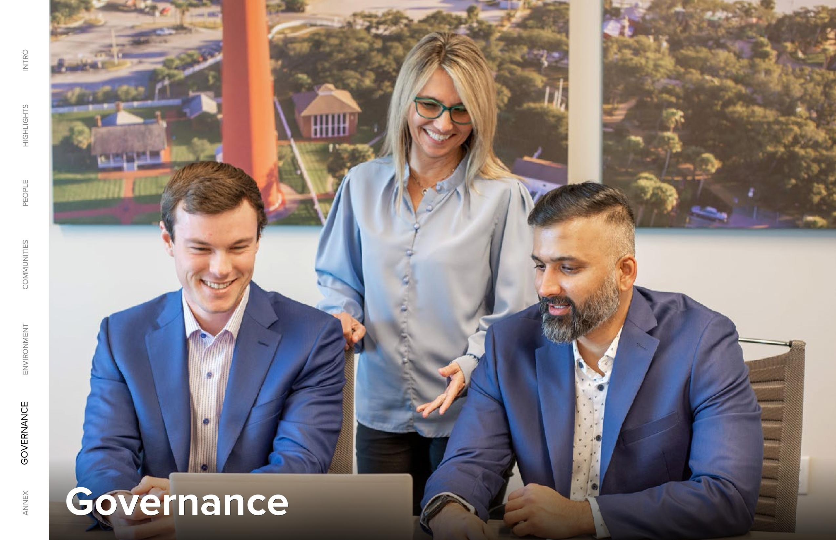

2024 GLOBAL IMPACT REPORT 35 ANNEX GOVERNANCE ENVIRONMENT COMMUNITIES PEOPLE HIGHLIGHTS INTRO Governance

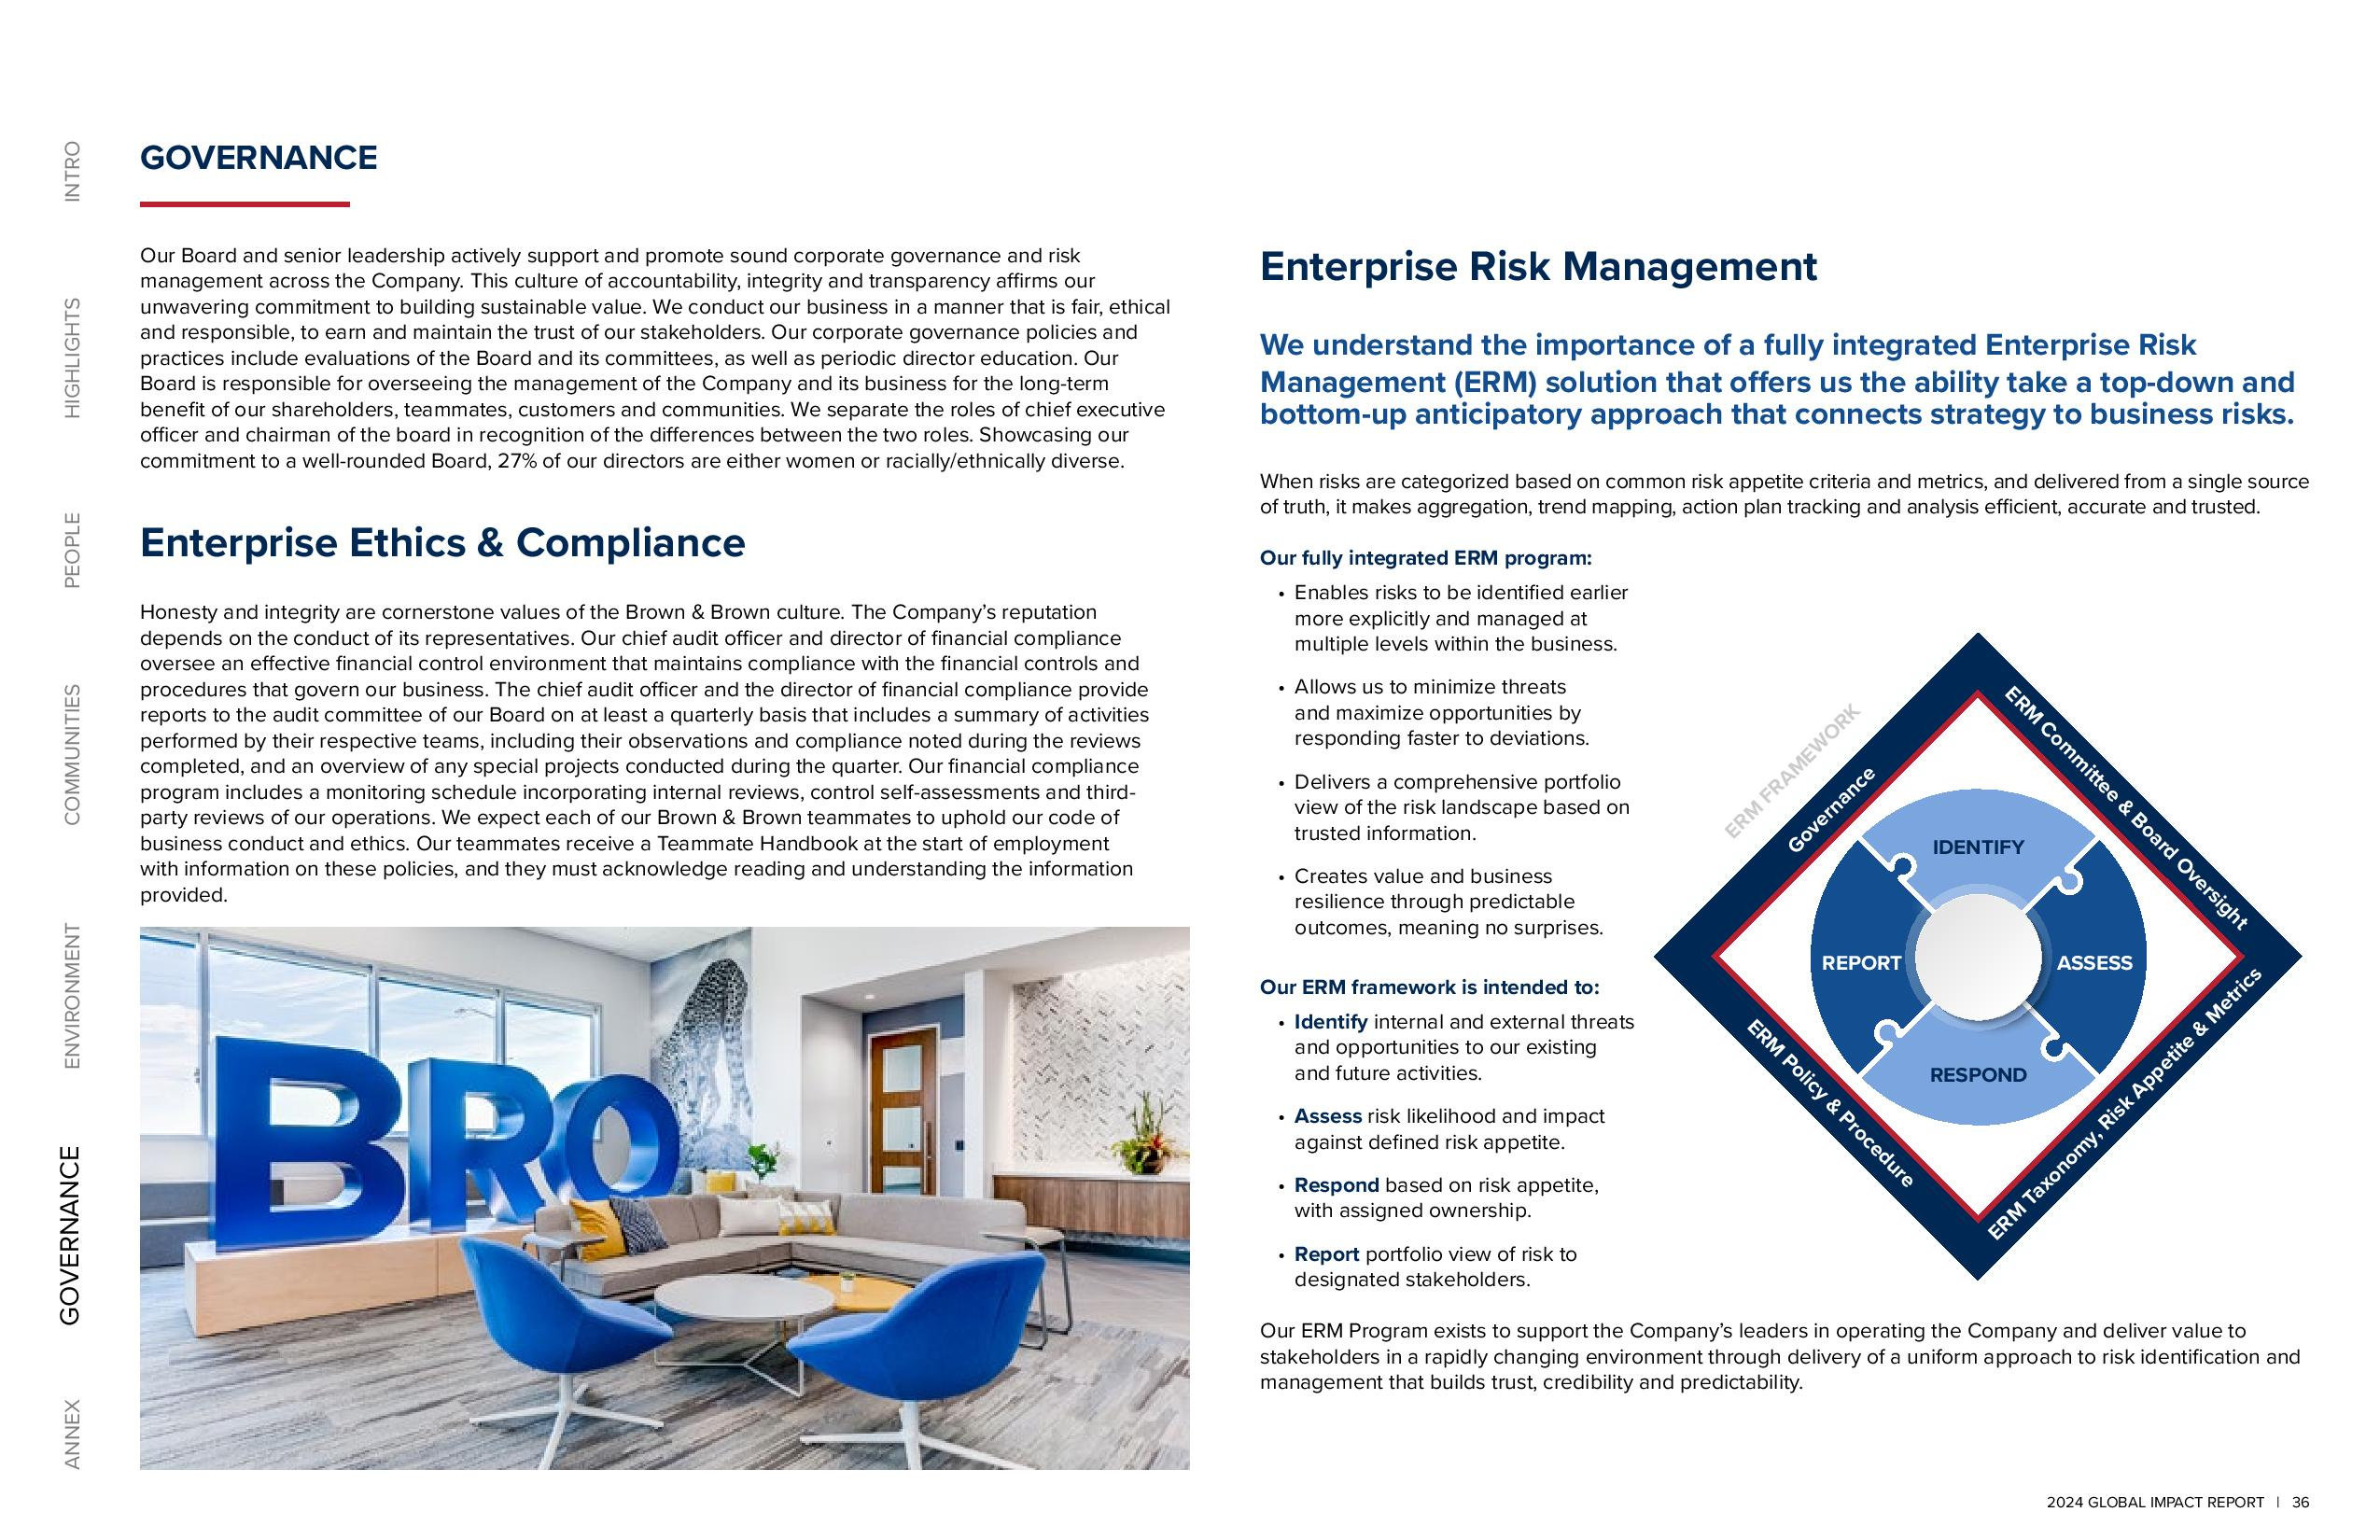

2024 GLOBAL IMPACT REPORT 36 ANNEX GOVERNANCE ENVIRONMENT COMMUNITIES PEOPLE HIGHLIGHTS INTRO Enterprise Risk Management We understand the importance of a fully integrated Enterprise Risk Management (ERM) solution that offers us the ability take a top-down and bottom-up anticipatory approach that connects strategy to business risks. When risks are categorized based on common risk appetite criteria and metrics, and delivered from a single source of truth, it makes aggregation, trend mapping, action plan tracking and analysis efficient, accurate and trusted. Our fully integrated ERM program: Enables risks to be identified earlier more explicitly and managed at multiple levels within the business. Allows us to minimize threats and maximize opportunities by responding faster to deviations. Delivers a comprehensive portfolio view of the risk landscape based on trusted information. Creates value and business resilience through predictable outcomes, meaning no surprises. Our ERM framework is intended to: Identify internal and external threats and opportunities to our existing and future activities. Assess risk likelihood and impact against defined risk appetite. Respond based on risk appetite, with assigned ownership. Report portfolio view of risk to designated stakeholders. Our ERM Program exists to support the Company’s leaders in operating the Company and deliver value to stakeholders in a rapidly changing environment through delivery of a uniform approach to risk identification and management that builds trust, credibility and predictability. Governance ERM Committee & Board Oversight ERM Taxonomy, Risk Appetite & Metrics ERM Policy & Procedure ERM FRAMEWORK IDENTIFY RESPOND REPORT ASSESS GOVERNANCE Our Board and senior leadership actively support and promote sound corporate governance and risk management across the Company. This culture of accountability, integrity and transparency affirms our unwavering commitment to building sustainable value. We conduct our business in a manner that is fair, ethical and responsible, to earn and maintain the trust of our stakeholders. Our corporate governance policies and practices include evaluations of the Board and its committees, as well as periodic director education. Our Board is responsible for overseeing the management of the Company and its business for the long-term benefit of our shareholders, teammates, customers and communities. We separate the roles of chief executive officer and chairman of the board in recognition of the differences between the two roles. Showcasing our commitment to a well-rounded Board, 27% of our directors are either women or racially/ethnically diverse. Enterprise Ethics & Compliance Honesty and integrity are cornerstone values of the Brown & Brown culture. The Company’s reputation depends on the conduct of its representatives. Our chief audit officer and director of financial compliance oversee an effective financial control environment that maintains compliance with the financial controls and procedures that govern our business. The chief audit officer and the director of financial compliance provide reports to the audit committee of our Board on at least a quarterly basis that includes a summary of activities performed by their respective teams, including their observations and compliance noted during the reviews completed, and an overview of any special projects conducted during the quarter. Our financial compliance program includes a monitoring schedule incorporating internal reviews, control self-assessments and thirdparty reviews of our operations. We expect each of our Brown & Brown teammates to uphold our code of business conduct and ethics. Our teammates receive a Teammate Handbook at the start of employment with information on these policies, and they must acknowledge reading and understanding the information provided.

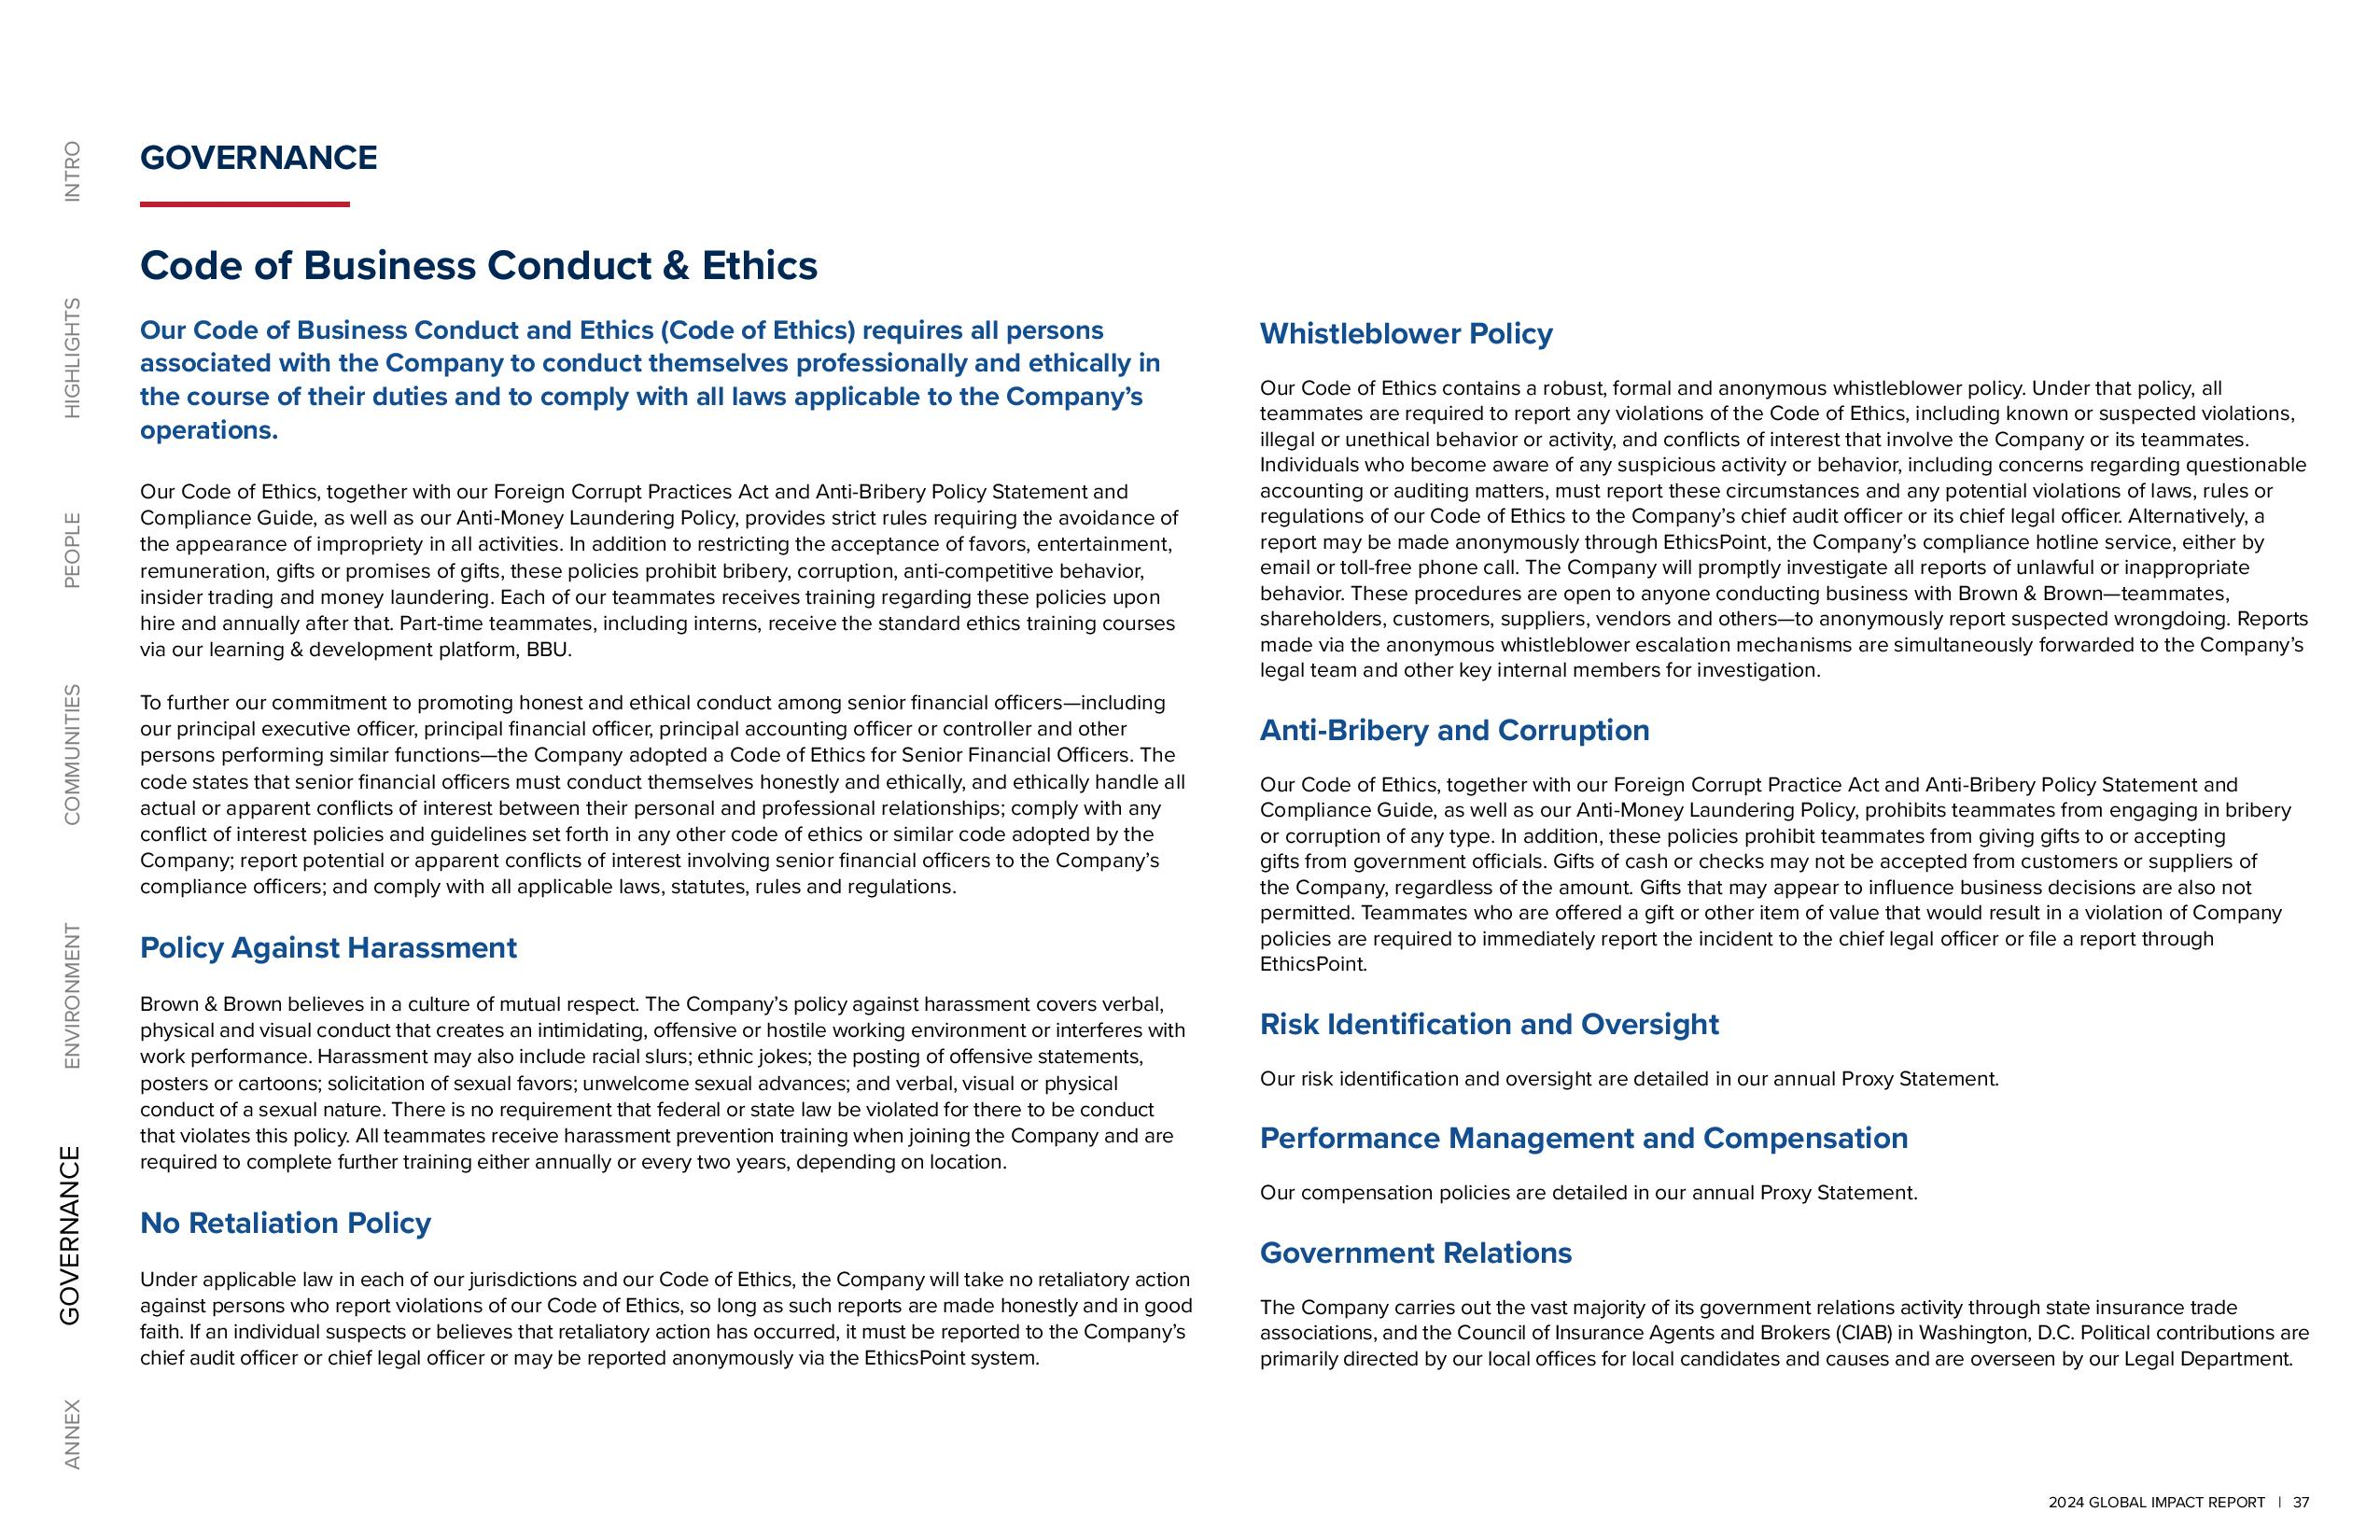

2024 GLOBAL IMPACT REPORT 37 ANNEX GOVERNANCE ENVIRONMENT COMMUNITIES PEOPLE HIGHLIGHTS INTRO GOVERNANCE Code of Business Conduct & Ethics Our Code of Business Conduct and Ethics (Code of Ethics) requires all persons associated with the Company to conduct themselves professionally and ethically in the course of their duties and to comply with all laws applicable to the Company’s operations. Our Code of Ethics, together with our Foreign Corrupt Practices Act and Anti-Bribery Policy Statement and Compliance Guide, as well as our Anti-Money Laundering Policy, provides strict rules requiring the avoidance of the appearance of impropriety in all activities. In addition to restricting the acceptance of favors, entertainment, remuneration, gifts or promises of gifts, these policies prohibit bribery, corruption, anti-competitive behavior, insider trading and money laundering. Each of our teammates receives training regarding these policies upon hire and annually after that. Part-time teammates, including interns, receive the standard ethics training courses via our learning & development platform, BBU. To further our commitment to promoting honest and ethical conduct among senior financial officers including our principal executive officer, principal financial officer, principal accounting officer or controller and other persons performing similar functions the Company adopted a Code of Ethics for Senior Financial Officers. The code states that senior financial officers must conduct themselves honestly and ethically, and ethically handle all actual or apparent conflicts of interest between their personal and professional relationships; comply with any conflict of interest policies and guidelines set forth in any other code of ethics or similar code adopted by the Company; report potential or apparent conflicts of interest involving senior financial officers to the Company’s compliance officers; and comply with all applicable laws, statutes, rules and regulations. Policy Against Harassment Brown & Brown believes in a culture of mutual respect. The Company’s policy against harassment covers verbal, physical and visual conduct that creates an intimidating, offensive or hostile working environment or interferes with work performance. Harassment may also include racial slurs; ethnic jokes; the posting of offensive statements, posters or cartoons; solicitation of sexual favors; unwelcome sexual advances; and verbal, visual or physical conduct of a sexual nature. There is no requirement that federal or state law be violated for there to be conduct that violates this policy. All teammates receive harassment prevention training when joining the Company and are required to complete further training either annually or every two years, depending on location. No Retaliation Policy Under applicable law in each of our jurisdictions and our Code of Ethics, the Company will take no retaliatory action against persons who report violations of our Code of Ethics, so long as such reports are made honestly and in good faith. If an individual suspects or believes that retaliatory action has occurred, it must be reported to the Company’s chief audit officer or chief legal officer or may be reported anonymously via the EthicsPoint system. Whistleblower Policy Our Code of Ethics contains a robust, formal and anonymous whistleblower policy. Under that policy, all teammates are required to report any violations of the Code of Ethics, including known or suspected violations, illegal or unethical behavior or activity, and conflicts of interest that involve the Company or its teammates. Individuals who become aware of any suspicious activity or behavior, including concerns regarding questionable accounting or auditing matters, must report these circumstances and any potential violations of laws, rules or regulations of our Code of Ethics to the Company’s chief audit officer or its chief legal officer. Alternatively, a report may be made anonymously through EthicsPoint, the Company’s compliance hotline service, either by email or toll-free phone call. The Company will promptly investigate all reports of unlawful or inappropriate behavior. These procedures are open to anyone conducting business with Brown & Brown teammates, shareholders, customers, suppliers, vendors and others to anonymously report suspected wrongdoing. Reports made via the anonymous whistleblower escalation mechanisms are simultaneously forwarded to the Company’s legal team and other key internal members for investigation. Anti-Bribery and Corruption Our Code of Ethics, together with our Foreign Corrupt Practice Act and Anti-Bribery Policy Statement and Compliance Guide, as well as our Anti-Money Laundering Policy, prohibits teammates from engaging in bribery or corruption of any type. In addition, these policies prohibit teammates from giving gifts to or accepting gifts from government officials. Gifts of cash or checks may not be accepted from customers or suppliers of the Company, regardless of the amount. Gifts that may appear to influence business decisions are also not permitted. Teammates who are offered a gift or other item of value that would result in a violation of Company policies are required to immediately report the incident to the chief legal officer or file a report through EthicsPoint. Risk Identification and Oversight Our risk identification and oversight are detailed in our annual Proxy Statement. Performance Management and Compensation Our compensation policies are detailed in our annual Proxy Statement. Government Relations The Company carries out the vast majority of its government relations activity through state insurance trade associations, and the Council of Insurance Agents and Brokers (CIAB) in Washington, D.C. Political contributions are primarily directed by our local offices for local candidates and causes and are overseen by our Legal Department. 2024

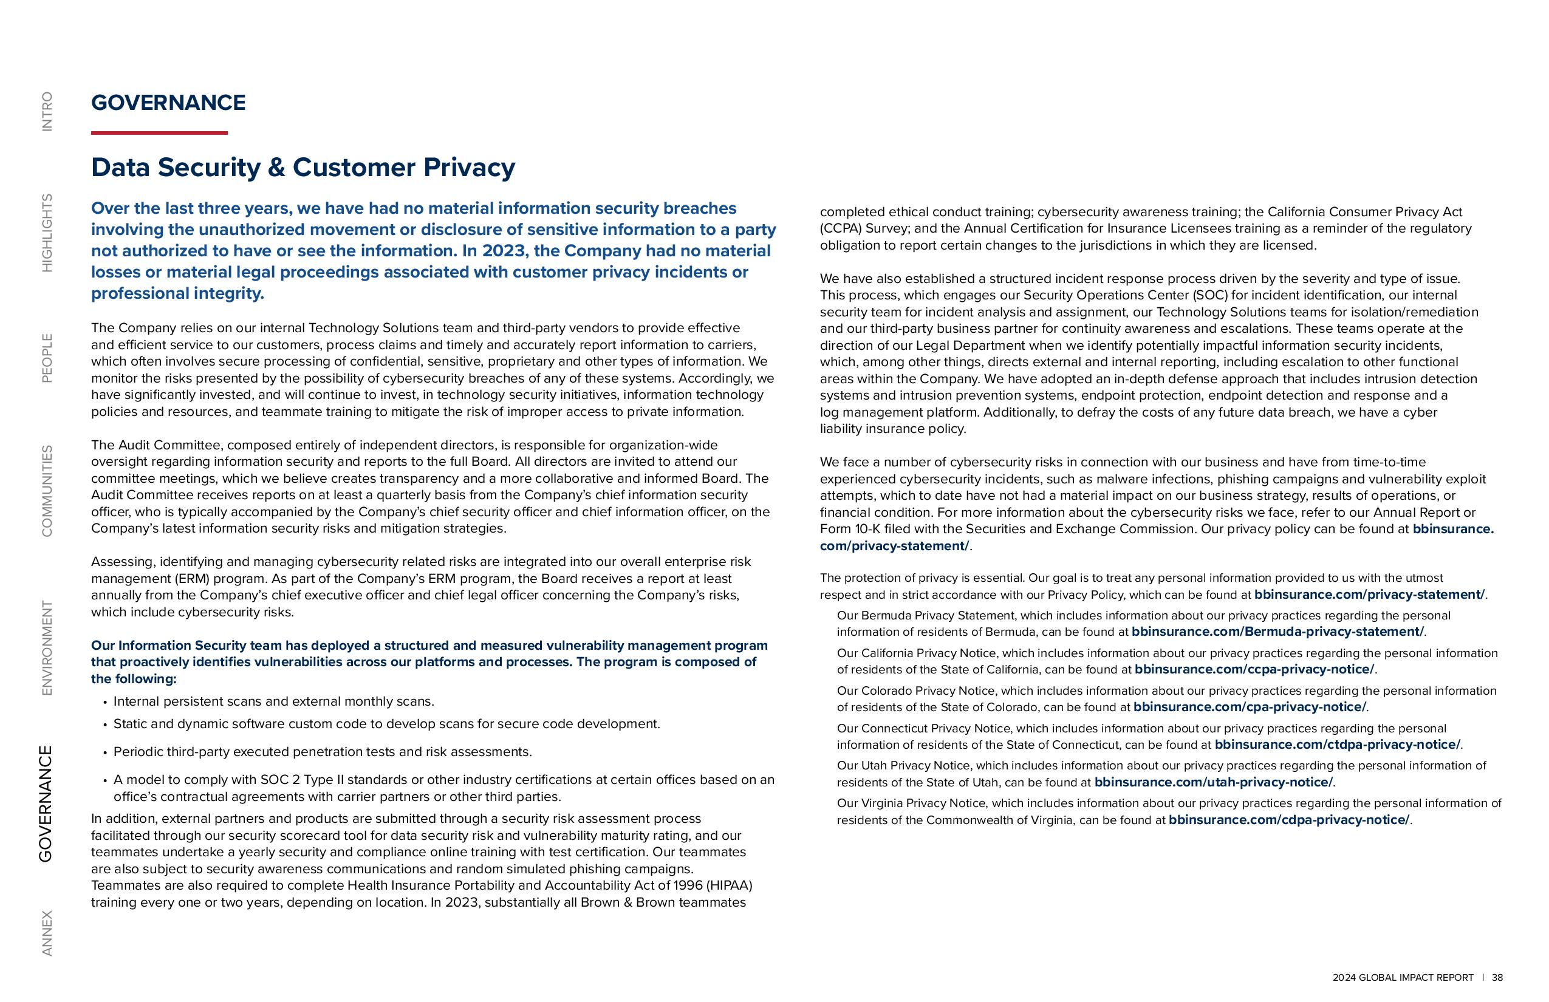

GLOBAL IMPACT REPORT 38 ANNEX GOVERNANCE ENVIRONMENT COMMUNITIES PEOPLE HIGHLIGHTS INTRO GOVERNANCE Data Security & Customer Privacy Over the last three years, we have had no material information security breaches involving the unauthorized movement or disclosure of sensitive information to a party not authorized to have or see the information. In 2023, the Company had no material losses or material legal proceedings associated with customer privacy incidents or professional integrity. The Company relies on our internal Technology Solutions team and third-party vendors to provide effective and efficient service to our customers, process claims and timely and accurately report information to carriers, which often involves secure processing of confidential, sensitive, proprietary and other types of information. We monitor the risks presented by the possibility of cybersecurity breaches of any of these systems. Accordingly, we have significantly invested, and will continue to invest, in technology security initiatives, information technology policies and resources, and teammate training to mitigate the risk of improper access to private information. The Audit Committee, composed entirely of independent directors, is responsible for organization-wide oversight regarding information security and reports to the full Board. All directors are invited to attend our committee meetings, which we believe creates transparency and a more collaborative and informed Board. The Audit Committee receives reports on at least a quarterly basis from the Company’s chief information security officer, who is typically accompanied by the Company’s chief security officer and chief information officer, on the Company’s latest information security risks and mitigation strategies. Assessing, identifying and managing cybersecurity related risks are integrated into our overall enterprise risk management (ERM) program. As part of the Company’s ERM program, the Board receives a report at least annually from the Company’s chief executive officer and chief legal officer concerning the Company’s risks, which include cybersecurity risks. Our Information Security team has deployed a structured and measured vulnerability management program that proactively identifies vulnerabilities across our platforms and processes. The program is composed of the following: Internal persistent scans and external monthly scans. Static and dynamic software custom code to develop scans for secure code development. Periodic third-party executed penetration tests and risk assessments. A model to comply with SOC 2 Type II standards or other industry certifications at certain offices based on an office’s contractual agreements with carrier partners or other third parties. In addition, external partners and products are submitted through a security risk assessment process facilitated through our security scorecard tool for data security risk and vulnerability maturity rating, and our teammates undertake a yearly security and compliance online training with test certification. Our teammates are also subject to security awareness communications and random simulated phishing campaigns. Teammates are also required to complete Health Insurance Portability and Accountability Act of 1996 (HIPAA) training every one or two years, depending on location. In 2023, substantially all Brown & Brown teammates completed ethical conduct training; cybersecurity awareness training; the California Consumer Privacy Act (CCPA) Survey; and the Annual Certification for Insurance Licensees training as a reminder of the regulatory obligation to report certain changes to the jurisdictions in which they are licensed. We have also established a structured incident response process driven by the severity and type of issue. This process, which engages our Security Operations Center (SOC) for incident identification, our internal security team for incident analysis and assignment, our Technology Solutions teams for isolation/remediation and our third-party business partner for continuity awareness and escalations. These teams operate at the direction of our Legal Department when we identify potentially impactful information security incidents, which, among other things, directs external and internal reporting, including escalation to other functional areas within the Company. We have adopted an in-depth defense approach that includes intrusion detection systems and intrusion prevention systems, endpoint protection, endpoint detection and response and a log management platform. Additionally, to defray the costs of any future data breach, we have a cyber liability insurance policy. We face a number of cybersecurity risks in connection with our business and have from time-to-time experienced cybersecurity incidents, such as malware infections, phishing campaigns and vulnerability exploit attempts, which to date have not had a material impact on our business strategy, results of operations, or financial condition. For more information about the cybersecurity risks we face, refer to our Annual Report or Form 10-K filed with the Securities and Exchange Commission. Our privacy policy can be found at bbinsurance. com/privacy-statement/. The protection of privacy is essential. Our goal is to treat any personal information provided to us with the utmost respect and in strict accordance with our Privacy Policy, which can be found at bbinsurance.com/privacy-statement/. Our Bermuda Privacy Statement, which includes information about our privacy practices regarding the personal information of residents of Bermuda, can be found at bbinsurance.com/Bermuda-privacy-statement/. Our California Privacy Notice, which includes information about our privacy practices regarding the personal information of residents of the State of California, can be found at bbinsurance.com/ccpa-privacy-notice/. Our Colorado Privacy Notice, which includes information about our privacy practices regarding the personal information of residents of the State of Colorado, can be found at bbinsurance.com/cpa-privacy-notice/. Our Connecticut Privacy Notice, which includes information about our privacy practices regarding the personal information of residents of the State of Connecticut, can be found at bbinsurance.com/ctdpa-privacy-notice/. Our Utah Privacy Notice, which includes information about our privacy practices regarding the personal information of residents of the State of Utah, can be found at bbinsurance.com/utah-privacy-notice/. Our Virginia Privacy Notice, which includes information about our privacy practices regarding the personal information of residents of the Commonwealth of Virginia, can be found at bbinsurance.com/cdpa-privacy-notice/.



2024 GLOBAL IMPACT REPORT 39 ANNEX GOVERNANCE ENVIRONMENT COMMUNITIES PEOPLE HIGHLIGHTS INTRO Annex

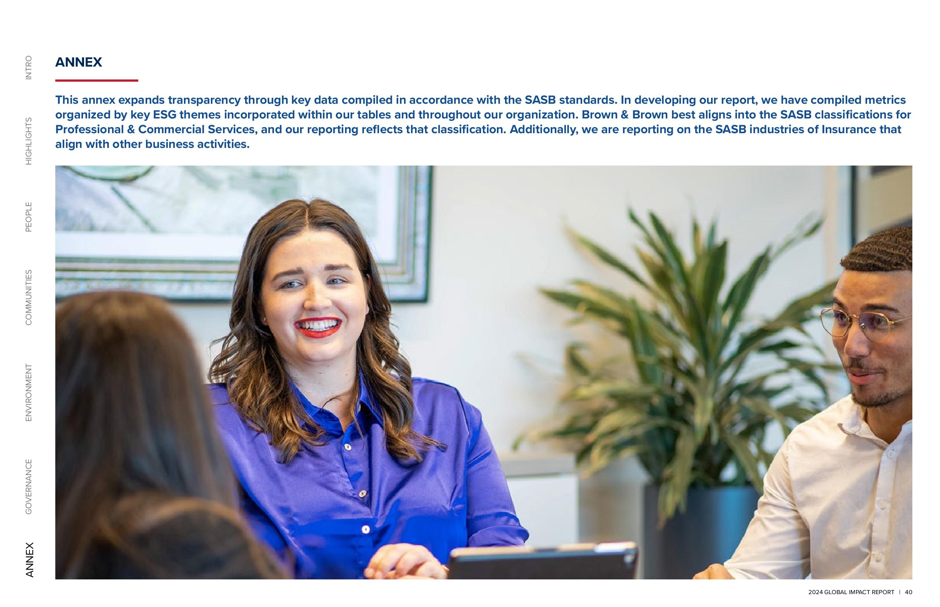

2024 GLOBAL IMPACT REPORT 40 ANNEX GOVERNANCE ENVIRONMENT COMMUNITIES PEOPLE HIGHLIGHTS INTRO ANNEX This annex expands transparency through key data compiled in accordance with the SASB standards. In developing our report, we have compiled metrics organized by key ESG themes incorporated within our tables and throughout our organization. Brown & Brown best aligns into the SASB classifications for Professional & Commercial Services, and our reporting reflects that classification. Additionally, we are reporting on the SASB industries of Insurance that align with other business activities. 2024 GLOBAL IMPACT REPORT

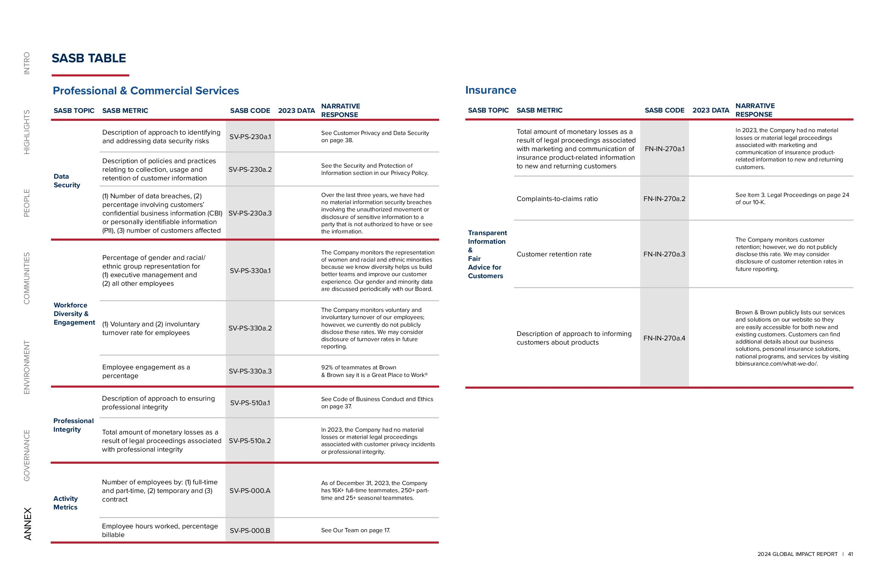
2024 GLOBAL IMPACT REPORT 41 ANNEX GOVERNANCE ENVIRONMENT COMMUNITIES PEOPLE HIGHLIGHTS INTRO Professional Integrity Description of approach to ensuring professional integrity SV-PS-510a.1 See Code of Business Conduct and Ethics on page 37. Total amount of monetary losses as a result of legal proceedings associated with professional integrity SV-PS-510a.2 In 2023, the Company had no material losses or material legal proceedings associated with customer privacy incidents or professional integrity. Activity Metrics Number of employees by: (1) full-time and part-time, (2) temporary and (3) contract SV-PS-000.A As of December 31, 2023, the Company has 16K+ full-time teammates, 250+ parttime and 25+ seasonal teammates. Employee hours worked, percentage billable SV-PS-000.B See Our Team on page 17. SASB TABLE Professional & Commercial Services SASB TOPIC SASB METRIC SASB CODE 2023 DATA NARRATIVE RESPONSE Data Security Description of approach to identifying and addressing data security risks SV-PS-230a.1 See Customer Privacy and Data Security on page 38. Description of policies and practices relating to collection, usage and retention of customer information SV-PS-230a.2 See the Security and Protection of Information section in our Privacy Policy. (1) Number of data breaches, (2) percentage involving customers’ confidential business information (CBI) or personally identifiable information (PII), (3) number of customers affected SV-PS-230a.3 Over the last three years, we have had no material information security breaches involving the unauthorized movement or disclosure of sensitive information to a party that is not authorized to have or see the information. Workforce Diversity & Engagement Percentage of gender and racial/ ethnic group representation for (1) executive management and (2) all other employees SV-PS-330a.1 The Company monitors the representation of women and racial and ethnic minorities because we know diversity helps us build better teams and improve our customer experience. Our gender and minority data are discussed periodically with our Board. (1) Voluntary and (2) involuntary turnover rate for employees SV-PS-330a.2 The Company monitors voluntary and involuntary turnover of our employees; however, we currently do not publicly disclose these rates. We may consider disclosure of turnover rates in future reporting. Employee engagement as a percentage SV-PS-330a.3 92% of teammates at Brown & Brown say it is a Great Place to Work® Insurance SASB TOPIC SASB METRIC SASB CODE 2023 DATA NARRATIVE RESPONSE Transparent Information & Fair Advice for Customers Total amount of monetary losses as a result of legal proceedings associated with marketing and communication of insurance product-related information to new and returning customers FN-IN-270a.1 In 2023, the Company had no material losses or material legal proceedings associated with marketing and communication of insurance productrelated information to new and returning customers. Complaints-to-claims ratio FN-IN-270a.2 See Item 3. Legal Proceedings on page 24 of our 10-K. Customer retention rate FN-IN-270a.3 The Company monitors customer retention; however, we do not publicly disclose this rate. We may consider disclosure of customer retention rates in future reporting. Description of approach to informing customers about products FN-IN-270a.4 Brown & Brown publicly lists our services and solutions on our website so they are easily accessible for both new and existing customers. Customers can find additional details about our business solutions, personal insurance solutions, national programs, and services by visiting bbinsurance.com/what-we-do/.



300 North Beach Street Daytona Beach, FL 32114 (386) 252-9601 bbinsurance.com

